 cid:image002.jpg@01D43A07.B25E17C0

Line Manager Guide

NHS Greater Glasgow and Clyde

2025 Version

iMatter team sends list of previous year’s Directorate/HSCP iMatter teams to Local Leads approx. 8 weeks before Team Confirmation

1. **Preparing for Distribution**

Local Leads liaise and discuss with line managers to determine any changes to team names or assigned line managers. This includes noting teams to be archived or new teams to be added

Administrators make updates on the system by the agreed date (2 weeks before Team Confirmation begins)

**2. Team Confirmation**

First day of Team Confirmation: managers in the system are emailed a link by Webropol advising them that they can go into the system for the 4 week Team Confirmation period

Managers edit, remove and add staff, and they can also amend preferred response methods

Managers confirm their team in the system once up-to-date

Should a manager confirm a team in error and need to make furtheramendments, Administrators can reset team confirmation

**3. Questionnaire**

First day of Questionnaire, staff are send links by Webropol via the email/SMS mobile number added to the system by their manager for them to fill in their unique questionnaire. Managers print staff’s paper copies (copies are unique to each staff member).

If a manager has confirmed an incorrect email address/SMS mobile number for a staff member, Administrators can amend these

If a staff member has been missed or added in error during Team Confirmation, Administrators can add, remove or exclude staff

**4. Reports and Action Planning**

2 weeks (or next day*) after the Questionnaire closes:

**\*reports are produced the next day if a Directorate/HSCP is fully electronic (i.e. has no paper copies in any team)**

Links are emailed/sent via SMS from Webropol directly to staff to view their team’s report; managers print off report for those staff who have not participated electronically

Managers access their team’s report* by logging in to their iMatter portal

*Managers will also receive an email from Webropol to view the team report for the team in they participated in as a team member (as a ‘respondent’) under their own line manager

This report is not available to managers via their accounts

A discussion between manager and team should take place - the manager then adds the team’s Action Plan via their iMatter portal

**5. Progress Update**

A Progress Update should be discussed with the team and recorded in the system approximately 3-4 months after submitting the Action Plan

**Contents**

**Line Manager Actions**

1. **Preparing for Distribution 4**
2. **Team Confirmation 4** 
   1. Accessing your iMatter account 4
   2. Updating staff details 6
      1. Adding staff and amending staff’s details 6
      2. Excluding staff from current year’s run 7
      3. Removing staff 7
   3. Confirming the team **7**
3. **Questionnaire 8**
4. **Reports and Action Planning 10**
   1. Report publication 10
   2. Action planning 12
5. **Progress Update 14**
6. **Help and Assistance 14**

**Line Manager Actions**

1. **Preparing for Distribution**

Before Team Confirmation begins, Local Leads within each area will be in touch to discuss any changes to the hierarchy structure. At this point, you should highlight:

* If the **team name** and team’s **assigned manager** are to remain the same or provide updates
* Any teams to be archived/removed
* Any additional/new teams required

This information will then be passed by Local Leads to iMatter system Administrators to make changes in the system.

1. **Team Confirmation**

**2.1 Accessing your iMatter account**

On the day team confirmation opens you will receive an email from Webropol containing your login link inviting you to update and confirm your team. You are required to log in to your iMatter account (‘portal’) and amend any staff details within your team and confirm the team by the agreed deadline.

The schedule dates can be found on [HR Connect](https://www.nhsggc.scot/staff-recruitment/hrconnect/imatter/).

If you are already registered on the system you will be able to login via <https://nhsscotland-sep.webropol.com/Account/Login> using the email address and password you used to set up your account.

If you are not yet registered on the iMatter system, you will receive an email from Webropol containing a link for you to set up your account.

Should you need to reset your password, you can do this by following the login link and using the ‘forgot password’ function - you will then be sent a link by Webropol to your email address to change your password:

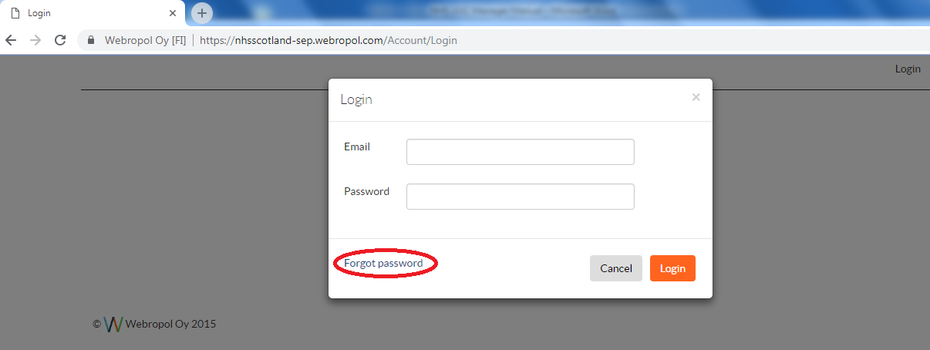

Once logged in to your account, you can access your team’s details via the homepage by clicking ‘iMatter Questionnaire’ followed by the team that you wish to amend and confirm (if you are assigned to more than one team), and then ‘Manage Team’ which will open the staff list within the chosen team:

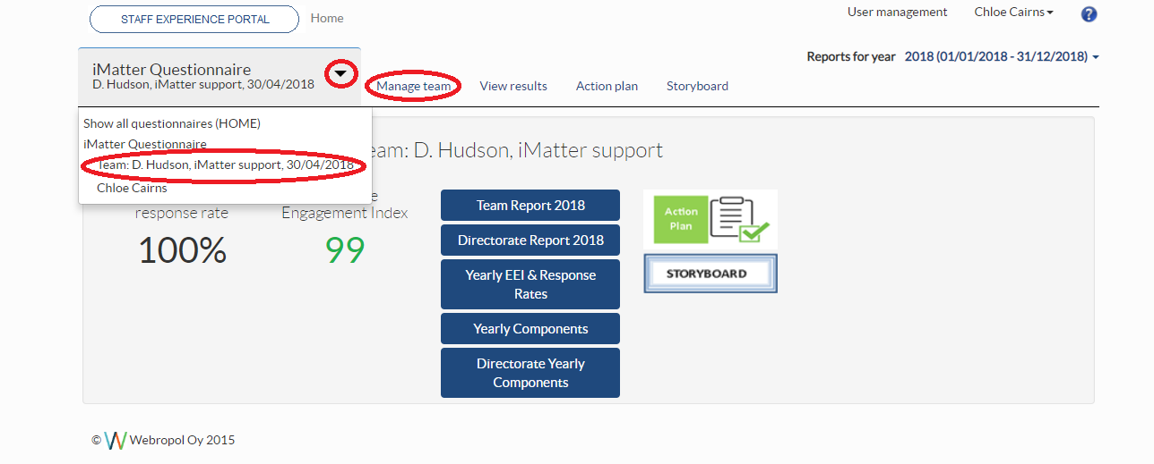

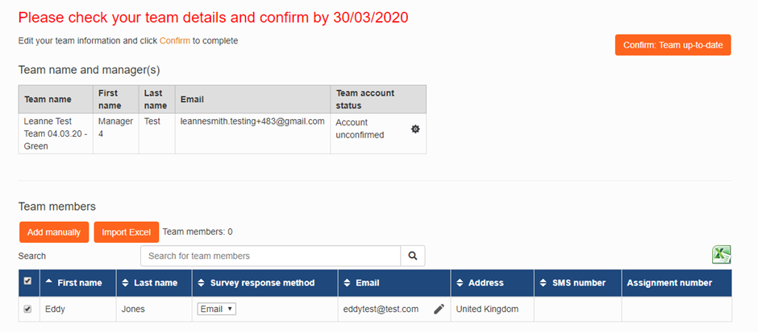

* 1. **Updating staff details**

Upon opening the team list, you will be able to add, exclude or remove staff members in order to ensure your staff list is up to date in preparation for the Questionnaire starting.

**2.2.1 Adding staff and amending staff’s details**

To add staff to your list you should use the ‘Add Manually’ button at the top left corner of the list and enter their details:

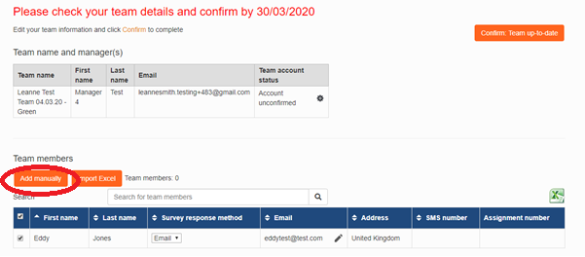

**Email**: If the staff member wishes to complete their questionnaire via email, click the drop down menu and select ‘email’ as their response method, enter the email address and save - this will ensure they receive a link for their questionnaire.

To amend staff’s email addresses you will need to remove the staff member and then re-add them with their correct email address.

**SMS**: For staff who would like to participate via SMS, select the ‘SMS’ option from the survey response method drop down list and ensure their mobile number is entered in the correct format, then save.

All mobile numbers should be formatted as **‘+441234567890’** and will require access to the internet on their mobile (i.e. via Wi-Fi or mobile data) in order to complete the questionnaire.

**Paper**: If the staff member is completing on paper, please select ‘paper’ and leave the address blank, then save. The manager is required to print off the unique paper copies and distribute to staff on the day the questionnaire launches. **Paper copies will not be sent out to any address entered.**

To change the response method from paper to email/SMS, you will need to remove the staff member and then re-add as email/SMS.

**2.2.2 Excluding staff from current year’s run**

If your staff member is only temporarily off work and won’t be taking part in the process in the current run (for example due to long term sickness absence, maternity leave etc.) then they can be ‘**excluded**’, meaning they will automatically be added back into the team next year. To exclude a staff member, tick the box on the left hand side of their name and click exclude and enter the reason why.

Please ensure you have communicated with the staff member and agreed exclusion before progressing, as staff are able to participate via personal email/mobile number/paper copy when not at work should they wish to do so.

If you are unsure whether to exclude or remove a staff member, please contact [ggc.nhsggc.imatter@nhs.scot](mailto:ggc.nhsggc.imatter@nhs.scot)

**2.2.3 Removing staff**

If a staff member is no longer in your team, you should remove them.

The check box down the left hand side of the name of the staff member’s name to be removed should be ticked followed by either ‘remove’ at the bottom of the list:

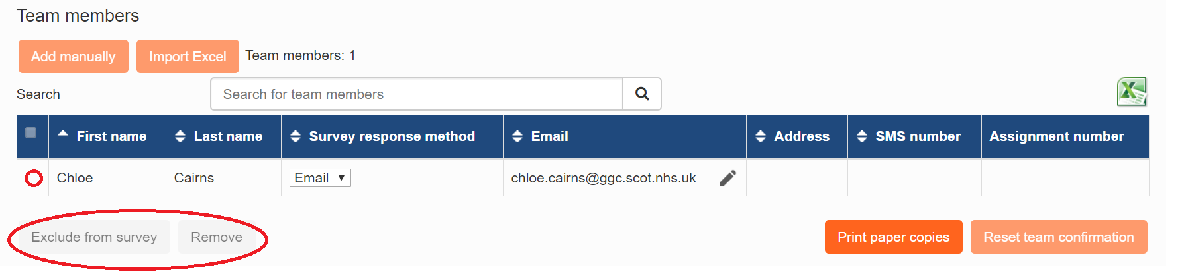

**2.3 Confirming the team**

Once your team details are up to date, you should click the ‘Confirm: Team up to date’ button on the right hand side of the page (this button can also be found at the bottom right hand side of the page):

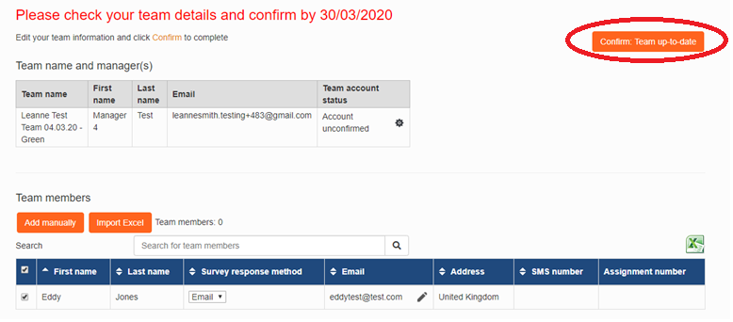

Should you have confirmed your team and need to make further amendments, contact a system Administrator who will be able to reset Team Confirmation for you. Once happy with the up-date, you will need to confirm your team once again.

If you have changes to make to the structure of your team set up (disaggregating or aggregating your team), contact [ggc.nhsggc.imatter@nhs.scot](mailto:ggc.nhsggc.imatter@nhs.scot) as soon as possible as this should be done prior to the questionnaire launching.

Please note that if you log in and confirm your team with ‘0’ staff listed, this will be considered as a ‘live’ team and will still show in reports. Therefore if you end up with no staff listed - whether they have been moved to another team or have left the organisation etc. - contact [ggc.nhsggc.imatter@nhs.scot](mailto:ggc.nhsggc.imatter@nhs.scot) as soon as possible as this should be done prior to the questionnaire launching.

Please note that if you log in and confirm your team with ‘0’ staff listed, please consider whether you still require a team. If so, please add in your staff details, and if you no longer require a team, please contact [ggc.nhsggc.imatter@nhs.scot](mailto:ggc.nhsggc.imatter@nhs.scot) or your Local iMatter Administrator to remove the team. Please do **not** confirm or leave a team with no staff added, in the system.

**3. Questionnaire**

On the day the questionnaire goes live for staff, those who have opted to participate via email or SMS should receive their link directly from Webropol 11am onwards.

However, for those participating via paper copy, you will require to log in and print off the staff’s unique paper. This should be done via the ‘Manage Team’ page (as above) once the questionnaire has gone live - for those participating via paper copy a printer icon will appear next to their name.

You can print papers individually by using the printer icon next to the staff’s name, or print all by using the ‘print paper copies’ button at the bottom of the staff list.

The paper copies will download as a PDF to print off and you are required to hand them out to staff along with the pre-paid envelopes supplied by Local Leads.

Paper copies are unique to each staff and therefore should not be photocopied. The cover letter will have the staff’s name on it - this part is removed when sending it to Webropol but checking this before handing out the copies ensures that staff have the correct copy for them.

Printed questionnaires should be provided to staff within the first few daysof the questionnaire going live (see chart at beginning - need to make it match) in order to give staff time to complete and return to Webropol:

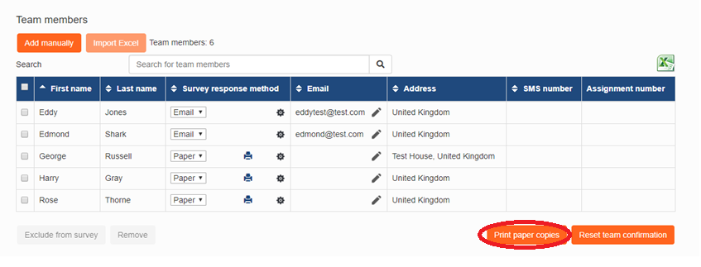

Those completing on paper have an additional week after the closing date, to allow their completed questionnaire to reach Webropol in time. Staff should use the pre-paid envelope to send their responses to Webropol. Webropol then inputs their response to the system.

The questionnaire is anonymous, therefore you will not be able to see which staff have completed and which have not. However you can check your team’s response rate on the home page during Questionnaire and you should encourage all staff to complete:

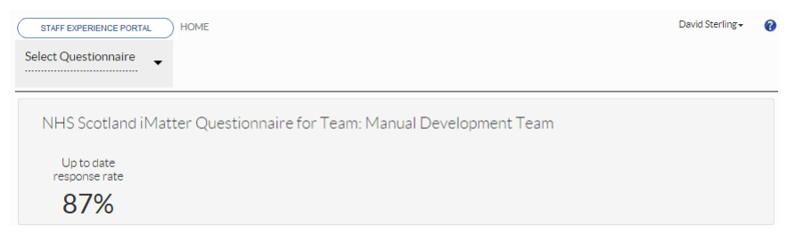

In order to generate a report for a team of less than 5, all staff must complete (a 100% response rate is required for teams of this size). For teams of 5 or more, there is no pre-required response rate to generate a report.

Please encourage your team to participate whilst the Questionnaire is live as it’s important to gather feedback on the experiences of staff, to support continuous improvement.

Please contact [ggc.nhsggc.imatter@nhs.scot](mailto:ggc.nhsggc.imatter@nhs.scot) with any queries as soon as possible (for instance, a staff member has been missed from the team, unexpectedly leaves and needs to be removed from the list, would like to change their response method etc.).

**4. Reports and Action Planning**

**4.1 Report publication**

Staff automatically receive the team report via email/SMS on the day reports are available.

This will either be the day following the questionnaire closing (where all teams in a Directorate/HSCP are fully electronic) or 2 weeks after, where there are any paper copies in the Directorate/HSCP.

If you have staff who have participated via paper copy within your team, the response rate can still change in the week following the closing date, as Webropol inputs the paper copies they received.

To view your team’s report, you will need to log in to your account. If your team has generated a report you will be able to access the report via the homepage of your portal:

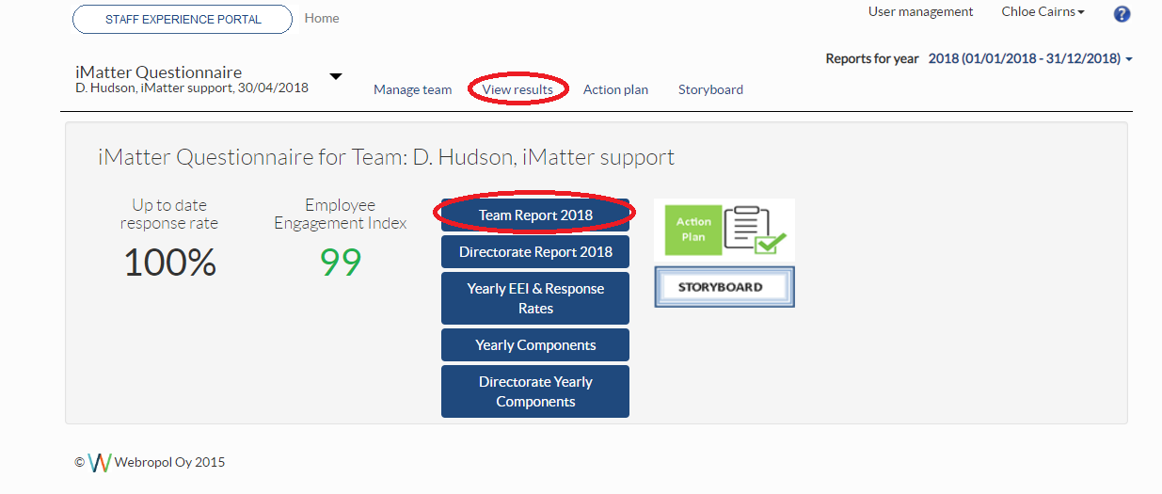

You can also download a PDF copy of your team’s report, for the staff who didn’t participate via email / SMS by using the PDF function at the top left hand side of the report:

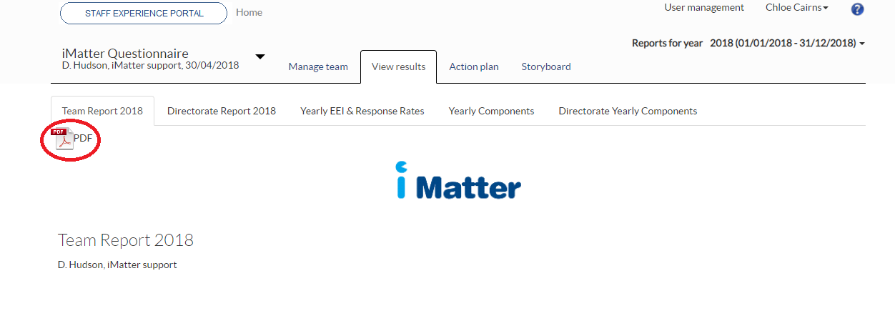

You will also receive an email from Webropol to view the team report for the team in which you participated in as a team member (as a ‘respondent’) under your own line manager.

This report is not available to you via your account.

**4.2 Action planning**

Following the report being distributed, please arrange a discussion with your team around the results, and develop an Action Plan with your team whichever way is convenient for you and your staff (this can be included in meetings that you already have planned, i.e. huddles, team meetings etc.).

You should discuss your team report and agree as a team on one activity which the team does well.

You should also agree up to three actions to progress, which are identified as improvement opportunities. These should then be entered in to the Action Planning section on your iMatter portal.

If your team has not generated a report, you should use either the Directorate Report or the Components Report which are available on your portal to discuss and develop an Action Plan with your team:

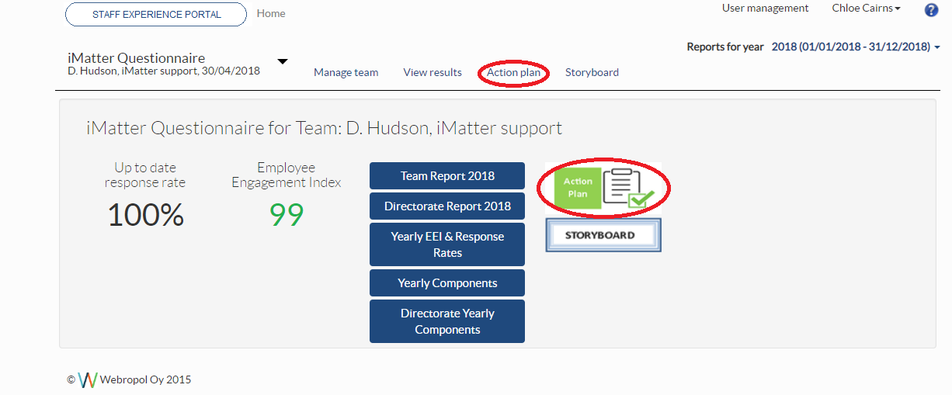

Ideally, Action Plans should be entered on the system by 11.59am on the 8 week deadline given for your area (please see the iMatter schedule on HR Connect for more information) in order for it to be included in the Action Planning KPI, reported on nationally.

However, please still enter your Action Plan if completed after this deadline, as the system will not close and your Action Plan will still be saved in the same way. Please note that it will not count in the figures calculated for the Action Planning KPI.

When completing your Action Plan, the (one) ‘What we do well’ should be filled in as shown below in the green box, and the (one, two or three) improvement actions for the team should be entered in the table with all four columns populated before saving.

If you wish to add more to the plan before finalising, use the ‘Save and continue’ button which will allow you to go back in at another time to edit further, otherwise click ‘Complete Action Plan & Create Storyboard’. This will lock your Action Plan and automatically create the Storyboard:



The character limit per section/free text box is 200 characters including spaces. However you might add a summary of your Action Plan into the system and the team can create a more detailed version out with the system (i.e. in Word, Excel etc.), this could then also be used as a fuller working document.

Should you have locked the Action Plan in error or need to make amendments, Administrators can unlock and reset the Action Plan for you. You will need to re-confirm the plan once updated. (Pease ensure this is done within the 8 week timeframe, as if reconfirmed after this, the completion rate with be affected).

More details on action planning can be found in the Action Planning Guide on [HR Connect](https://www.nhsggc.scot/staff-recruitment/hrconnect/imatter/).

The Storyboard (i.e. Action Plan Summary) is automatically sent out to staff who completed the survey via email or SMS, allowing them to view the Action Plan Summary. The Storyboard should be downloaded by the manager for staff who didn’t participate via email / SMS by using the PDF icon at the top left hand side of the report:

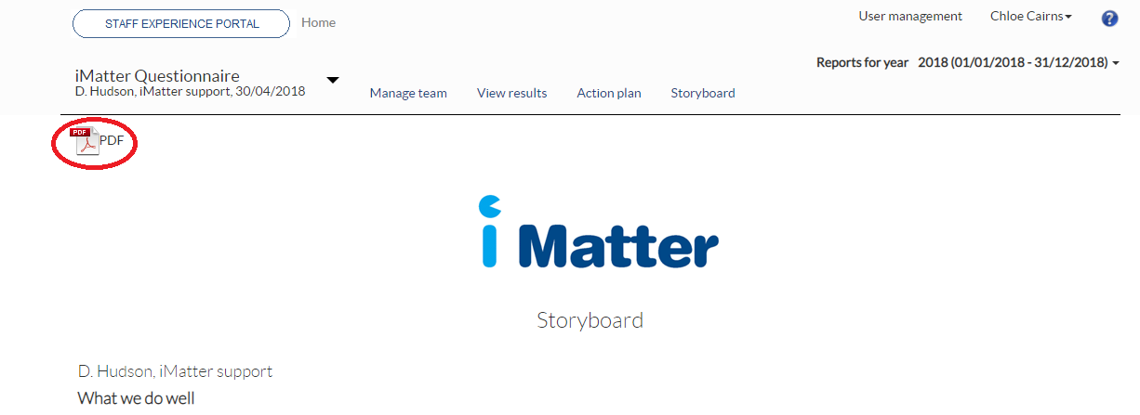

1. **Progress Update**

Over the next few months once the team have had time to progress the agreed actions, managers should log in and enter a Progress Update which is ‘Step 3: Record of Progress’ within the Action Plan.

If you are updating one area at a time, the ‘save changes’ button should be used until all areas have been recorded on the Progress Update, then the ‘complete and lock’ button should be pressed:

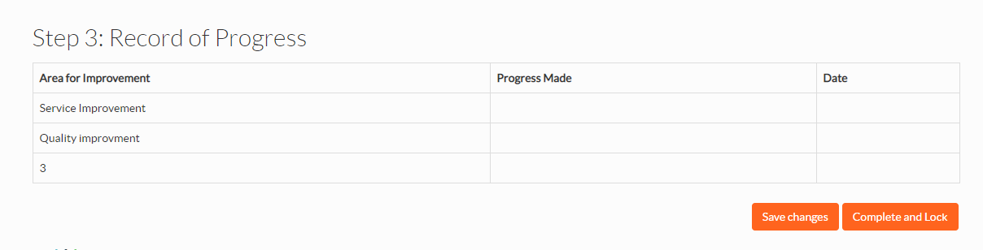

The ‘Record of Progress’ should be filled in throughout the year.

1. **Help and Assistance**

Should you have any questions at any point of the iMatter run, please contact your Local Administrator if there is one assigned in your area; otherwise please contact the NHSGGC iMatter mailbox at [ggc.nhsggc.imatter@nhs.scot](mailto:ggc.nhsggc.imatter@nhs.scot)