 

**iMatter Sub Reporting Guide**

Managers with a Sub Report set up on the system will be able to access the report from the portal on their iMatter account. Log in to your account <https://nhsscotland-sep.webropol.com/Account/Login> where the portal page below will appear -

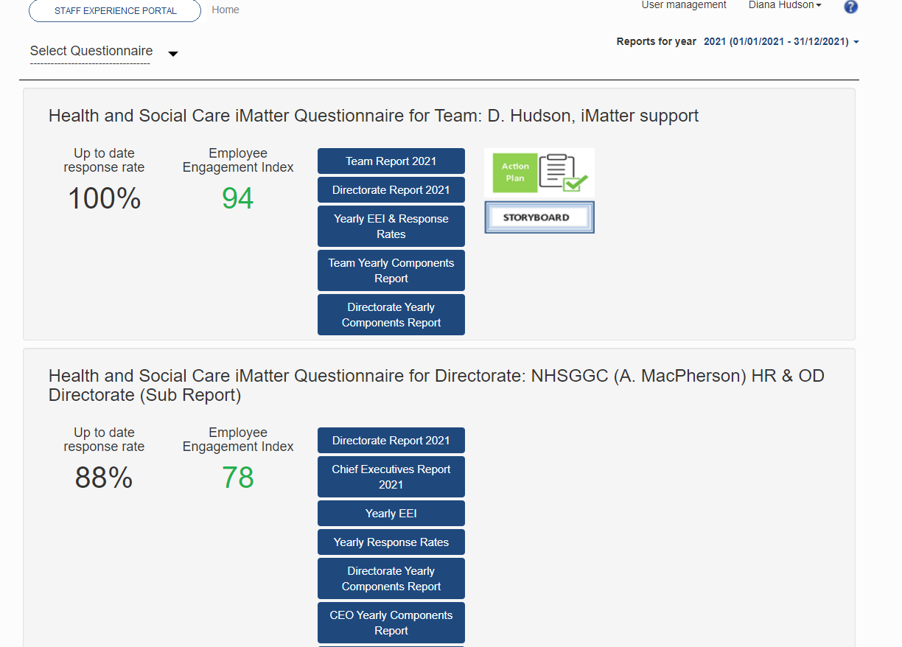

This section here is for the Sub report set up for the area/service you oversee

This section here is for the team you directly line manage

Click ‘Directorate Report’ to access your Sub Report

You can also access your Sub Report by clicking ‘Select Questionnaire’. On the drop down menu, there will be an option to select your team report, or Sub Report. The Sub Report will include “(Sub Report)” in the drop down menu.

Once you have clicked into the Sub Report, this will appear as below, showing an aggregated report of responses from recipients across all the teams included in the Sub Report -

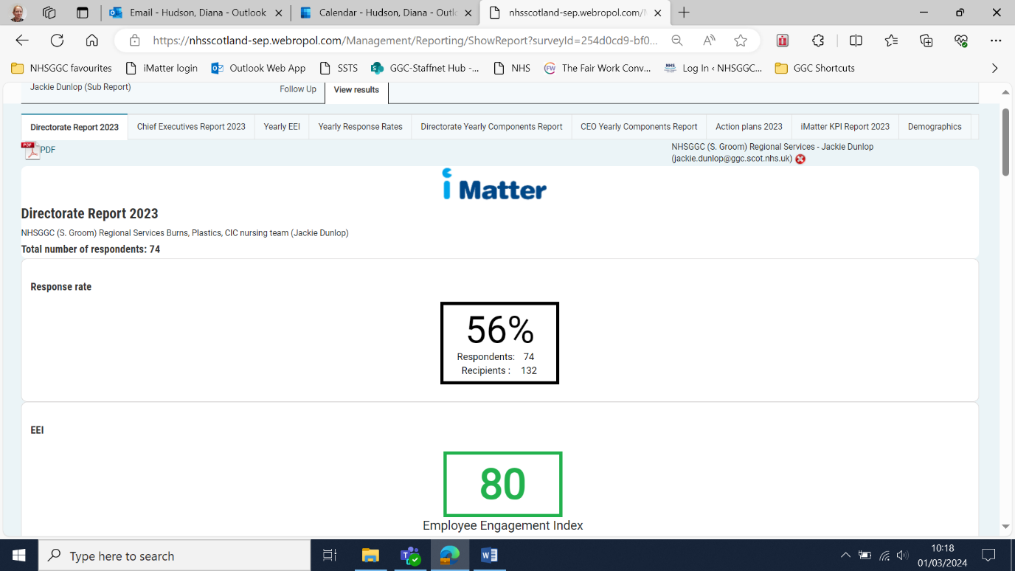

Each tab is a different report.

These reports are for the teams within your Sub report and **not** the overall Directorate or CEO

Report PDFs can be downloaded to save and print by clicking here

The yearly EEI report as shown below will list each team within your Sub Report and if the EEI has improved from the previous year. Where ‘no report’ is shown, this means that there was no team report achieved. (If a ‘–‘ is shown against any team, this indicates the team was not in the system during that particular year).

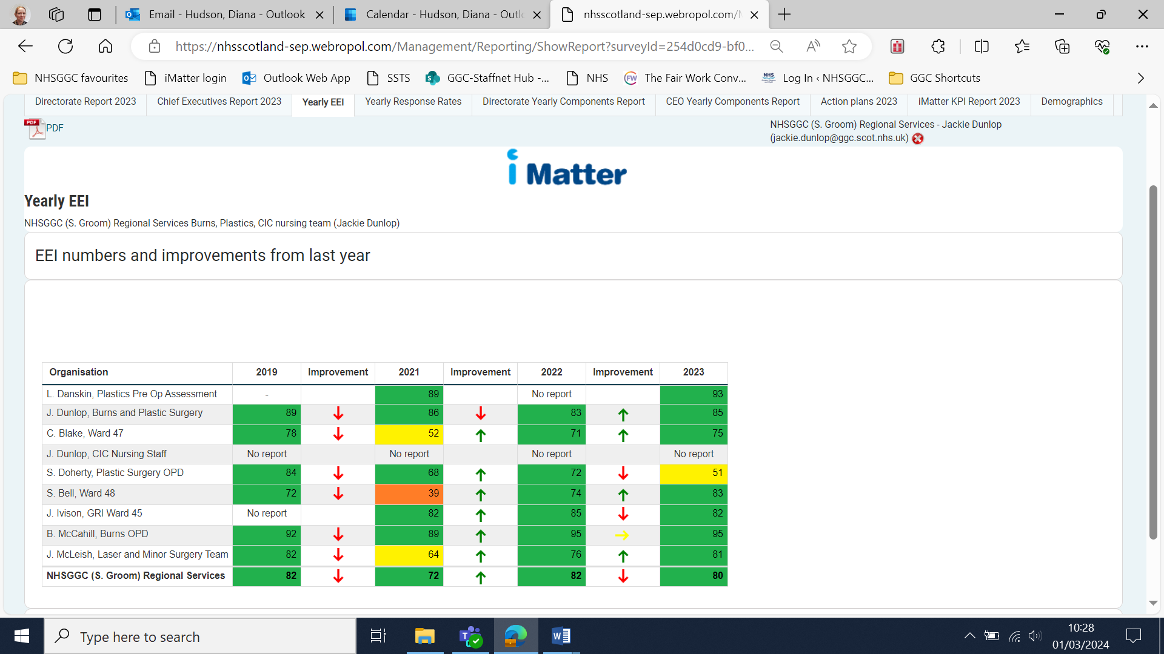

The overall EEI score for the Sub-Directorate is shown in bold at the bottom of the table

Teams within your Sub-Directorate Report will be listed here

The Yearly Response Rates tab will allow you to analyse if the response rates of the teams within your Sub Report have improved, decreased, or stayed the same year on year.

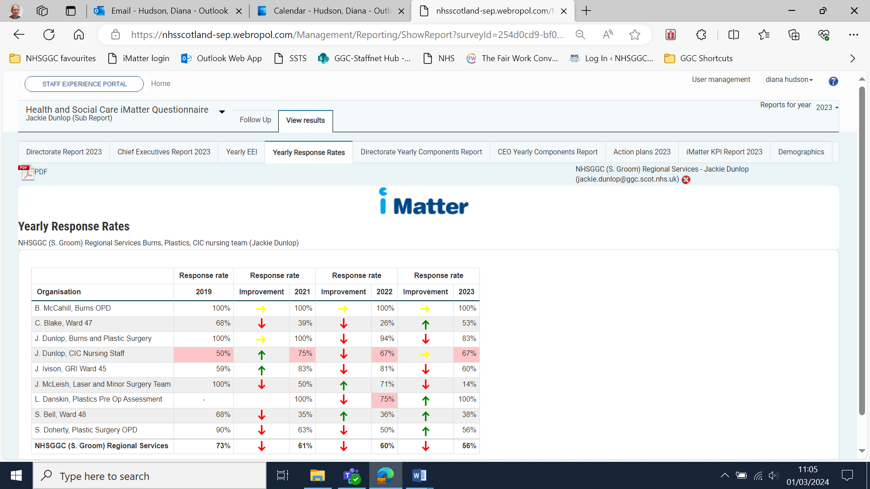

The Yearly Components Report will show the average response score for each question and shown in Green, Yellow, Amber or Red.

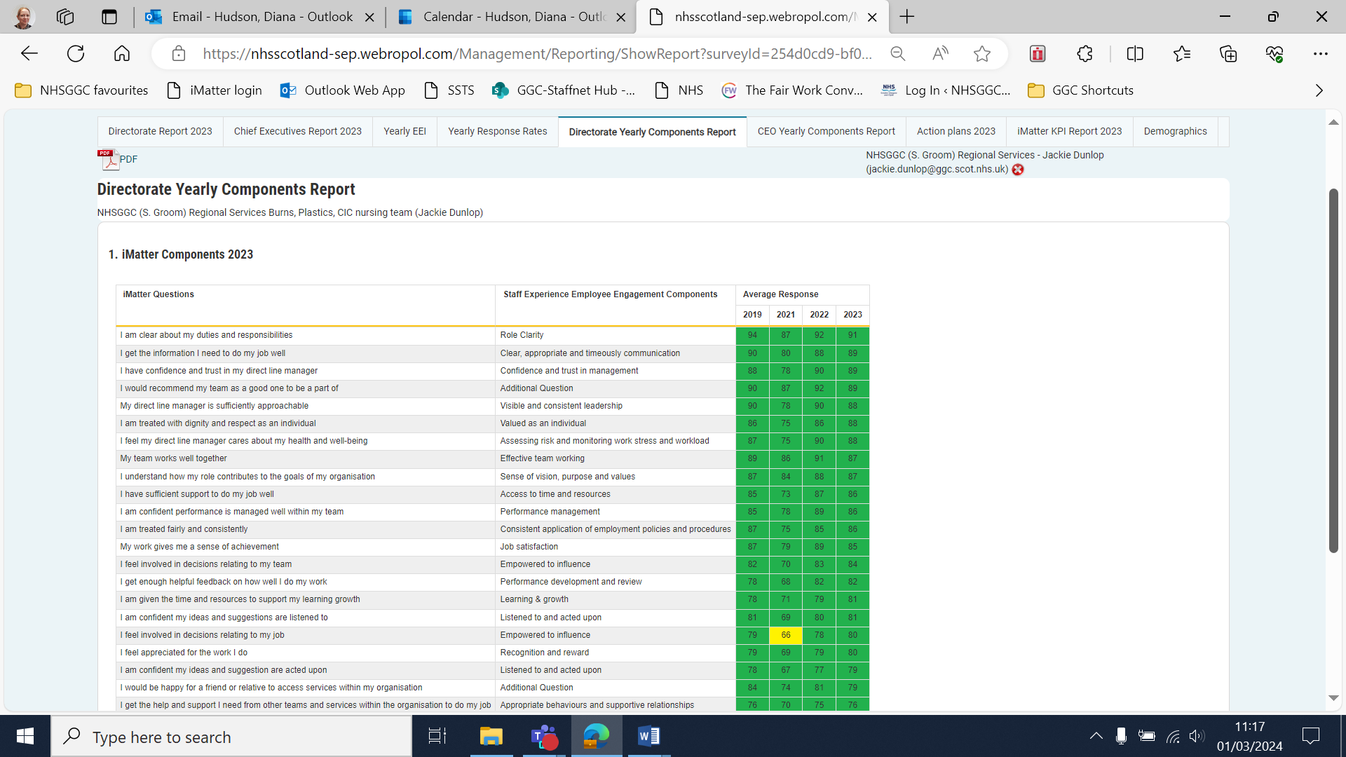

The Action Plan tab will show which teams within your Sub Report have completed their Action Plans within 8 weeks (the timescale associated with the iMatter Action Planning Key Performance Indicator (KPI). If the Action Plan was uploaded within 8 weeks, it will show as 100%, and if the Action Plan was not uploaded within the 8 weeks, it will show as 0%.

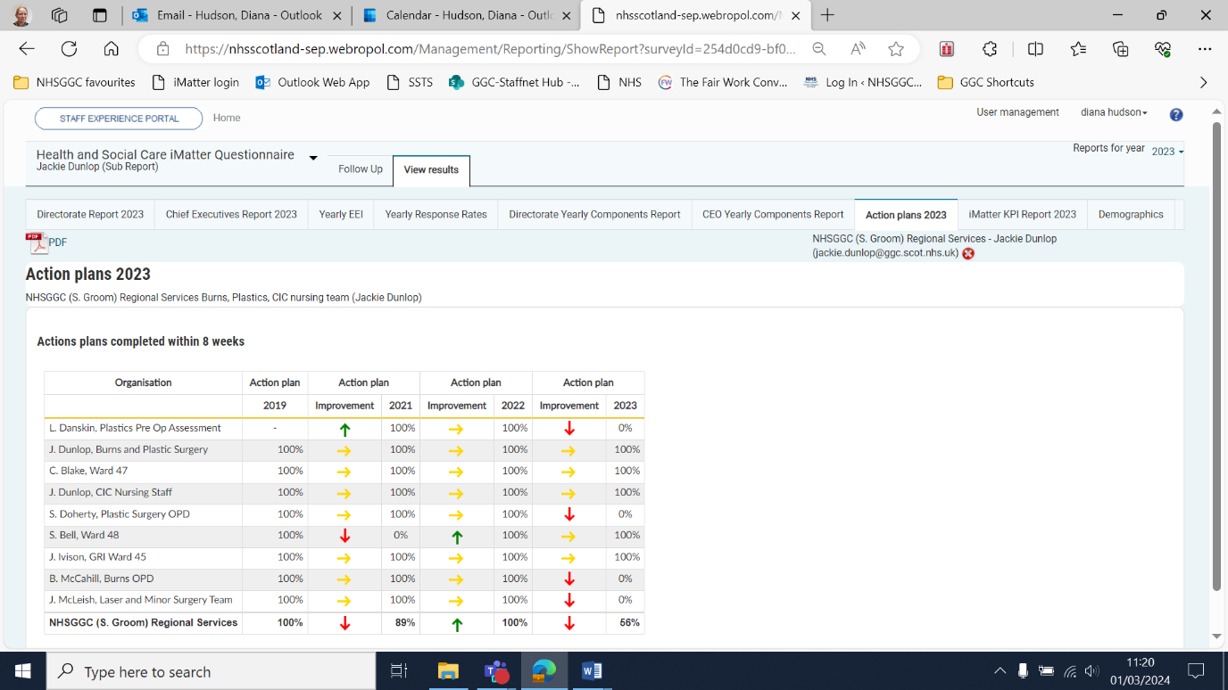

The iMatter KPI Report will show the response rates, EEI score, and if an Action Plan has been uploaded (within 8 weeks) for each of the teams in your Sub Report. Where ‘no report’ is shown, the team did not achieve the required response rate in order for a team report to generate, therefore no EEI score is available.

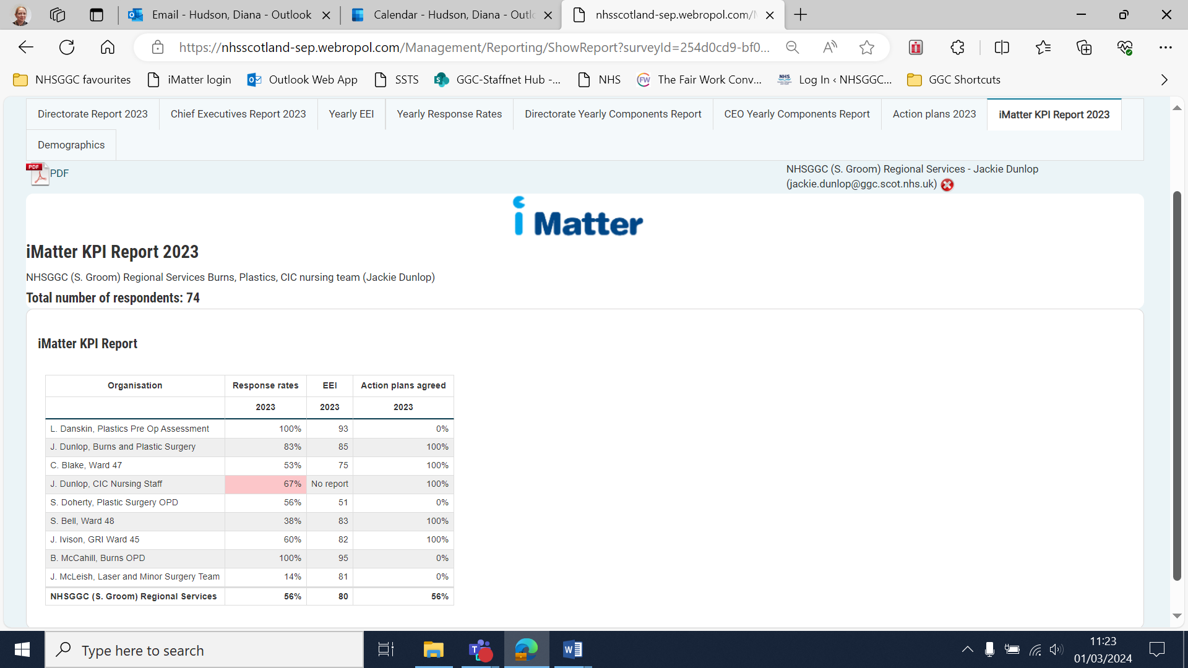

Key Points to note for Sub Reports:

* Teams can appear in more than one Sub Report
* A manager can only be assigned one Sub Report, however different managers can be set up with same Sub Report, where there is an appropriate business need
* Sub Reports can be built for a number of levels, so could cover a service, site, Sub-service etc.
* Can be changed at any time – for instance, as Sub Report managers change, or you become aware of additional reports which require to be built

Should you have any questions about Sub Reporting, please contact the NHSGGC iMatter mailbox at [ggc.nhsggc.imatter@nhs.scot](mailto:ggc.nhsggc.imatter@nhs.scot)