Patient Information Sheet

7T MRI Image Optimisation

**Study Title: Image Optimisation for 7T MRI Research Studies**

You are being asked to take part in a clinical research study. Before you decide it is important for you to understand why the research is being done and what it will involve for you. Please take time to read the information sheet carefully and discuss it with others if you wish. Please ask us if there is anything you are unclear about or if you would like more information. Take time to decide whether or not you wish to take part.

**What is a 7T MRI scanner?**

Since the 1970s, magnetic resonance imaging (MRI) has been shown to be a safe diagnostic imaging procedure. 1.5T scanners are now standard diagnostic tools used within the clinical service, with 3T systems introduced for more specialist clinical imaging. Across the world there are about 50 centres using ultra-high field (7T-11.7 T) scanners for human imaging. Currently such use is for scientific and clinical research only.

**Is a 7T MRI scanner safe?**

The 7T scanner at Queen Elizabeth University Hospital is not currently CE Marked, which means that it can only be used in a research setting with appropriate Ethics approval. The purpose of CE Marking is to show that the equipment complies with the relevant European health, safety and environmental protection legislation. The scanner has been built and tested in accordance with this legislation. In addition, recent Health Protection Agency and European (ICNIRP) advice has stated that field strengths up to 8T can be safely used as long as the participant is aware of the possibility of dizziness when moving into the MRI scanner.

**What are MRI coils?**

A coil helps the MR machine gather high-quality images of a specific body part and it is essential to generate images. **No coils = No images!**

During an MRI scan a radiofrequency is transmitted into your body. The coil acts as an antenna to receive the radio frequency signal coming out of your body and transmit that data to a computer which then generates images.

### Coils are designed for each body part. For example, in a spine scan, you might lie on top of a coil and not even know it’s there. Other coils are flexible, wrapping around the body part to be scanned and are held together with Velcro. You might get one of these coils if you are getting an MRI of the hand, wrist, shoulder, abdomen, or pelvis.

Most of our 7T imaging currently involves brain coils. These coils look like plastic football helmets – see below:

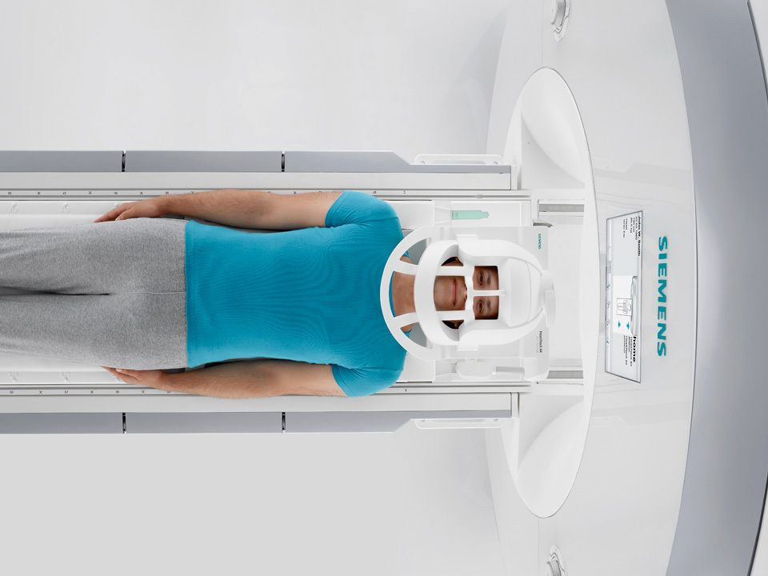

Any coils that we are testing will replicate those developed elsewhere and are for local use only. Coils will have been tested on phantoms (a test object filled with a liquid or a gel that will give a calibrated MRI signal/image)and have undergone mandatory tests by NHS clinical physics prior to approval for testing in volunteers or patients.

**What are MR sequences?**

An **MRI sequence** is a number of radiofrequency pulses and gradients that result in a set of images with a particular appearance. In clinical and research MRI, it is usually hydrogen atoms that are used to generate a detectable radio-frequency signal to map the location of water and fat in the body. By varying the parameters of the pulse sequences, different contrasts may be generated between tissues. For example, difference sequence protocols can be used to optimise tissue contrast or signal localisation.

However by using specially designed coils and sequences, other nuclei such as Carbon, Fluorine, Phosphorus etc can be used for MR imaging.

Safety testing (as specified above) will be conducted prior to testing in volunteers and patients.

**What is the purpose of this study?**

Our research team has considerable experience of conducting research studies using 1.5 and 3T MRI imaging. However, the 7T MRI unit at the Imaging Centre of Excellence (ICE) on the Queen Elizabeth University Hospital campus is relatively new. We have been working hard to gain experience of 7T imaging by conducting feasibility, pilot and quality assurance studies to optimise the images that we generate.

At this point our aim is to establish good image quality with protocols that have often been tested and run in human participants in other 7T centres. We aim to extend these protocols to relevant patient groups. In some cases, we will test new coils or new MR sequences.

**Why have I been invited to take part?**

You have been invited to take part because you responded to a recruitment poster or were approached by a member of your clinical team because the study is related to your health condition. Your involvement will allow us to develop our imaging protocols to make sure that the quality and reproducibility of MRI scans are as good as possible before the actual study begins.

**Do I have to take part?**

No, it is up to you to decide whether or not to take part. If you do decide to take part you will be asked to sign a consent form, and given a copy to take home. If you decide to take part you are still free to withdraw at any time and without giving a reason.

**What will happen to me if I take part?**

When you come for your scan, we will discuss the study with you and if you want to take part you will be asked to sign a consent form. A member of the research team will also take you through a pre-scan checklist to make sure that it is safe for you to enter the scanner. Once you have been approved to enter the scanner you will be asked to change into a gown and taken into the MRI room.

Once in the MRI room, you will be positioned on the table and the coil will be placed around your head. The table will then move into the scanner, and the scan will begin.

You will be given earplugs or headphones to reduce the noise generated by the machine to an acceptable level. Some participants may find the process of an MRI scan potentially claustrophobic and or it may cause discomfort. However you will be monitored throughout and will be able to communicate with the research team via intercom should you wish to stop at any time.

In some cases, we may need to repeat the MRI scan to check if the technique gives the same results each time. The specific details of the scan which we would like you to have are provided at the end of this document.

**Do I need to do anything before the scan?**

There is no preparation required on your part before having the scan.

**What are the risks involved in participating?**

If you have any implants or devices in or on your body or any tattoos above the elbow then you will not be allowed to take part in this study. This is because the scanner is a powerful magnet and uses radiowaves, and implants could move or heat up. Similarly, there is a risk that the pigment used in tattoos could heat up during scanning. You will be taken through a safety checklist prior to entering the scanner room to determine if it is safe for you to participate. A copy of the checklist is attached at the end of this document, and we would ask you to read through it and contact Dr John Foster on 452 4218 before your scan if you answer “yes” to any of the questions, or if you have any concerns. It is very important that you answer the safety checklist honestly and that you seek clarification for anything which you do not understand. The safety checklist will be treated confidentially.

**If you have had surgery of any kind or are unsure of any of the answers, it is not a problem, but we will err on the side of caution and will not scan you.**

It is possible that you may feel dizzy when moving around in the scanner room. This is completely normal, and the feeling will pass when you lie down on the scanner bed or leave the scanner room. There are no known long-term effects from exposure to the magnetic field used in 7T MRI.

**What are the benefits in my participation?**

You will not receive any direct benefit from the scan, but the information that we get may improve the quality and amount of information that can be obtained from scans in subsequent clinical trials, and hence help to improve treatment of patients in the future.

**Will my taking part in this study be kept confidential?**

All information that is collected about you during the course of the research will be kept strictly confidential. All images collected from the scans will be anonymised before any analysis is carried out on them, therefore you will not be able to be identified from the images in any way. Your personal information will be kept on file and stored in a secure place at the Imaging Centre of Excellence.

**How will the images from my scan be used?**

Your images will help us to decide what we need to do to make sure that the scans we use in future research studies are as good as possible. We may also use your images to test analysis software. Your images may be used in scientific presentations and for teaching purposes, but no information will be used that would allow you to be identified.

**Will my GP be informed?**

We do not intend to routinely contact your GP. However, you may choose to discuss your involvement with your GP yourself.

Because 7T MRI is not in clinical use, your images will **not** always be reviewed by a doctor. However, sometimes imaging staff will pick up what is called an ‘incidental finding i.e. something that is unrelated to your illness, and is discovered unintentionally. As MRI techniques improve, unexpected brain abnormalities, which are not causing symptoms, will be discovered in some patients. Incidental findings are common, and are more common in older people. But the vast majority of incidental findings are of no consequence to the patient, and will never cause any problems.

If an incidental finding is detected, you may be contacted for further imaging on a clinical MRI scanner and you may be referred for further investigation within NHSGGC. Your GP will be sent the results of any diagnostic imaging that is conducted.

**What will happen to the study results?**

You will not be informed of the results of your scan. The results of the analysis will be used to improve our techniques for use in larger clinical studies initially, and hopefully to provide an improved service to patients in the future.

**What if there is a problem?**

This study is sponsored by NHS Greater Glasgow & Clyde. The sponsor will be liable for negligent harm caused by the design of the trial. NHS indemnity is provided under the Clinical Negligence and Other Risks Indemnity Scheme (CNORIS). If you have any complaint about the way you have been dealt with during the study you should discuss this with the research team in the first instance. In the event that something does go wrong and you are harmed during the research study there are no special compensation arrangements. The normal National Health Service complaints mechanism is also available to you and the contact telephone number for this is 0141 201 4500.

**Who has reviewed the study?**

The Programme of development work has been reviewed and approved by the West of Scotland Research Ethics Committee 3 and NHS Greater Glasgow & Clyde Research and Development Department. Each individual development study is reviewed and approved by the Clinical Research Imaging Facility Approval Group.

Thank you for taking the time to read this information sheet. If you have any questions or would like some more information, please feel free to contact a member of the research team and discuss it with them.

**For further information on the study, please contact:**

Dr John Foster

Consultant Clinical Scientist (MRI)

Queen Elizabeth University Hospital

Tel: 0141 452 4218

Email: [johnfoster2@ggc.scot.nhs.uk](mailto:johnfoster2@ggc.scot.nhs.uk)

**For independent advice on participating in research, please contact:**

Dr Ruth Hamilton

Consultant Clinical Scientist

(Paediatric Physiological Measurement)

Royal Hospital for Children

Tel: 0141 452 4217

Email: ruth.hamilton@glasguk

**IMAGE OPTIMISATION FOR 7T MRI RESEARCH STUDIES**

**Details of MRI Scan – 7T**

*Specify here if fMRI etc.*

**Area of Body** Brain ……………………………...

**Expected Total Time for Visit** ……………………………...

**Expected Time in Scanner** ……………………………...

**Further Information**

*The text in this section will be reviewed by the CRIF Scientific Access Group for each optimisation project. The following text is an example for a 7T brain study, and has been adapted from the UK 7T Network “travelling heads” study documentation.*

We would like to invite you to participate in a study which aims is to introduce new scanning sequences and homogenise protocols across all 7Tesla MRI scanners in the UK7T network (Glasgow, Cambridge, Cardiff, Nottingham and Oxford). Not all parts of the procedures described below may be used for all scanning sessions and the researcher conducting the study will be able to tell you which parts of this information sheet are directly applicable to you.

When you come for your scan, you will lie on you back on the scanner bed. We will place a coil over your head to allow us to take images of your brain, and will then move you head-first into the scanner.

During some of the scans we may ask you to perform a series of tasks. These tasks may involve looking at visual information, listening to sounds through a set of headphones or responding to external stimulus such as heat applied to you hand or arm.

It is important that you stay completely still during your scan (unless we instruct you to move as part of a task) since any movement will cause blurring in the images. The radiographer will be in contact with you via intercom throughout the scan, and you will be given a buzzer to press if you wish to stop the scan at any time.