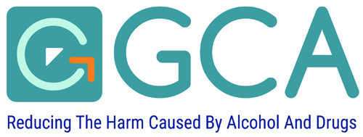

Application for ABI Training for Trainer course

PERSONAL INFORMATION
Course Dates
Name:
Current Role:
Time in Role:
Contact Address:
Post Code:
Contact Number:
Email:

Course Criteria
 | Yes | No
Have attended Alcohol Awareness Training, or must work in the alcohol field, and have an understanding of units
an experienced trainer or facilitator
able to attend both full days of the training
Agree to deliver at least 2 ABI Practitioner training courses within the next 12 months
Have your Line Manager’s approval to both, attend and fulfil the acceptance criteria stated above

Any Other Supporting Information:

Line Manager Details
Name:
Contact Address:
Post Code:
Contact Number:
Email:

Thank you for taking the time to fill in this application

Please return by email to

abi@glasgowcouncilonalcohol.org

