Active Staff Walking Challenge March 2022

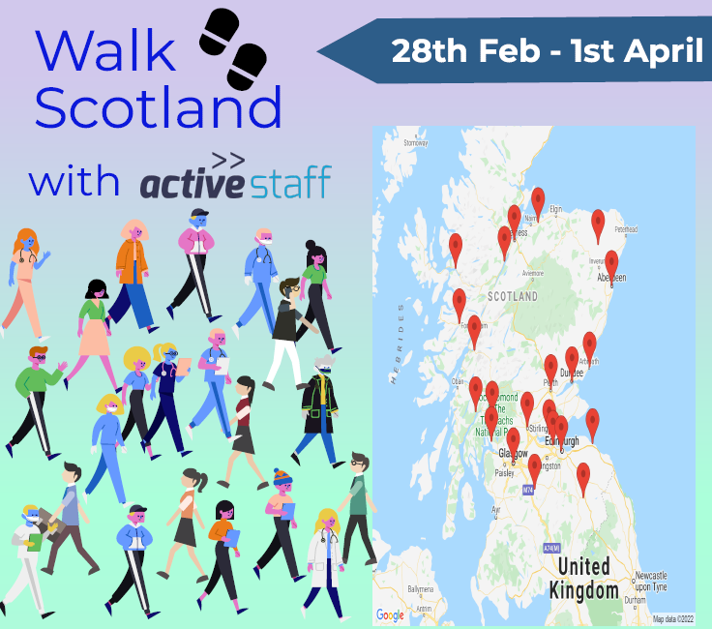

Background
The Active Staff Programme was set up to protect and promote health in the workplace by providing a range of free opportunities for all NHSGGC staff to engage in Physical Activity.
We want equitable access by all staff groups regardless of their fitness level, shift pattern or protected characteristics
Engaging in physical activity not only supports good physical health but also good mental health.

Introduction
Walking is simple, free and one of the easiest ways to get more active, lose weight and become healthier. Being outdoors can help guard against key health issues such as depression and heart disease. It can also be fun. It can connect people to nature and to each other.
The Walking Challenge was promoted to staff across NHS Greater Glasgow & Clyde and the Local Health and Social care Partnerships. The challenge was promoted to staff through the Core Brief two weeks in advance of the start date of 28th February and encouraged staff to register and form teams of up to five people.

The Route
The route chosen from https://worldwalking.org/ encouraged staff to walk virtually around Scotland starting at Dunbar and heading on the journey of 1,564,377 steps before finishing in Edinburgh hitting several milestone achievements along the way.

Staff Participation
The total number of challenge participants was 832 making up 189 teams with 51 teams completing the distance.
Steps | Kilometres | Miles
174041995 | 132, 620 | 82,406
The total steps added and distance covered by staff was:

This is the equivalent of walking approximately three times around the world!

Challenge competitions
Throughout the four weeks, staff were encouraged to enter three competitions with the winning team receiving £20 of Love to Shop vouchers for each team member:

The three challenges comprised of:

- A ‘selfie’ competition where staff had to send in pictures of themselves when walking.

- An ‘All Ears’ competition where staff could enter a favorite tune or sound that motivated their walk.

- A competition for the best team name best team name with an explanation of why they chose that name

All teams were entered into a final random prize draw at the end of the challenge as a thank you for taking part.

Feedback
- 61% of walkers set themselves goals and/or targets
- 72% achieved their goals and/or targets

What did you hope to achieve by doing the Walking Challenge?

- Renewed energy and the motivation to keep going, especially as I am still 'home working'
- Achieve my daily step count of 10,000 steps
- Increase activity
- More connection, more time outside
- Comradery with a remote team

Is there anything we could have done/do differently and are there any improvements you would like to see for your next Active Staff Walking Challenge?

- More opportunities to share selfies, tips, routes, etc. with other teams. This helps to bring the challenge to life.
- More notice of when the next challenge will be so there is time to get a team together and plan.

- Would like to see a list of finishing places for the teams and when they finished the challenge
- Could it be clearer that there is no ‘winner’
- I think getting buy in from management / senior staff members and seeing them not only take part, but actually proactively promote more active time during the working day (for example -promoting time away from desk at lunch times for example to take a walk etc.)

Did you enjoy the Walking Challenge?

99% said yes they enjoyed taking part and would recommend to a colleague, here are some of the responses why they said they enjoyed.

- Getting out into the country with plenty of fresh air. Our team worked hard together which bonded us.
- It encouraged me to go out walking even if I wasn’t really in the mood. I was always glad I did go out. There was also another team from our department taking part so there was a bit of friendly rivalry. We won. :-)
- Linking in with some my colleagues even though we are WFH
- Encouraged to go out waking whilst at work
- That the challenge made me think about being more active and moving more... it gave me an excuse to get away from the laptop...
- Great team building initiative but focused around being more active (double whammy]

- Really motivated to do more steps (especially when the weather was not too good). Good to do these while working from home, as I seem to take less breaks and move less while working from home.
- I walked every day during the challenge and since the challenge stopped. I am slipping into old habits so time for another challenge I think!

Conclusions

- Staff/participants unaware that walking challenge is not a competition
- Communication needs to take place more than two weeks prior to challenge.
- Communication needs to be clear, succinct and have a call to action
- Communication needs to be more diverse, using different methods to make information and participation accessible to all
- The challenge is an enjoyable activity supporting better health outcomes for staff mentally and physically.
- The challenge should continue to be offered biannually

Future Plans

- A new challenge will take place in September 2022
- Diversify & increase communication channels to make challenge more accessible to all staff and increase participant levels
- Give a minimum of four weeks’ notice via communication channels. These to include; Core Brief, Social Media, local HSCP reps, internal distribution lists, Healthy Working Lives groups, internal forums and other opportunities as they arise
- All communication to be clear and succinct and have a call to action.
- Make sure Walking Challenge promoted as a challenge to become more active and have fun with colleagues and not as a ‘challenge’ where the highest number of steps wins.

Further Information

Active Staff link | Active Staff - NHSGGC
Active Staff email | activestaff.legacy2014@ggc.scot.nhs.uk
Staff Health Strategy Lead | Debbie.Nelson@ggc.scot.nhs.uk
Active Staff Coordinator | Craig.Paxton@ggc.scot.nhs.uk

