**National Smile Month 16th May – 16th June 2023**

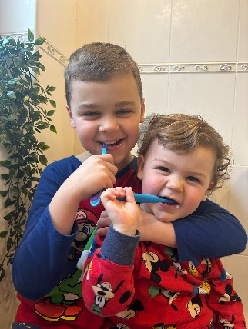**Tuesday 16th May**

Today is the start of National Smile Month. NHS GGC Oral Health Improvement Team is campaigning throughout this month promoting a healthy mouth means a healthy body.

#smilemonth #Childsmile #shareyoursmile @cdo_childsmile @NHSChildsmile

**Wednesday 17th May**

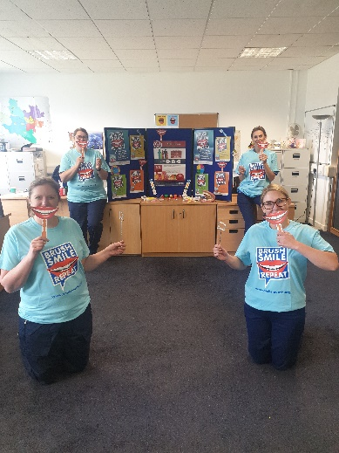

National Smile Month is the perfect chance to share your smile and promote the importance of having a healthy mouth.

Sharing a smile can be such a powerful thing to do. It can be a sign of friendship, trust, togetherness and love. It’s also a sign of good health.

#sharingasmile #smilemonth #NHSGGC #childsmile

**Thursday 18th May**

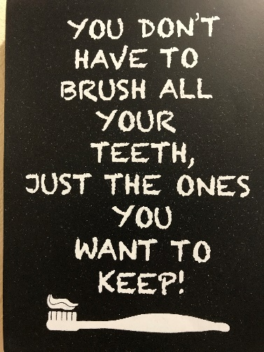

During National Smile Month, we are promoting four key messages for better oral health:

* Brush teeth for two minutes, last thing at night and one other time during the day, with a fluoride toothpaste.
* Clean between your teeth every day.
* Cut down how much and how often you have sugary foods and drinks.
* Visit a dentist regularly.

**Friday 19th May**

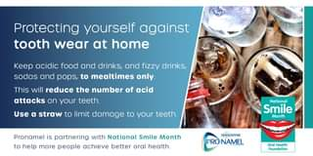

Oral Health top Tip- If you can’t resist the temptation of drinking sugary or fizzy drinks… then use a straw to attempt to minimise the damage to your teeth and keep to mealtimes. Plain milk and water are the safest drinks for your teeth. @CDO_Scotland #Childsmile #SugarSmart

**Monday 22nd May**

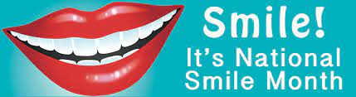

**Tuesday 23rd May**

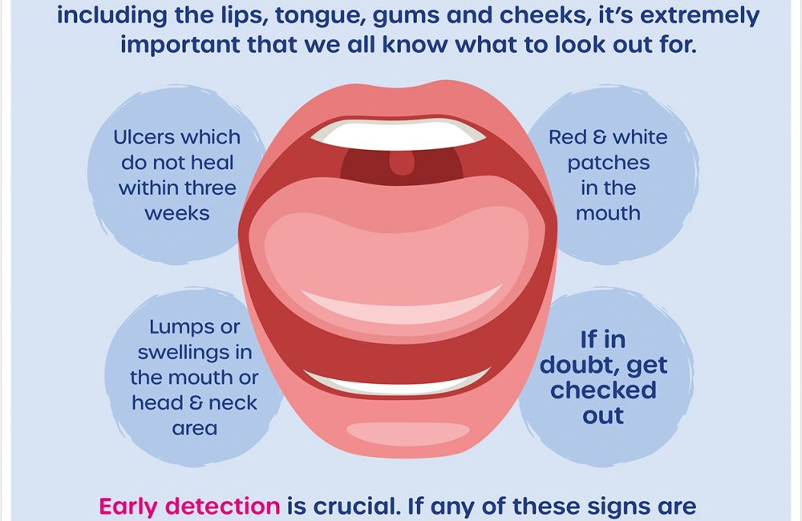

When brushing your teeth and gums don’t forget to clean your tongue. Healthy tongue should be pink and symmetrical in shape and size. Most of us don’t look inside our own mouths. It is important to have a look at your own tongue and soft tissues regularly. Seek advice if you have any ulcers, sores or any changes that last for more than 2 weeks.

#smilemonth #mouthcancerfoundation #NHSGGC

**Wednesday 24th May**

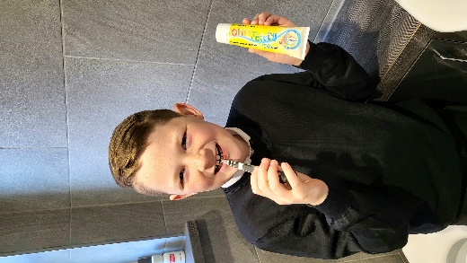

Terrific Tuesday Toothbrusher today is Cameron, age 9. Brush your teeth at least twice per day, especially at night-time. Keep up the good work Cameron!

#Childsmile #SmileMonth #brushtwiceaday #2minutes #NHSGGC

**Thursday 25th May**

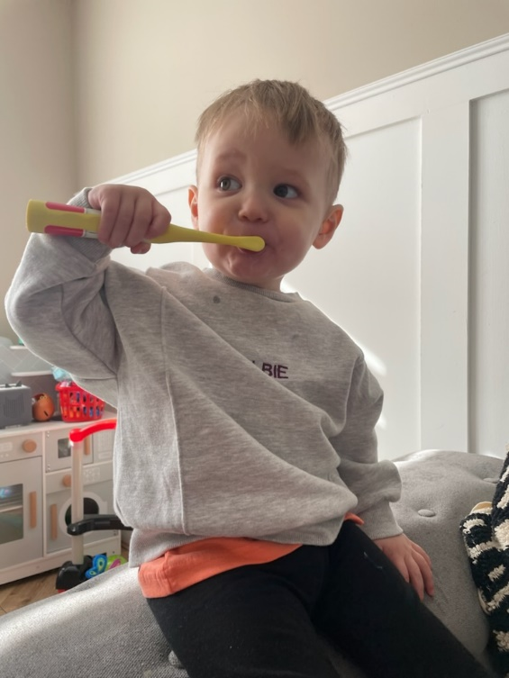

Good oral health should be established in the child's earliest years, even before the first tooth appears.

* Children should be assisted to brush their teeth as soon as they erupt.
* Brush teeth at least twice a day for at least two minutes with fluoride toothpaste.
* Replace the toothbrush every three months or when the bristles start to splay out.
* Rinse the toothbrush thoroughly after every use and store upright in a clean dry place.
* Children should be encouraged to spit out excess toothpaste and not rinse with water after brushing. This helps the fluoride toothpaste work harder to strengthen the teeth.
* Children who are unable to brush their teeth unaided should be assisted to do so, until about seven years of age.

There are a team of people ready to help you look after your children's teeth. You can contact the Childsmile Team on 0141 201 4218.

**Friday 26th May**

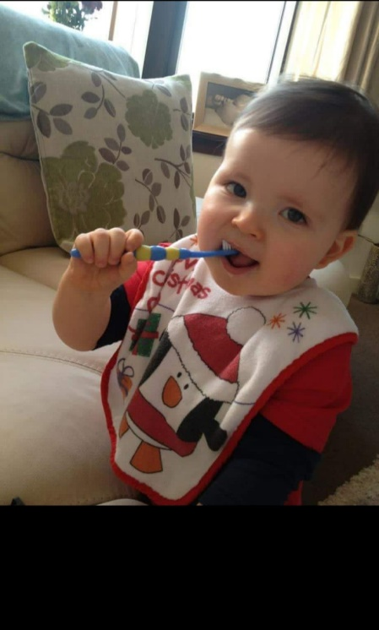

Childsmile is a Scotland-wide programme designed to improve the oral health of children in Scotland. #Childsmile #brushtwiceaday #spitdontrinse

**Monday 29th May**

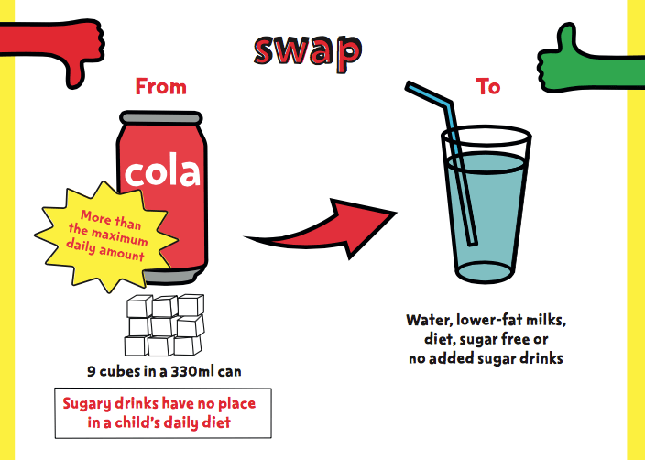

Oral Health top tip - To Keep your teeth healthy, reduce your frequency and consumption of sugary snacks and drinks and keep to meal times. @CDO_Scotland #Childsmile #sugarsmart #NHSGGG

**Tuesday 30th May**

Fun Facts

It takes 43 muscles to frown but only 17 to smile.

Everyone loves the quote “laughter is the best medicine,” and have experienced the benefits of smiling and laughter. But did you know that the simple act of smiling can boost your mood and even your immune system?

Smiling is infectious #smiles

 [](https://www.bing.com/images/search?view=detailV2&ccid=Z1my/dqp&id=734C506C730A76165741680780F4AFBD086753F2&thid=OIP.Z1my_dqp5AFH6WmBQziLTQHaHs&mediaurl=https://i.ebayimg.com/images/i/222077111380-0-1/s-l1000.jpg&exph=1000&expw=963&q=happy+faces&simid=608022701356420776&selectedIndex=63)

**Wednesday 31st May**

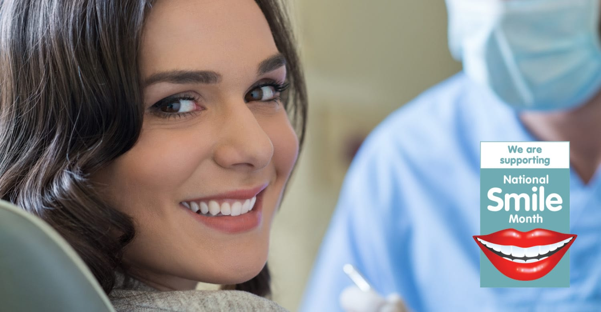

Your local Childsmile team is happy to help you find your nearest NHS dentist. NHS dental treatment in Scotland is free up to and including the age of 17. You should visit the dentist at least once per year. #NHSGGC #Childsmile #smilemonth

**Thursday 1st June**

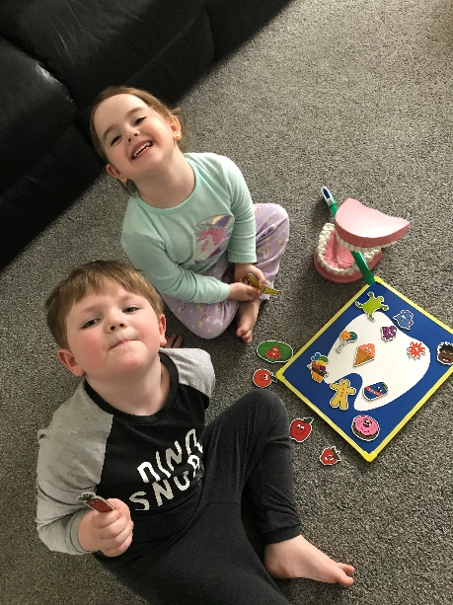

Oral Health should be fun. Good way to engage with children is to incorporate oral health games. This helps with getting the key messages across about toothbrushing, diet and dental attendance.#NHSGGC #Childsmile #smilemonth

**Friday 2nd June**

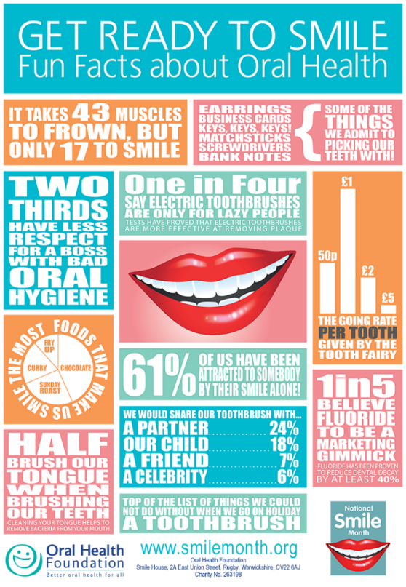

**Monday 5th June**

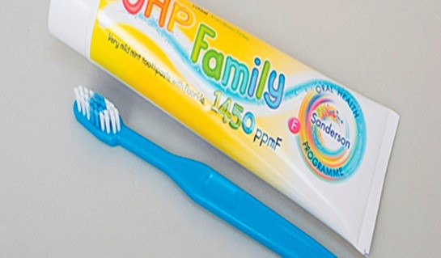

Children aged 3 years and above should use a pea-sized amount of at least 1000-1450ppm fluoride toothpaste. They should toothbrush for 2minutes 2xdaily and spit don’t rinse.

Adults should assist with toothbrushing until the child is about 7 years old. #NHSGGC #Childsmile #smilemonth

**Tuesday 6th June**

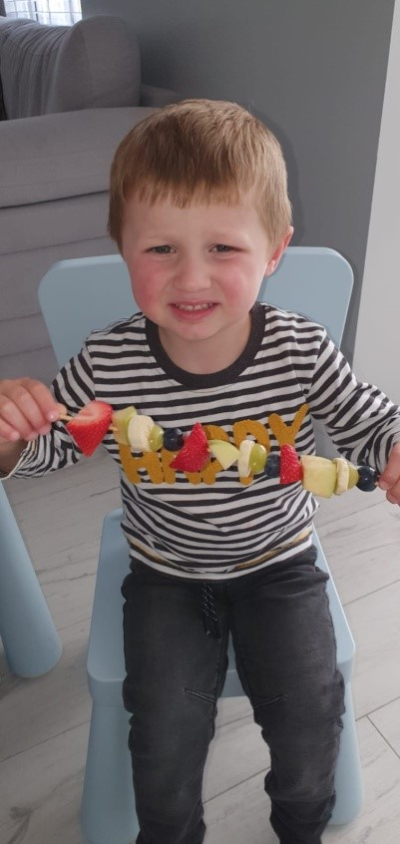

To reduce tooth decay keep sugary snacks and drinks to meal times. Try fruit kebabs as a healthy snack alternative.

#Fruity Friday #healthychoices #Childsmile @cdo_Scotland

**Wednesday 7th June**





National smile month is the perfect time to evaluate your oral health, improve your routine and help others in your household do the same. If you or someone you know has got into some bad habits, it’s never too late for you to make a positive change and improve your oral health. #NHSGGC #Childsmile #smilemonth

**Thursday 8th June**

Be Mouthaware, It is important that you are aware of how mouth cancer can present itself. Early detection is key – Check for Mouth Ulcers which do not heal in three weeks, red and white patches in the mouth and unusual lumps or swellings in the mouth and neck area. #MouthCancerAction#NHSGGC #mouthcancer #smilemonth

**Friday 9th June**

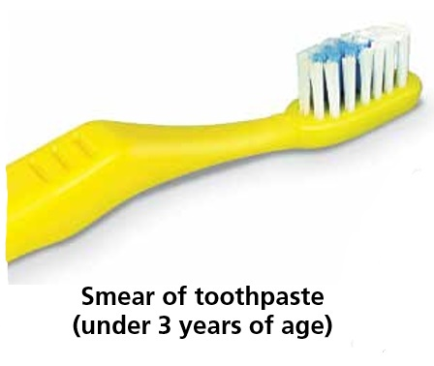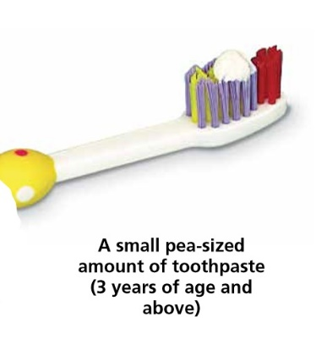

One in four (25%) adults do not brush twice a day with a fluoride toothpaste. It is best to brush your teeth last thing at night, before you go to bed. You should brush your teeth for two minutes.  That’s all it takes to brush your teeth effectively. Whether you use a manual toothbrush or an electric one, it’s important that you take the time to cover the surfaces of your teeth and all areas of your mouth. #NHSGGC #Childsmile #smilemonth

**Monday 12th June**

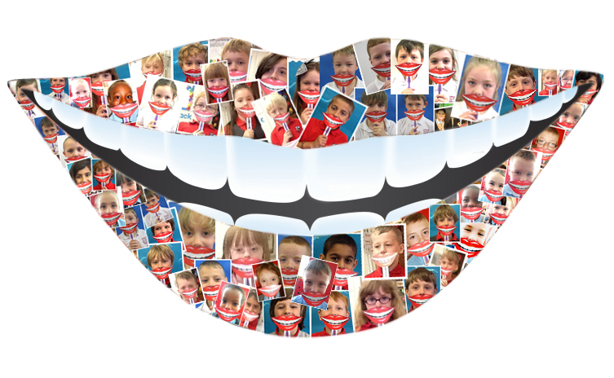

We believe that everybody deserves a healthy smile. A person’s oral health is a crucial part of their overall wellbeing

**Tuesday 13th June**

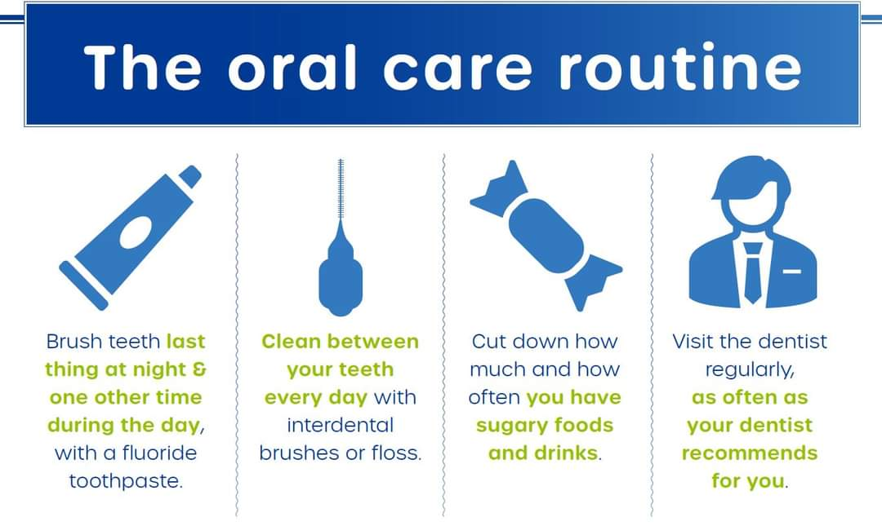

The mouth is one of your greatest assets.

It helps you to communicate your thoughts and emotions, and gives you extra confidence in your relationships, social life and career.  Your mouth is also important for speaking, eating and drinking and breathing.

**Wednesday 14th June**

It is recommended that children should go to the dentist with their parents as soon as possible. You should then take them regularly, as often as your dental team recommend. This will let them get used to the noises, smells and surroundings and prepare them for future visits. The earlier these visits start, the more relaxed the children will be.

**Thursday 15th June**

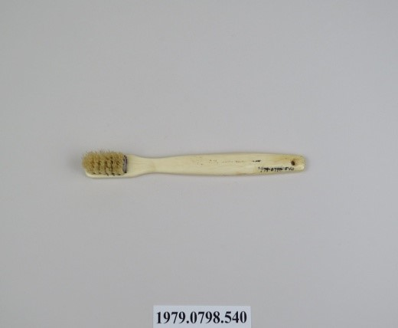

The very first tooth brush was made out of animal bone. The bone had small holes drilled into it where bristles were placed. Toothbrush tip - Replace your toothbrush every three months or when the bristles become splayed, choose a small headed toothbrush medium textured bristles. Toothbrushes can be recycled, to find out where your nearest public recycling centre is visit www.terracycle.com #NHSGGC #Childsmile #smilemonth

**Friday 16th June**

‘Your mouth is a mirror to your body it reflects your health and your general wellbeing’ #NHSGGC #Childsmile #smilemonth