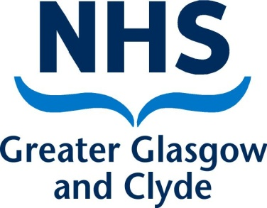

**Additional Information about Pregnancy Screening Tests**

Please read this in conjunction with “You’re pregnant! Scans and tests – NHS Health Scotland booklet. [You're pregnant! Scans and tests (healthscotland.com)](http://www.healthscotland.com/uploads/documents/30532-__You're%20pregnant!%20Scans%20and%20tests-July2021-English.pdf)

First trimester screening for Down’s syndrome is made up of a combination of tests to find out how likely it is that your baby has Down’s syndrome. This is called **"Combined Ultrasound and Biochemical" (CUB) screening**. It's called the combined test because it includes an ultrasound scan with a blood test. One of these tests is to measure the level of Pregnancy Associated Plasma Protein A (PAPP-A) in your blood. PAPP-A is a protein that is produced by the placenta in pregnancy.

Even if your risk of having a baby with Down’s syndrome is low, a low PAPP-A result may be identified as part of your combined test. Studies have shown that low PAPP-A levels may be associated with low birth weight babies and premature (early) birth. If the PAPP-A level is low, we will offer you extra ultrasound scans to check the growth of your baby. If your baby’s growth is normal and you go into labour on your own you can choose low risk care after a discussion with your consultant.

Unfortunately in some instances, we are unable to perform the CUB screening test. This may be because of the position of your baby at the booking scan or because your pregnancy is too far advanced for this particular test. As you will have consented to the combined screening test which is now not possible, we will offer you a further test for Down’s Syndrome screening from 15 weeks of your pregnancy. This will be a blood test only and will not provide a result for the PAPP-A level.

**Please be aware that we do not offer PAPP-A testing on its own as it is part of the combined tests used in Down’s syndrome screening**.

If you have any questions please speak to your midwife.

Review Date; November 2024