

**NHS GGC Diagnostics Directorate**

# Vitamin B12: Diagnosis of

**Deficiency in Adults**

**SCOPE:**

This guidance gives advice on how to treat adults who are at risk of B12 deficiency or who are known to have deficient/insufficient levels of vitamin B12.

**KEY POINTS:**

1. The vast majority of patients with a low serum Vitamin B12 level do NOT have Pernicious Anaemia (PA). However PA is an important diagnosis NOT to miss.

1. Metformin, proton pump inhibitors (PPIs), and other drugs discussed in the full guideline are causes of a low serum Vitamin B12. They do NOT require B12 replacement unless B12 deficiency anaemia or neuropathy is suspected.
2. As of 14/05/24 NHSGGC assesses B12 deficiency using an active B12 (holotranscobalamin) assay. This has the advantage of not being affected by hormone levels and inflammation.

**WHAT TO DO WITH A LOW B12 LEVEL**

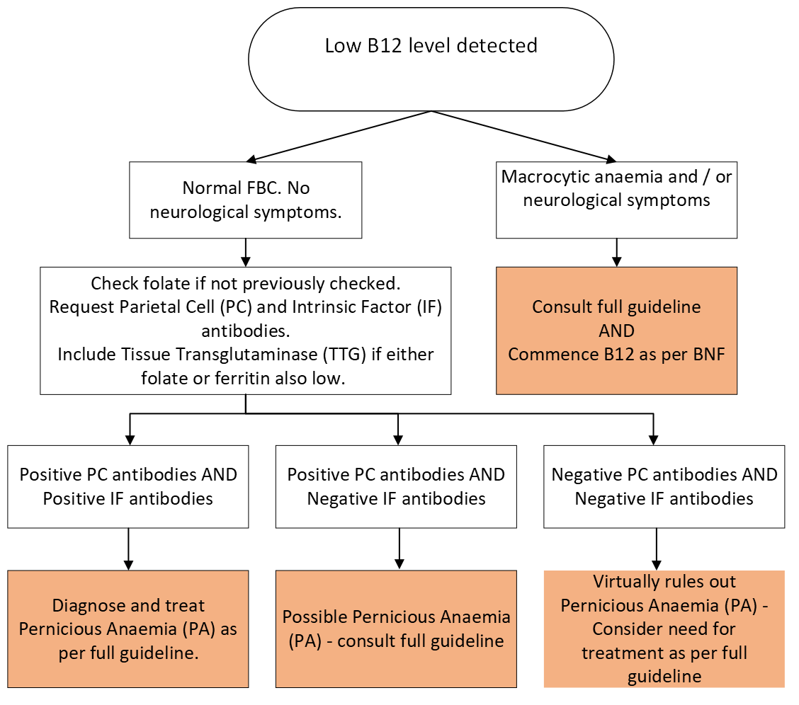

**BACKGROUND:**

Vitamin B12 deficiency can take years to manifest as the body has significant stores of the vitamin. Symptoms of anaemia such as fatigue and lethargy, dyspnoea, faintness, palpitations, headache, tinnitus, anorexia, angina (if the person has pre-existing coronary artery disease) may be present but are not diagnostic. Patients may also present without anaemia. Vitamin B12 deficiency should be suspected if the person reports unexplained neurological symptoms e.g. paraesthesia, numbness, cognitive changes, or visual disturbance.

Low B12 levelspredominantly affect older adults with prevalence rates of around 5% in 65–74 year olds, and more than 10% of people over 75 according to [NICE CKS, Anaemia - B12 and folate deficiency.](https://cks.nice.org.uk/anaemia-b12-and-folate-deficiency)

**CAUSES OF VITAMIN B12 DEFICIENCY / LOW SERUM B12 LEVELS**

* Pernicious anaemia (PA) - (Autoimmune Atrophic Gastritis). Vitamin B12 combines with Intrinsic Factor (IF), which is produced by parietal cells in the stomach, to form an IF-B12 complex, which then allows absorption to take place in the terminal ileum. Pernicious anaemia is an auto-immune disorder which results in reduced production of IF and therefore reduced absorption of B12.
* Inadequate dietary intake of B12 - Vitamin B12 is present in virtually all animal tissues including eggs. Vitamin B12 is not generally present in plant foods, but many foods are fortified with B12 including breakfast cereals, soya drinks, and yeast extracts such as marmite.
* Dietary deficiency is rare in younger people but occurs more frequently in older people living in institutional environments. Individuals adhering to a vegan diet may be at risk of B12 deficiency.
* Intestinal causes e.g. malabsorption, ileal resection, Crohn’s disease.
* Medications e.g. colchicine, metformin, anticonvulsants, long term Proton Pump Inhibitors (PPIs) or H2 blockers may cause low levels which do not require treatment unless there is associated B12 deficiency anaemia or suspected neurological symptoms.
* Folate deficiency per se may cause B12 levels to be low. **Although dietary deficiency is the most common cause of a low serum folate** all patients with combined low folate **and** B12 levels should have a tissue transglutaminase (TTG) level checked (to exclude coeliac disease) regardless of the presence or absence of gastro-intestinal symptoms of malabsorption.
* Recently the syndrome of food-cobalamin malabsorption has been described. In this syndrome patients have a negative Parietal Cell (PC) and Intrinsic Factor (IF) antibody screen. The absorption of vitamin B12 bound to food is impaired but the absorption of free vitamin B12 such as in oral vitamin B12 supplements, is normal. This appears to be related to altered acid levels in the stomach. It is common in the elderly and in those taking antacid therapies. Predisposing factors are as follows:

o Atrophic gastritis, chronic helicobactor pylori infection (HP infection)

o Microbial proliferation, AIDS

o Long term ingestion of antacids or biguanides (e.g. metformin)

o Chronic alcoholism

o Gastrectomy, gastric bypass surgery

o Pancreatic exocrine failure

o Idiopathic (age related)

Food based malabsorption associated with gastric atrophy (age related or associated with long term PPI use) is the likely cause of 30 to 50% of cases of sub-clinical B12 deficiency. The NHSGGC reference ranges for B12 and folate

are as follows:

|  |  |
| --- | --- |
| Serum B12 (active) | >25 pmol/L |
| Serum Folate | 3 - 20 ug/L |

Vitamin B12 deficiency - as defined by serum vitamin B12 levels below the reference - is a common finding; however the identification of significant pathology either underlying or secondary to this deficiency is not.

* The clinical picture is the most important factor in assessing significance of serum vitamin B12 results. Definitive cut off points for clinical and subclinical deficiency are not possible. The levels are not easily correlated with clinical symptoms, although people with active vitamin B12 levels less than 25 pmol/L often have clinical or metabolic evidence of vitamin B12 deficiency.

The new active B12 test measures holotranscobalamin, Vitamin B12 in the form that it is taken up into cells. It has been suggested that it is a better marker of clinical B12 status, It has the advantage of not being affected by other illnesses such as malignancy which can cause spurious elevation of total B12 levels.

An active B12 level of 25-70 pmol/L should be regarded as an indeterminate result indicating possible Vitamin B12 deficiency. For patients with an indeterminate result treatment with IM Vitamin B12 should be started in patients:

* Who are pregnant or breast feeding.
* Who have had surgery likely to induce Vitamin B12 deficiency: gastrectomy, terminal ileal resection, bariatric surgery.
* Who have an irreversible cause of B12 deficiency (autoimmune gastritis etc).
* Who have haematological or neurological symptoms potentially due to B12 deficiency which may deteriorate rapidly (anaemia, ataxia etc).

For patients who have other symptoms investigate other potential causes for their symptoms and if not other cause identified consider a repeat active B12 level at 3 to 6 months.

For patients with no symptoms suggest that they attend if they develop symptoms in future.

The B12 assay is a frequently requested test, generating many results out with the reference range and thus reported as abnormal. Determining the relevance and appropriate management of these results has been highlighted as an area of concern by many GPs locally. Our aim is to provide a simple means of assessing and replacing vitamin B12 which will ensure adequate treatment of those with genuine B12 deficiency or underlying disease whilst minimising the treatment and investigative burden of those with clinically insignificant low B12 levels.

**WHEN TO MEASURE VITAMIN B12**:

It is appropriate to measure serum B12 in the following circumstances. Serum folate should also be measured at the same time:

* **Macrocytosis** (MCV > 100fl). Note: Liver disease, alcohol, smoking, medicationshypothyroidism should also be considered as possible causes of a macrocytosis, especially when anaemia is not present.
* **Unexplained anaemia**
* **Unexplained neurological signs and symptoms** e.g. peripheral neuropathy, visual loss and dementia
* **Severe depression** (especially in the elderly)
* **Gastro-intestinal symptoms** e.g. glossitis, abnormal taste, bowel malabsorption or unexplained diarrhoea.
* Levels should also be monitored in patients who have had surgical resections or radiotherapy to stomach/small intestine including bariatric procedures.
* **Vegan Diet** (long term)
* **Hypothyroidism** - there is a high incidence of hypothyroidism in patients with PA and vice versa.

**WHEN NOT TO MEASURE VITAMIN B12:**

* Tiredness is **not** an indication for serum vitamin B12 assay, but unexplained fatigue limiting activities of daily living may be.

**HOW FREQUENTLY TO MEASURE VITAMIN B12:**

We now no longer recommend repeating B12 levels to confirm an initial low result. Repeat at an interval should only be considered if needed in a patient with an indeterminate result as per guidance in that section. Vitamin B12 analysis will not be repeated within 28 days under any circumstances.

**FURTHER LABORATORY INVESTIGATIONS:**

**Parietal Cell (PC) and Intrinsic Factor (IF) antibodies** should be tested in addition at this stage. PC and IF antibody testing is undertaken by the Immunology Laboratory.

See Appendix 1 for a summary table explaining interpretation of results.

* The absence of Parietal Cell (PC) antibodies virtually rules out a diagnosis of pernicious anaemia (PA).
* PC antibodies have high sensitivity but low specificity for PA. Positive PC antibodies are a relatively common finding (seen in up to 10% of individuals) and are therefore not diagnostic in isolation. A negative result is valuable (PA most unlikely) but positive results can be found in iron deficiency and in patients with other autoimmune diseases apart from PA e.g. hypothyroidism.
* IF antibody positivity is strongly predictive for pernicious anaemia and should be considered diagnostic unless clinical features suggest otherwise.
* IF antibody is only present in 50% of cases of PA so a negative result does not rule out a diagnosis of PA i.e. high specificity but low sensitivity
* Less than 5% of cases of PA are negative for both PC and IF antibodies hence the importance of checking for both PC and IF antibodies.

Regular monitoring of patients on maintenance IM B12 replacement therapy is not normally considered necessary. Patients with confirmed PA should however have TFTs checked on an annual basis.

**WHEN TO REFER TO SECONDARY CARE:**

Hospital referral should be reserved for those with severe symptoms or in whom standard investigations fail to clarify the cause of a clinically significant deficiency.

* Seek urgent advice from a neurologist if the person has neurological symptoms.
* Refer to haematologist if macrocytic anaemia does not respond to appropriate B12 replacement.
* Refer to a gastroenterologist if:
  + o Malabsorption of vitamin B12 (other than due to pernicious anaemia) or folate is suspected.

o The person has PA and upper gastrointestinal symptoms. Gastric carcinoma should be excluded if a patient with PA develops iron deficiency or upper GI symptoms.

**CORRECTING VITAMIN B12 DEFICIENCY:**

No recent changes to this have been made in NHSGGC. For guidance on treatment of Vitamin B12 deficiency please see the appropriate section of the Vitamin B12 deficiency treatment guideline:

<https://rightdecisions.scot.nhs.uk/ggc-clinical-guideline-platform/haematology/benign-haematology/>

## Appendix 1 - Interpretation of PC / IF Antibody Testing for PA

|  |  |  |
| --- | --- | --- |
| **PC antibody** | **IF antibody** | **Interpretation of Results** |
|  |  | **PA MOST UNLIKELY**    The absence of Parietal Cell antibodies virtually rules out a diagnosis of pernicious anaemia (PA).  Less than 5% of cases of PA are negative for both PC and IF antibodies. |
|  |  | **DIAGNOSES OF PA**  IF antibody positivity is strongly predictive for pernicious anaemia and should be considered diagnostic unless clinical features suggest otherwise. |
|  |  | **INCONCLUSIVE – PA POSSIBLE**    Positive PC antibodies are a relatively common finding (seen in up to 10% of individuals) and are therefore not diagnostic in isolation. IF antibody is only present in 50% of cases of PA so a negative result does not rule out a diagnosis of PA |