Moving & Handling Competency Assessor’s Information Pack

Contents | Page
The competency assessors role | 3
Competency assessment process flowchart | 4
Competency assessment criteria | 5
Competency assessment record form  Process for recording local competency assessments | 6  8
Competency assessment tracker form | 10
Self Assessment Form (Clinical Handling) | 11
Frequently asked questions  Notes | 13  15

Links
- Post assessment information sheets to support self learning are available on our web pages on HRConnect at the following location:
HRConnect – Health & Safety Services – Specialist Services – Moving & Handling – Competency Assessment

- General guidance documents relating to a range of moving and handling activities are available on the following HRConnect page:
HRConnect – Health & Safety Services – Specialist Services – Moving & Handling – Guidance Documents and Links

The above web pages will be added to and updated on a regular basis and therefore should be checked regularly. New or updated documents will be clearly marked on the webpage. If there are additional guidance documents that you would find helpful please do get in touch with anyone from the Moving and Handling Service.

Moving and Handling Competency Assessors Role

Moving & Handling Policy (2017) (Link)
5.4. Local Managers
Are responsible for ensuring that work is undertaken safely in their area of responsibility, this includes:
6) where staff regularly physically assist people to move or undertake regular moving and handling of loads, that an appropriate system of local competency assessment is provided
7) ensuring their staff have received appropriate education through Foundation (Induction) training prior to starting employment (for example, the Manual Handling Passport) / moving and handling competency assessment / face to face instruction / e-Learning or other approaches
8) ensuring that staff complete their moving and handling self assessments
9) maintaining a record of moving and handling assessment / training for individual members of staff at Ward/Departmental level, for example, within the employees personnel file or a dedicated training file

5.5. Moving & Handling Competency Assessors:
1) ensure competency assessments are completed of designated staff, timeously
2) following an assessment, provide feedback to the person being assessed in relation to the outcome and how the outcome was reached
3) when an outcome is assessed as Medium, signpost the employee to the moving and handling pages on HRConnect (link) where they can find educational materials for supported self learning. Collect evidence of self learning identified through a self assessment form (link) and keep with competency assessment record
4) when an outcome is High or Very High, refer to Moving & Handling for further support for the employee and a re-assessment
5) present local manager with completed competency assessment documentation for safe keeping and update on progress and outcomes

Learning Outcomes
By the end of the 1 day Competency Assessors course, delegates will be able to:
- Describe the competency assessment process
- Demonstrate competence undertaking a minimum of three activities relevant to own role
- Demonstrate competence undertaking a minimum of three competency assessments of a range of moving and handling activities relevant to own work place.
- Demonstrate competence completing Competency Assessment Record and Tracker Forms

Competency assessment process flowchart:
- Initial Competency Assessment’s completed by Moving and Handling Practitioners - completed
- SCN/TL identify staff to undertake assessments. Normally there will be at least 2 with one being Band 5 or higher
- Identified staff to attend a 1 day Competency Assessors training course

- Competency assessors to undertake assessment’s of staff in areas agreed with SCN/TL
Training sessions will include:
- Skills update
- The criteria being assess against
- Practical assessment & review
- How to complete the Record Form
- After assessment, outcome to be explained. Potential actions include:
Very High = assessment has been stopped. Reason for stopping explained to person. If person understands the reason and believes can rectify the issue, refer to ‘High’ for action.
If doesn’t believe can rectify, refer to M&H to support the individual and reassessment within 1 month

Include in PDP/KSF review.

Low = No further action required

Schedule for reassessment in 18 months
Medium = point towards MH pages on staff net for MH guidance information sheets and self assessment documentation for self learning.

Record self learning on CA assessment form and reschedule for reassessment in 12 months

Include in PDP/KSF review.

High = if person understands the outcome and believes can rectify the issue, reassess.
If rectified, refer to low or medium for action.
If reassessed as high, refer to M&H to support the individual and reassessment within 1 month

Include in PDP/KSF review.

- Complete CA Record Form and update ward CA Tracker. Update SCN/TL
Competency assessments:
- Each member of staff will require to be assessed three times within an 18 month period
- The activities assessed should be representative and normally include 1 of bed, chair and hoisting activities. Where this is not representative, for example, theatres where hoists/chairs are not used, assess 3 different bed activities

Moving and Handling Competency Assessment Criteria
Risk  Criteria | Low | Medium | High | Very High
- Handling Risk Factors | - Indirect (open) holds taken  - Appropriate level of support provided | - Some direct holds (gripping) taken which could lead to excessive force being applied  - Inappropriate level of support provided to the person, particularly too much. | - Use of holds that could lead to being ‘locked’ onto the person, including;  - Holding under the persons axilla / Palm to palm thumb holds / enabling the person to hold onto your neck, torso and/or arm  - Examples include using the above holds to help a person sit forwards and walking linked arms with a person  - Inappropriate level of support provided to the person, particularly too little, potentially not enough people involved | - Use of High Risk (Controversial) Techniques.  - These can be defined as ‘techniques that involve lifting all or most of the person’s weight’, and include - Drag lift (under arm hook); Orthodox Lift (cradle lift); Through Arm Lift (top and tail); Australian Lift (shoulder lift); Straight Lift  - Examples include using the above holds to ‘drag’ a person up the bed and bodily lifting a person into standing
- Personal Movement Risk Factors | - Rarely adopts top heavy postures  - Rarely adopts twisted postures | - Occasionally (less than half the activity) adopts/sustains top heavy postures  - Occasionally (less than half the activity) adopts/sustains twisted postures | - Frequently moves into top heavy postures (bending) and/or adopts prolonged top heavy postures  - Frequently moves into twisted postures and/or adopts prolonged twisted postures | Not assessed – assessment stopped due to evidence of High Risk (Controversial) Technique being used
- Other Risk Factors | - Good verbal communication with person including explanation of task to be performed  - Good preparation of the environment | - Some verbal communication, limited in explanatory content  - Environment appropriate for task however further preparation required | - Very little verbal communication with person, no explanation of the task to be performed  - Environment inappropriate for proposed task, that is, no attempt made to alter either the environment (e.g. move bed, chair, cables) or task (e.g. change plan) | Not assessed – assessment stopped due to evidence of High Risk (Controversial) Technique being used

Moving & Handling Competency Assessment Record Form
Personal Details
Name |  | Pay Number
Job Title
Hospital |  | Ward/Department

Assessment Details
Overall Risk | Comment
Low | All Factors are Low. Good skills identified. Reassess within 18 months.
Medium | One or more Factors is Medium. Some non-critical skills, knowledge and/or awareness gaps identified. Direct person to guidance documents on HRConnect (Link). Instruct to complete self-assessment (Link), identifying learning, and return within 3 months. Discuss at KSF review. Reassess within 12 months.
High | One or more Factors is High. Significant skills gaps have been identified refer to Moving and Handling Team for supported learning and reassessment. Reassess in 1 month.
Very High | Record when a Very High Risk Handling Factor is identified, that is, the use of a full body lift of a patient including; Australian, Orthodox, Straight and Though Arm Lift. The activity and assessment was stopped prior to the lift occurring. Refer to moving and handling team and local manager for support, learning input and re-assessment. Reassess within 1 month.

Notes: Three different activities normally undertaken by the employee are to be assessed within an 18 month time period. In most areas this should be 1 chair, 1 bed/trolley and 1 hoisting activity. In some areas this will differ, for example, within theatres, 3 different bed / trolley activities should be undertaken. The3 assessments may be undertaken 1 each at six monthly intervals, or all three around the same time. It may be possible that three assessments can be undertaken within the same activity, for example, hoisting a person from bed to a chair could involve, rolling the person in bed (to fit a sling), hoisting the person and moving the person back in the chair.
Activity 1 (Give a brief description of activity)
Risk Factor  Assessment Factors |  | Low  Risk |  | Medium Risk |  | High  Risk |  | Very High Risk |  |  | Remedial Action |  | Overall Risk
Handling |  |  |  |  |  |  |  |  |  |  | Yes / No |  | Low  Medium  High  Very High
Personal Movement |  |  |  |  |  |  |  |  |  |  | Yes / No
Other |  |  |  |  |  |  |  |  |  |  | Yes / No
Details of proposed remedial action to be taken / remedial action taken:

Directed to guidance and self assessment documents |  |  | (When assessment outcome was ‘Medium’) Yes / No |  | Self assessment  Return by date |  |  |  |  |  |  | Self assessment  Returned |  | Y / N
Referral Date to M&H | (When assessment outcome was ‘High’ / ‘Very High’) |  |  |  |  |  | Assessor
Assessee |  |  |  |  |  |  | Line Manager
Assessment Date |  |  |  |  |  |  | Reassessment Date (Month / Year)
Activity 2 (Give a brief description of activity)
Risk Factor  Assessment Factors |  | Low  Risk |  | Medium Risk |  | High  Risk |  | Very High Risk |  |  | Remedial Action |  | Overall Risk
Handling |  |  |  |  |  |  |  |  |  |  | Yes / No |  | Low  Medium  High  Very High
Personal Movement |  |  |  |  |  |  |  |  |  |  | Yes / No
Other |  |  |  |  |  |  |  |  |  |  | Yes / No
Details of proposed remedial action to be taken / remedial action taken:

Directed to guidance and self assessment documents |  |  | (When assessment outcome was ‘Medium’) Yes / No |  | Self assessment  Return by date |  |  |  |  |  |  | Self assessment  Returned |  | Y / N
Referral Date to M&H | (When assessment outcome was ‘High’ / ‘Very High’) |  |  |  |  |  | Assessor
Assessee |  |  |  |  |  |  | Line Manager
Assessment Date |  |  |  |  |  |  | Reassessment Date (Month / Year)

Activity 3 (Give a brief description of activity)
Risk Factor  Assessment Factors |  | Low  Risk |  | Medium Risk |  | High  Risk |  | Very High Risk |  |  | Remedial Action |  | Overall Risk
Handling |  |  |  |  |  |  |  |  |  |  | Yes / No |  | Low  Medium  High  Very High
Personal Movement |  |  |  |  |  |  |  |  |  |  | Yes / No
Other |  |  |  |  |  |  |  |  |  |  | Yes / No
Details of proposed remedial action to be taken / remedial action taken:

Directed to guidance and self assessment documents |  |  | (When assessment outcome was ‘Medium’) Yes / No |  | Self assessment  Return by date |  |  |  |  |  |  | Self assessment  Returned |  | Y / N
Referral Date to M&H | (When assessment outcome was ‘High’ / ‘Very High’) |  |  |  |  |  | Assessor
Assessee |  |  |  |  |  |  | Line Manager
Assessment Date |  |  |  |  |  |  | Reassessment Date (Month / Year)

Process for Recording Local Competency Assessments
- After assessing someone, complete the Competency Assessment Record Form with the staff member, either electronically or using hard copy:
  - Electronically – after completing the form and saving it to an appropriate folder, email it to local manager, copying employee in – an employee signature on the form will not be required. Local manager stores records in appropriate electronic folder.
  - Hard copy - print out form and complete it asking the employee to sign it and give to local manager for signing and keeping as per local arrangements. The original must not be given to the employee, however, copies can be provided
- Enter the details of the assessment into the online form (link below). This will allow the record to be entered into eESS which is used to report to Directors.
https://link.webropolsurveys.com/S/C07B9E850E91179F (Updated 2nd may2018)
To save the link to your web browser. Click on the link and follow the instructions below:
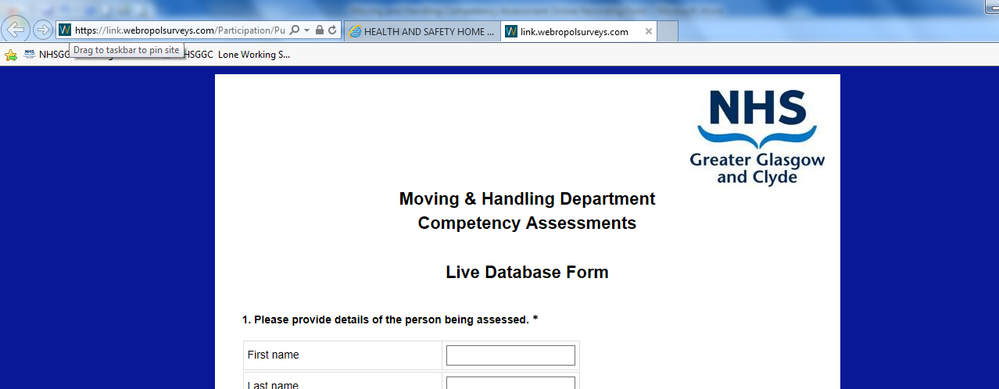
Hover over here, press mouse button and hold, drag mouse pointer to here (Favorites bar) and release. The next time you open your web browser, just click on the link you have made here.
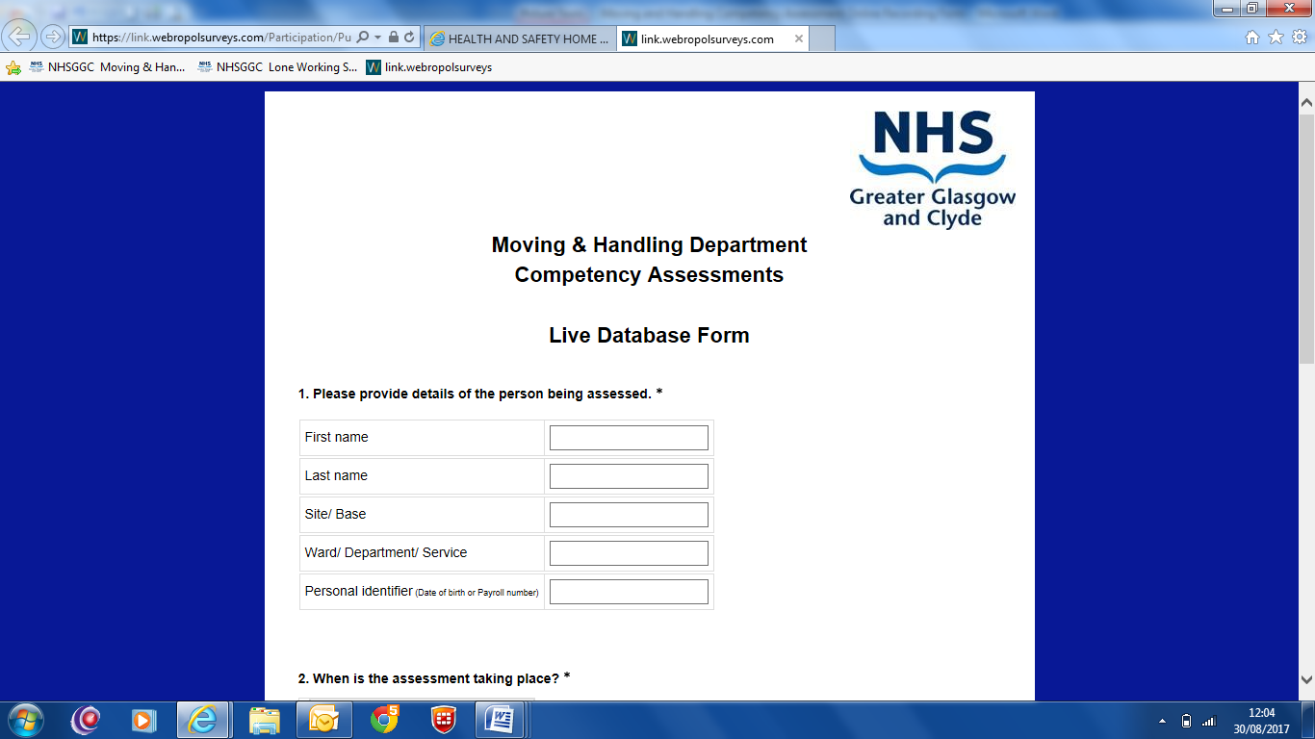
If you cannot see the ‘Favorites bar’, right click here and from the drop down menu click on Favorites bar

Alternatively you can use the Tracker Form instead of the online form. The tracker can also be used at a local level to allow assessors to identify who they have assessed and plan when their next assessments will be. On a monthly basis (when assessments have been completed) the tracker should be scanned and emailed to WIG-Movhan736@ggc.scot.nhs.uk or copied and sent to Moving and Handling, Ward 5A, West Glasgow ACH, Dalnair Street, Yorkhill, Glasgow, G3 8SJ for entering onto eESS.

Moving & Handling Clinical Competency Assessment Tracker
Site Based |  |  |  | Ward / Department
Tracker Period  (mm/yyyy to mm/yyyy) |  |  | NB A new Tracker should be started for each 12 - 18 month period.
The purpose of this form is to allow you to keep track of who requires to be assessed, any follow up action required and the date of the next assessment – usually within 12/18 months. The tracker should list every member of staff in the department required to be assessed, noting where a member of staff is on long term absence and their expected date of return. Each member of staff should be assessed undertaking three different manual handling tasks normally associated with their work duties whilst working with a patient in their normal working environment e.g. in a care of the elderly ward a) using a hoist b) using sliding sheets to move a patient up the bed c) assisting a patient to stand and walk.
On completion of an assessment, enter the relevant information directly into the online recording tool (Link). If this is not possible, this tracker should be sent on a monthly basis (when assessments have been undertaken) to WIG-Movhan736@ggc.scot.nhs.uk to allow central reporting to occur. Assistance with any aspect of the assessments process can be sought from the moving and handling team.

 | Employee Details |  |  |  |  | Date Assessed | Activity Assessed  Bed / Chair / hoist / Mobilise | Risk Score  VH/H/M /L | Reassess Date | Date Self Assessment Returned (M only)
 | Forename |  | Surname
 | Payroll No. or eESS ID |  | Band
 | Forename |  | Surname
 | Payroll No. or eESS ID |  | Band
 | Forename |  | Surname
 | Payroll No. or eESS ID |  | Band
 | Forename |  | Surname
 | Payroll No. or eESS ID |  | Band
 | Forename |  | Surname
 | Payroll No. or eESS ID |  | Band
 | Forename |  | Surname
 | Payroll No. or eESS ID |  | Band

Self Assessment Form (Clinical Handling)
Reflective practice is the reflection on an activity that enables you to participate in a process of continuous learning. It is a useful tool where you can learn from your own experiences, rather than from formal teaching and is an important source of personal development and improvement.
This form asks you to first identify the moving and handling activities that you are involved with. Then, to identify whether you perceive you need learning in terms of your knowledge and skills with regards how you currently perform the activity. For those activities that you perceive you need additional learning, undertake the activity(s) and reflect on your performance, using the prompts on the reflective analysis form.
This tool once completed can be used as evidence for your KSF and / or PDP review and CPD portfolio. If doing so, it should be discussed and countersigned by your local manager or KSF reviewer.
Moving and handling activities  Do you know how to: |  | Do you undertake this activity?  (Yes, No, N/A) |  | Learning required?  (Yes, No)
Move in balance when doing your work activities, that is, move without adopting excessive stooping or twisting postures?
Physically assess a person prior to assisting them?
Assist a person to sit down or stand up from a chair and / or bed?
Assist a person to walk?
Assist a person who is starting to fall during assisted transfer or mobilisation or helping them get back up (including with a hoist)?
Work all the features of electric beds in your area?
Laterally transfer a dependent patient from a bed to a trolley and back?
Insert, use and remove slide sheets?
Assist a person to turn in bed, or turn a dependent person?
Assist a person to move up the bed (including with slide sheets)?
Assist a person from lying to sitting up in bed?
Assist a person from lying to sitting up over the edge of their bed?
Assist a person sitting on the edge of their bed, back in to bed?
Use the hoist(s) in your area?
Use the standing aid(s) in your area?
Identify the different types of hoist slings available?
Fit and remove a sling with the person lying in their bed?
Fit and remove a sling with the person sitting on their chair?
Other activities:
Reflector: | Signature: |  | Date:
Local Manager: | Signature |  | Date:

This form can be used to record your thoughts after undertaking an activity you perceive you needed additional learning for. Undertake the activity and reflect on your performance, using the prompts in each section below, you may need a different sheet for each activity. This process is intended to be self-reflective; however, asking another person, for example, the patient or a colleague to comment on the activity may help inform your analysis.
Name of Activity/Situation:
Location: |  | Date:
Description of activity undertaken:
What were the challenges you experienced during the activity?
What do you feel you did well during the activity?
How will the above learning influence your future practice?
Have you identified any further learning needs? If yes, outline the needs below and identify how you will address them.
Reflector: | Signature: |  | Date:
Local Manager: | Signature |  | Date:

Background
Starting in 2012, moving and handling within NHSGGC adopted a competency assessment approach to identify individual and departmental learning needs. The approach started with the moving and handling team assessing staff within their own environments undertaking manual handling activities.
After this initial assessment, the responsibility for implementing a process for future assessment lies with the Senior Charge Nurse or Team Lead (SCN / TL). Some of the questions and answers that have been discussed regarding what this means are outlined below.
Competency assessment frequently asked questions
 | Question | Response
1 | Why do I have to do this? | The Management of Health & Safety at Work Regulations requires employers to monitor and review the implementation of control measures, of which the application of skills and knowledge (including those acquired from moving and handling training) within a workplace is included. This approach provides an opportunity to be able to evidence good practices.  The first assessments were undertaken by the moving and handling (M&H) team who provided onsite coaching and advice to add to staffs existing knowledge and skills as required, therefore, future assessments should reveal a higher number of staff being assessed as demonstrating good practice.
2 | What are the assessment outcomes likely to be? | Of the several thousand staff assessed, 68% were assessed as Low, 31% as medium and 1% as high or very high. This suggests that 99% of staff have demonstrated good or acceptable moving and handling skills which should be positively acknowledged. All those assessed as high / very high have received coaching from M&H staff in their work place and have been reassessed as low or medium.
3 | What will be being assessed? | The assessment criteria are provided and will be discussed at the training provided.
4 | How can staff outside of the moving & handling team, assess moving and handling competence? | The criteria being assessed against will be recognisable to all staff who have attended M&H training in the past and assist people with movement. The skills at the level they are being assessed at are used daily by all healthcare practitioners. Therefore, the assessor will be assessing only what they know and practice themselves.
5 | I have not been trained how to assess staff? | You will be provided with training. The training will be a 1 day course initially and you will receive regular updates. The M&H team will be available to support you in your work area after the training if required.
6 | Who will be doing the assessments? | Any member of staff who has attended the competency assessors (CA) training can undertake the assessments. It is the SCN / TL’s responsibility to identify appropriate staff to attend the CA training.
7 | I am worried about having to train staff? | At no point will staff outwith the moving and handling team be asked to train or coach other staff identified by a competency assessment as high or very high. Anybody identified through CA’s as requiring training or coaching should be referred to the moving and handling team.

 | Question | Response
8 | I am worried about assessing the people I work with? | For some people this can feel awkward initially. However, our experience suggests that staff want reassurance about the job they are doing and welcome the opportunity for feedback. Support from the M&H team will be available if required.
9 | What about backfill for those going on training | Backfill will need to be agreed locally, however, will be considerably less than that required to release all staff to attend M&H training courses every year. This should prove to be advantageous to most areas
10 | If I assess someone and they injure themselves later on where do I stand? | The person’s competence to undertake CA’s will be assessed by the M&H team. As long as the assessor gives due diligence, that is, by working within their skill and knowledge base to any completed assessments, this should satisfy any enquiry.
11 | What will the moving and handling staff be doing? | M&H staff will continue to provide training, coaching and advice regarding all aspects of M&H. The CA approach will allow those individuals and areas who need additional support to be identified.
12 | How long will an assessment take? | Completing the paperwork and discussing the assessment outcome takes less than five minutes. The CA Record Form is provided on HRConnect. The assessor may chose to observe staff undertaking an activity, in which case the assessment will take however long the activity lasts; or the assessor could chose to assess somebody whilst assisting them with the activity, in which case no additional time is involved other than completing the form at the end of the assessment.
13 | Where is the paperwork? | The competency assessment record form, ward / department tracker form and information sheets are available on HRConnect.

Notes:

