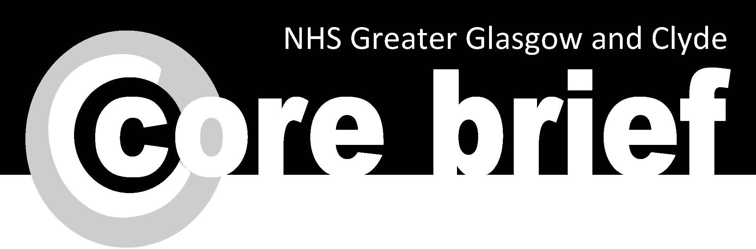

**Daily update**

**(9 March 2021, 4.20pm)**

Topics in this Core Brief:

* Special Delivery – Postman Paddy’s incredible message of thanks to NHS Staff
* No Smoking Day 2021 – Wednesday 10 March
* Social Distancing Spot Checks



**Special Delivery – Postman Paddy’s incredible**

**message of thanks to NHS Staff**

Almost 700 staff at GRI have received a hand written

thank you card from Paddy Joyce, an autistic teenager,

who began writing to healthcare staff in mid-January as

a way to help with his anxiety and reward those on the

frontline fight against COVID-19.

Dr Barbara Crooks, consultant anaesthetist at the GRI,

who helped to co-ordinate the huge task of getting

names together for Paddy to write the cards, said:  “I

know this was a tremendous effort from Paddy to write

an individual thank you to so many of our team.

“They have been blown away by Paddy’s heartfelt messages which have been quite touching and certainly lifted our spirits.

“Thank you to Paddy and his mum Indra for providing a much needed morale boost. Paddy is a fine example of a very caring young Scot and I wish him all the very best for the future.”

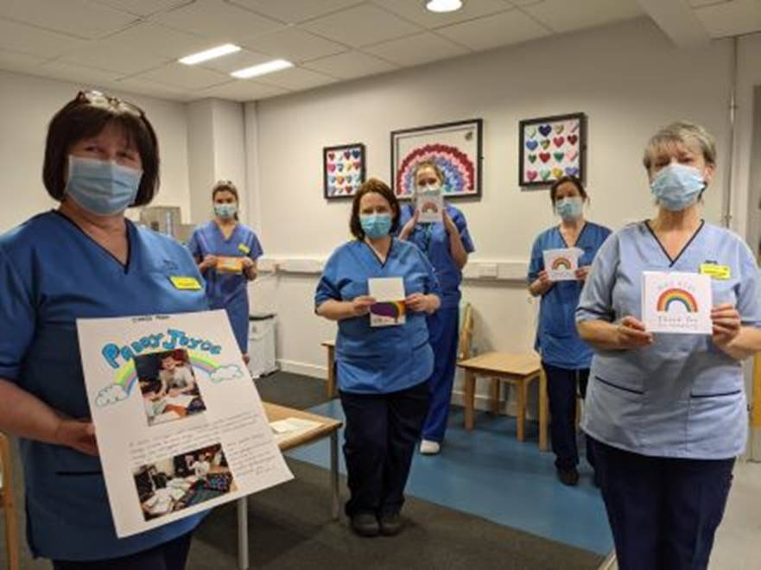Paddy is continuing to write the cards to NHS staff and hopes to send more than 5,000 by the end of the year.

Thank you Paddy!

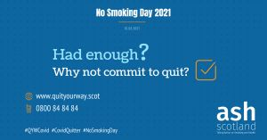**No Smoking Day 2021 – Wednesday 10 March**

Quitting smoking is one of the best things you can do for

your physical and mental health and what better day to

take that step than No Smoking Day tomorrow

(Wednesday 10 March).

Paul, one of our Quit Your Way lockdown quitters said “I

have been smokefree for six months now after 35 years

and it’s changed my life.  My moods have been more

stable, I’m a lot more optimistic about the future and I’ve also been able to go for walks with my daughter.”

If you’ve had enough, then why not commit to quit?  To find out about the help and support available from your local Quit Your Way service call 0800 916 8858 or visit: [www.nhsggc.org.uk/quityourway](http://www.nhsggc.org.uk/quityourway)

**Social Distancing Spot Checks**

The Health and Safety Service conducted over 75 social distancing spot checks from December 2020 to February 2021, across NHSGGC.

A lot of good practice was observed as well as opportunities for improvement. A lessons learned briefing has been created ([available here](https://www.nhsggc.org.uk/media/265668/covid19_social_distancing_risk_assessment_audit_summary.pdf)) to help share and learn.

Managers are asked to review the key areas identified and, if necessary, to implement in their area of responsibility. The key findings were associated with:

* Signage
* Cleaning
* Room occupancy
* Seat allocation and positioning
* Availability of sanitiser
* Understanding of mask/covering usage

Thank you to staff for supporting this process.

Information relation to Social Distancing can be found [here](https://www.nhsggc.org.uk/your-health/health-issues/covid-19-coronavirus/for-nhsggc-staff/social-distancing-in-the-workplace/).  If you have any ideas to improve Social Distancing practice, please share with your line manager and email here: [SDCommsGroup@ggc.scot.nhs.uk](mailto:SDCommsGroup@ggc.scot.nhs.uk)

Please keep up-to-date with the latest guidance on our dedicated web pages at: [www.nhsggc.org.uk/covid19](http://www.nhsggc.org.uk/covid19). If you have any questions about the current situation please check the [FAQs](https://www.nhsggc.org.uk/your-health/health-issues/covid-19-coronavirus/for-nhsggc-staff/faqs/) first. If you have any further questions, please email: [staff.covid19@ggc.scot.nhs.uk](mailto:staff.covid19@ggc.scot.nhs.uk)

***Staff are reminded to make sure their [personal contact details are up to date on eESS.](https://www.eess.nhs.scot/ess/)***

**It is important to share Core Brief with colleagues who do not have access to a computer.   
A full archive of printable PDFs are available on** [StaffNet](http://nhsggc.us12.list-manage.com/track/click?u=0f385b5aea37eaf0213bd19fb&id=4a0fd596c9&e=5af5e1832c)