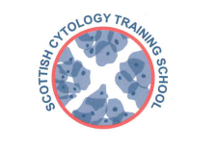

Scottish Cytology Training School

Course Programme 2025

|  |  |
| --- | --- |
| 28th January | Update Course |
| 3rd – 5th February | Pre-Exam Course |
| 3rd – 4th March | Training Workshop – The Coombe |
| 26th March | Update Course |
| 13th May | Medic Update Course |
| 28th May | Assessors Course |
| 19th June | Update Course |
| 19th – 21st August | Pre-Exam Course |
| 6th – 10th October | ST1 Introductory Course |
| 11th November | Update Course |
| 4th December | Assessors Course |

Additional outreach/workshop days TBA

Topics for Update courses may include:-

* *Cytology and Management Pathways*
* *Categorising Invasive Cancer Reviews*
* *Borderline and Squamous Metaplasia*

**No course fee is charged for gynae cytology courses to non-medical staff employees of Scottish NHS Trusts**

**Non-NHS Scotland laboratories price on application**