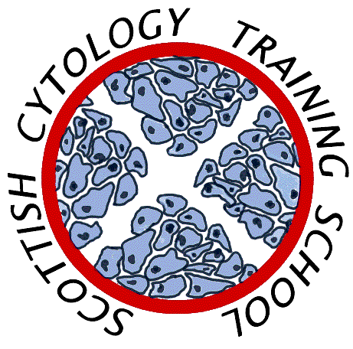

Scottish Cytology Training School

Course Programme 2025

|  |  |
| --- | --- |
| 7th January | Update Course |
| 20th – 31st January | Introductory Course Part 1A |
| 3rd – 5th February | Pre-Exam Course |
| 24th Feb – 7th March | Introductory Course Part 1B |
| 26th March | Update Course |
| 13th May | Medic Update Course |
| 28th May | Assessors Course |
| 19th June | Update Course |
| 25th – 29th August | Introductory Course Part 2 |
| 6th – 10th October | ST1 Introductory Course |
| 11th November | Update Course |
| 4th December | Assessors Course |

Additional outreach/workshop days TBA

Topics for Update courses may include:-

* *Cytology and Management Pathways*
* *Categorising Invasive Cancer Reviews*
* *Borderline and Squamous Metaplasia*

**No course fee is charged for gynae cytology courses to non-medical staff employees of Scottish NHS Trusts**

**Non-NHS Scotland laboratories price on application**