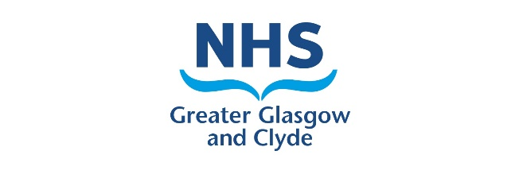

**COVID-19 Checklist   
Glasgow Dental Hospital   
Outpatients**

Ahead of your upcoming appointment within Glasgow Dental Hospital, please review the following checklist before attending the department.

In the last 14 days have you, or anyone living with you had:

* **A confirmed diagnosis of COVID-19**
* **A high temperature**
* **New, continuous cough  
  (Coughing a lot for more than an hour, or 3 or more coughing episodes in 24 hours)**
* **Loss or change of sense of smell or taste**
* **Cold/Flu Symptoms**

Most people with coronavirus will have at least one of these symptoms.

If you have had any of these symptoms within 2 weeks of your appointment date please contact **0141 211 9815** to discuss**.** This also applies to any person required to accompany you to the appointment.

Please note, if you require to cancel your appointment for any other (non-Covid) related reason, please contact the number on your appointment letter.

Please note that social distancing is no longer required within waiting areas however we request that you attend on your own where possible. If you have carer or support requirements, please let a member of our nursing team know so we can make sure that we can accommodate this within our waiting areas.

We strongly recommend that patients and visitors to the Dental Hospital wear a face mask unless they are exempt.

We will also ask you on arrival if you have any of the above symptoms. If you do, we may reschedule your appointment until your symptoms have resolved unless your treatment is urgent.

With Kind Regards

NHS Greater Glasgow and Clyde

Glasgow Dental Hospital Outpatients