Queen Elizabeth University Hospital
1345 Govan Road
Glasgow
G51 5TF

You are currently on our waiting list for a Dermatology consultation and we are pleased to offer you an appointment on our Digital Dermatology Asynchronous System (DDAS) which will enable a virtual consultation with your Consultant.

To participate in this appointment we require a valid email address unique to you in order to send you the link to the DDAS system.

I would be grateful if you could make contact with our booking team using the number on the attached letter to discuss the suitability of this appointment and to provide them with your e-mail address. They will be happy to talk you through the system and answer any questions you have.

For information, please find below a QR Code and web link which will direct you to our DDAS step-by-step guide for signing up to the system, uploading photographs and completing the questionnaire:

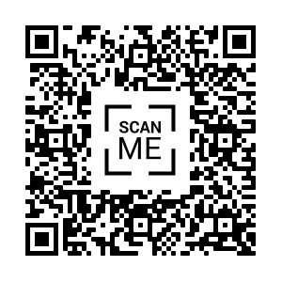
https://www.nhsggc.org.uk/media/263250/dermatology-digital-appointment-service-webpage-step-by-step.pdf

