Will I be asked for information and is it secure?

If you receive a notification either through email or text message, from the senders listed above, you can be assured that all links are safe to click.

You will be asked to complete the following security steps to access your information:

1. For security purposes, you will be asked to enter your date of birth (or that of the patient you are acting on behalf of).
2. You will be asked for either your mobile number or email address. You are not required to enter both.
3. A security code will then be sent to the mobile number we have on file for you, which you will be asked to enter.

All verification information you share is stored on our secure system and is only used to let you log into Patient Hub.

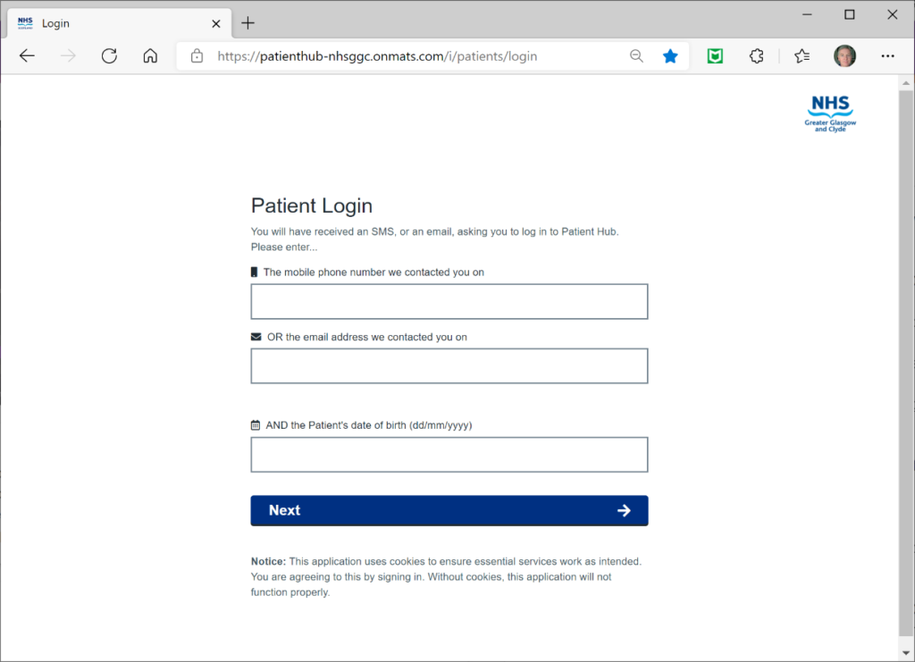

The secure website you will be directed to is: [patienthub-nhsggc.onmats.com/i/patients/login](https://patienthub-nhsggc.onmats.com/i/patients/login)

These SMS messages will be sent from: NHS-NoReply

While emails will be sent with sender name: noreply

And address: [noreply@netcall-health-patient.onmats.com](mailto:noreply@netcall-health-patient.onmats.com)

What about my confidentiality?

The message that arrives on your phone or email makes no reference to the type of service or test result we are contacting you about.