|  |  |  |  |
| --- | --- | --- | --- |
| Form number | **Form 52.009C** | Version | **3.0** |
| Title | **Template e-file** | | |

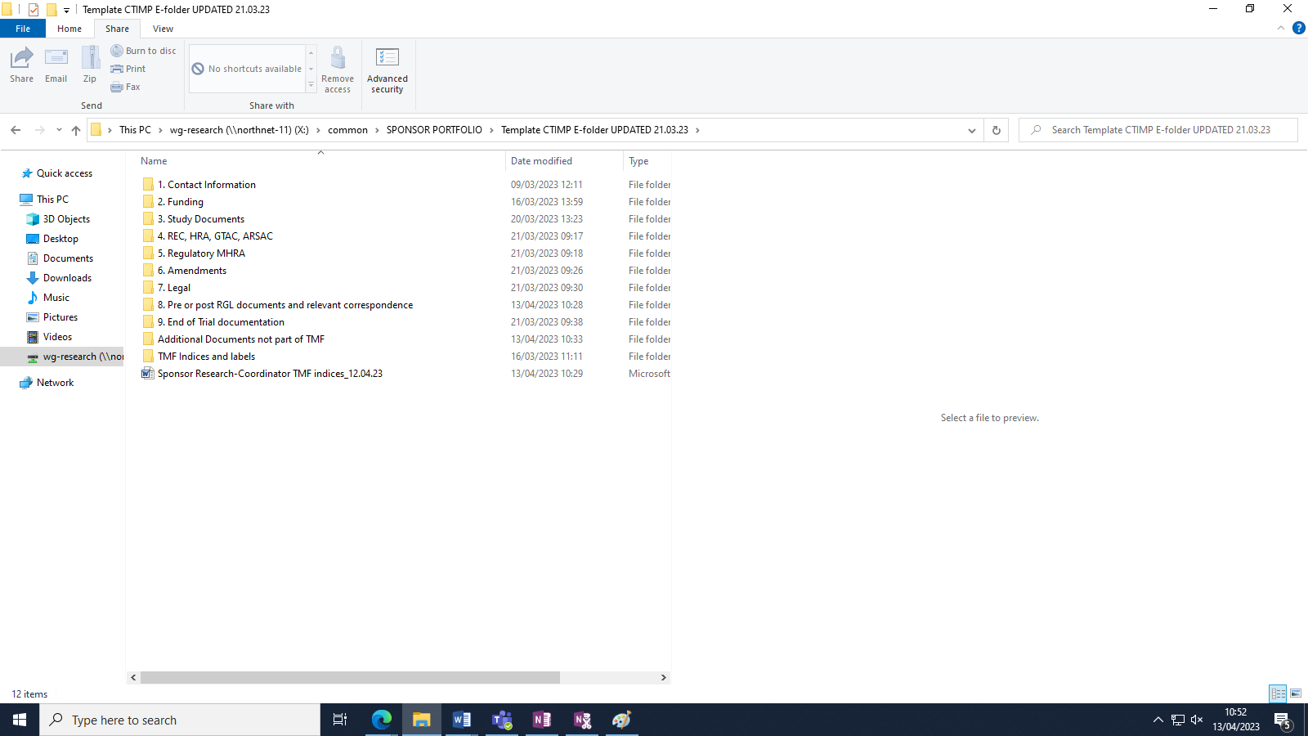

|  |
| --- |
| This Form is a controlled document. The current version can be viewed on the GCTU website.  Any copy reproduced from the website may not, at time of reading, be the current version. |