**Link to GGC External eHealth Portal -** <https://nhsscotland.service-now.com/ehealth>

**Students can register here – Select Register on this page**

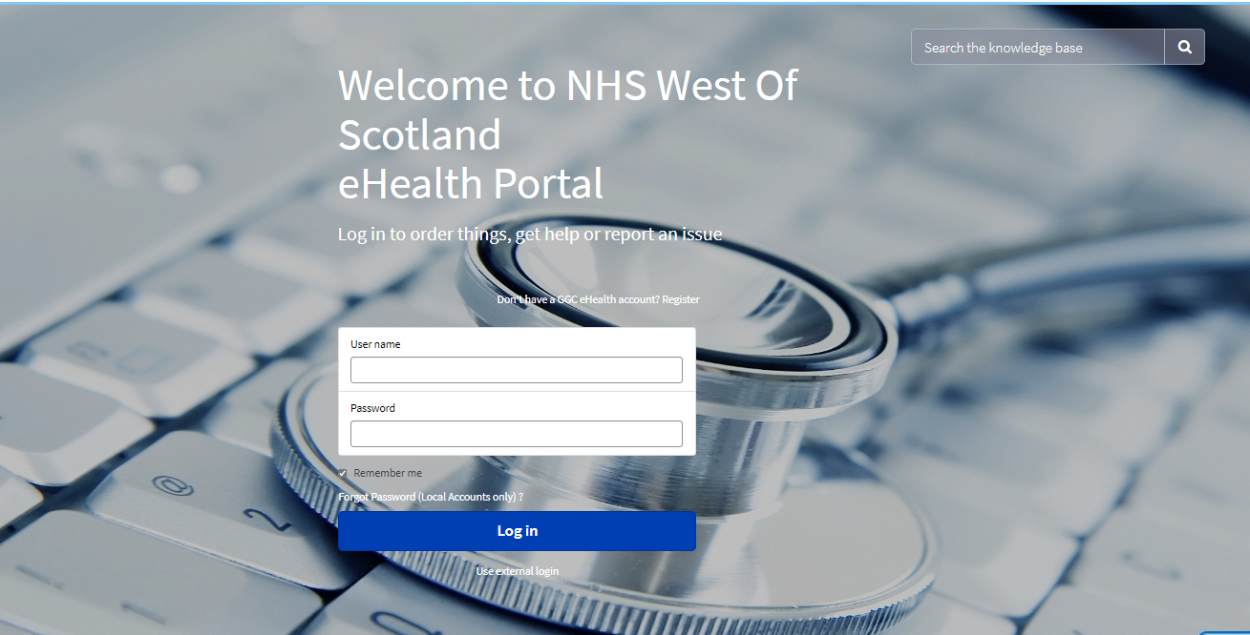

**Complete the University Student Self Register details – Select University Student from Type of Service List**

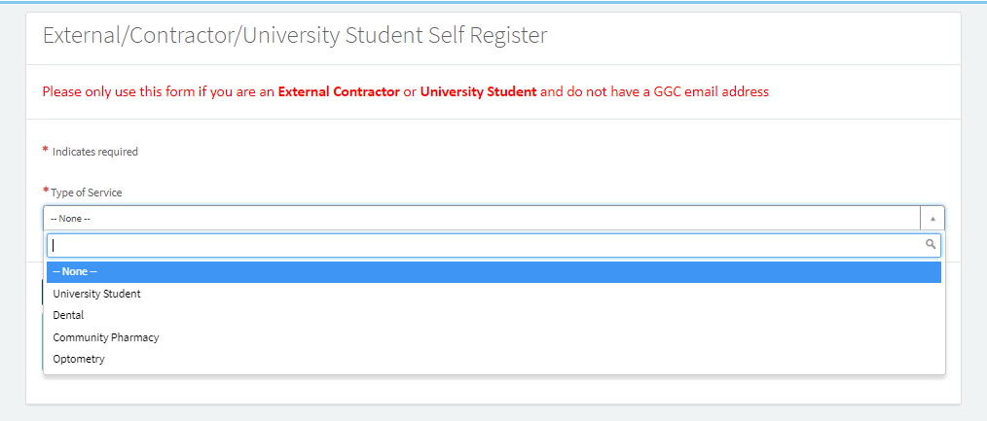

**Complete all fields on this form and then select Sign up**

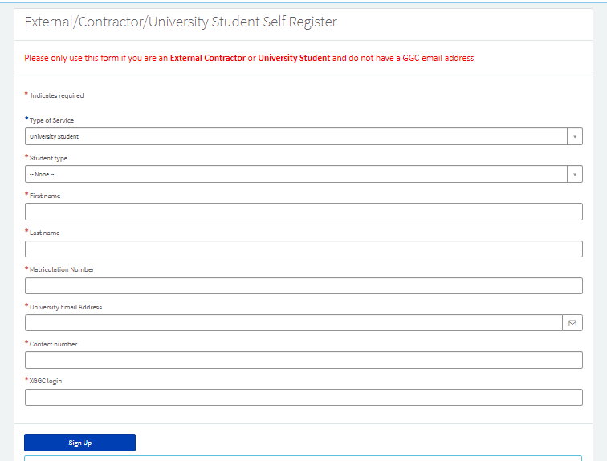

**You will receive this prompt after signing up.**

**Please check your university email address for instructions. This email will have the Subject Heading : Your GGC eHELP Login Details   
Your Student eHELP User ID will be your Univesity email address and you will be requested to set a password for your User Account**

**When ready to raise a support ticket – please enter your Student eHELP User ID into the User Name field and your password**



**Once you have logged in successfully the page below will be displayed**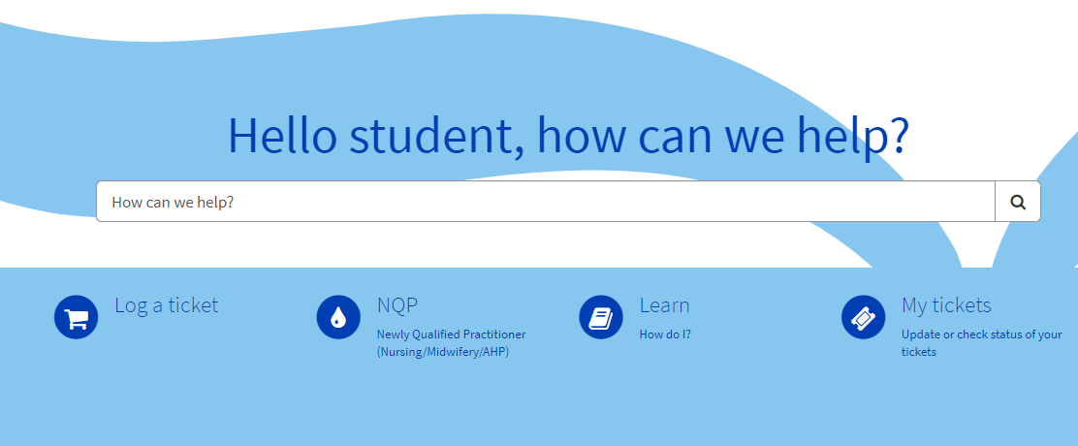

**Your default details will be included in any tickets logged, however for each ticket please complete your Location, Exact Location, if you wish to be contacted on your mobile and the nature of the request on any tickets you log.**

**Log a ticket**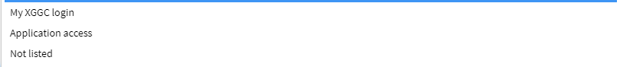

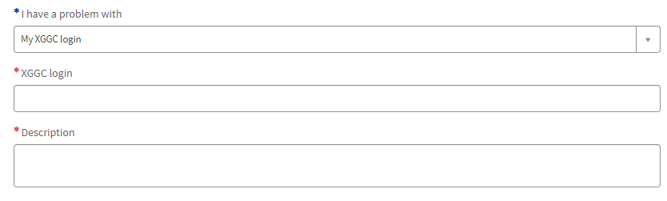

**You can select multiple Applications, clicking on Applications line will allow you to select these, you will be prompted to provide you login for each application. Once you have completed all fields please select Submit and your ticket will be logged. You will receive emails with your ticket number and when your request has been actioned.**

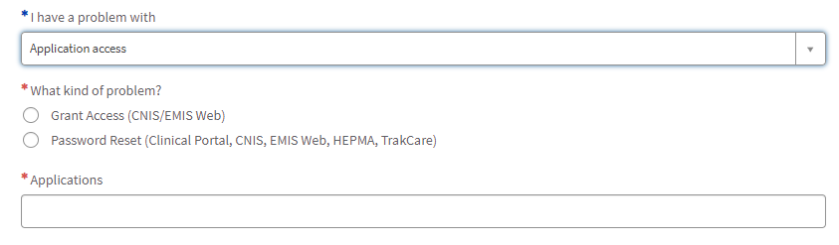

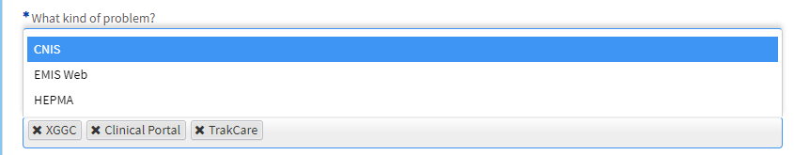

**If you are unsure on which option to choose, please select Not listed and provide details, please provide as much information as possible, this will**

**Assist the Support Teams in resolving your request. Once you have completed all fields please select Submit and your ticket will be logged. You will receive emails with your ticket number and when your request has been actioned.**

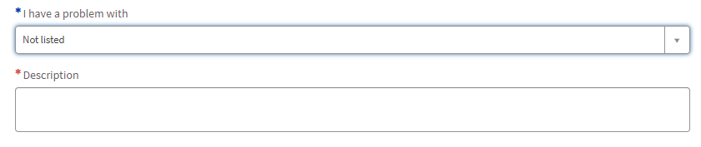

**If you are a Newly Qualified Practitioner and require accounts to be updated, please select this option. Please complete all fields, you will be required to provide your Nursing and Midwifery Council Number (NMC number)**



**Learn is work underway and will soon be populated with useful Student Information – check here periodically to view the progress of this.** 

**My tickets will allow you to view your tickets and the status of these**



**If you experience any issues in registering or logging tickets, please email** [**itservicedesk.nhss-ggc@atos.net**](mailto:itservicedesk.nhss-ggc@atos.net) **and provide as much information as possible.**