

**Guidance on DATIX Reporting – COVID-19**

**November 2020**

During the current COVID-19 pandemic staff are encouraged to continue to report incidents and near misses via the DATIX reporting system. [http://www.staffnet.ggc.scot.nhs.uk/Applications/DATIX/Pages/default.aspx](http://www.staffnet.ggc.scot.nhs.uk/Applications/Datix/Pages/default.aspx)

To report an event that relates to COVID-19, please select category **Infection Control**. There is a specific Covid choice within the sub-category box. This can be accessed via typing “covid” into the box

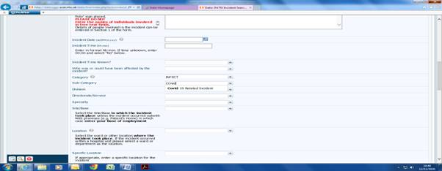

Or by scrolling down the drop box

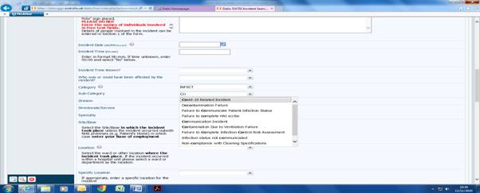

As with current practice on DATIX, where a Reviewer has the view that an incident may be RIDDOR reportable they must select Yes in the drop down selection box on the DiF2 form.

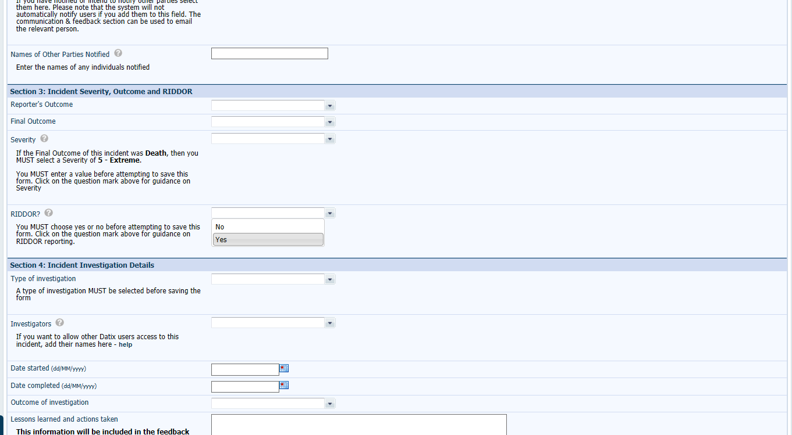

This will then be brought to the attention of the Health and Safety Service. The Health and Safety Service, will review the DATIX and determine if the criteria for a RIDDOR report has been met. Where it has the Health and Safety Service will be responsible for making the report to HSE.