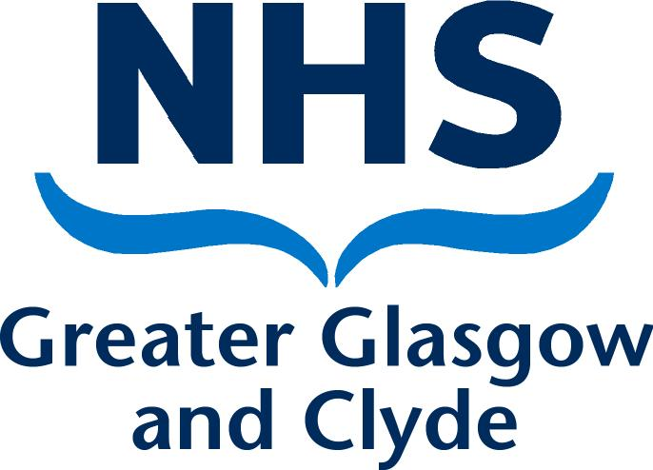
Occupational Health Service
Level 6
West Glasgow ACH
Dalnair Street
Glasgow
G3 8SJ

Tel 0141 201 0600
Fax 0141 201 0585

Date:
Dictated:
Our Ref: LCT

PRIVATE AND CONFIDENTIAL

Acceptance into NHS GG&C employee Long Covid Rehabilitation programme

A referral has been accepted for you to engage with the Long Covid team. We enclose a leaflet about the team for your information.
Could you please complete and return the attached questionnaire by post to the address above or by email to Occupational.Health@ggc.scot.nhs.uk. The questionnaire is also available on our website www.nhsggc.org.uk/working-with-us/hr-connect/occupational-health under Occupational Health Long Covid Service.
Access to the rehabilitation programme will be based on responses to the questionnaire. You will not be able to access the rehabilitation programme without returning the questionnaire. You will be contacted directly once an appointment is available.
A range of accessible self-management information and resources can be found on the Occupational Health website: www.nhsggc.org.uk/working-with-us/hr-connect/occupational-health. The self–management resources are freely available and can be used to begin addressing Long Covid immediately. Staff are strongly encouraged to read and begin using these.

We look forward to working with you.

Yours sincerely

OH LONG COVID SERVICE

Cc GP
Cc Employer.
Enc

Occupational Health Long Covid Service

The aim of the team
The aim of the team is to support employees to improve their health, functional capabilities, and quality of life, aiming whenever possible to help people to return to work.
The Occupational Health Long Covid service provides support, advice, and rehabilitation for NHS GG&C employees who continue to be affected by ongoing symptoms related to Covid-19 infection that have lasted more than 12 weeks and which impact on their performance or attendance at work.
The team members
The Long Covid team is made up of a Physiotherapist, two Occupational Therapists and an Occupational Health Nurse, with access to support from the wider Occupational Health team.
What the team offer
The team offer a broad range of interventions to address the needs of individuals referred. Interventions may include supporting employees to access self–management resources to assist in the understanding of Long Covid and aid recovery, advice on workplace adjustments, joining group rehabilitation sessions, and additional rehabilitation for employees with more complex needs.
The process
A Health and Well-being questionnaire will be sent to the employee on receipt of a referral or for quickness can be accessed directly from the OH Long Covid Service web site www.nhsggc.org.uk/working-with-us/hr-connect/occupational-health/occupational-healt-long-covid-service .
Access to the rehabilitation programme will be based on responses to the completed questionnaire. Early return of these is encouraged to access an appointment. Appointments will not be issued to the rehabilitation programme without completion and returning the questionnaire.
Management referral appointments will be prioritised to those who are at work but who would benefit from further advice on adjustments and individuals within 4-6 weeks of returning to work.
The service will use information provided by employees to ensure appropriate intervention is offered and with their consent in service evaluation
Employees will be contacted directly once an appointment is available.

A host of clear and accessible self-management information and resources can be found on the Occupational Health website: www.nhsggc.org.uk/working-with-us/hr-connect/occupational-health/occupational-health-long-covid-service.

