Reporting of faults to electric frame beds
All departments across NHSGGC are required to follow the correct process below for reporting faults to electric frame beds:
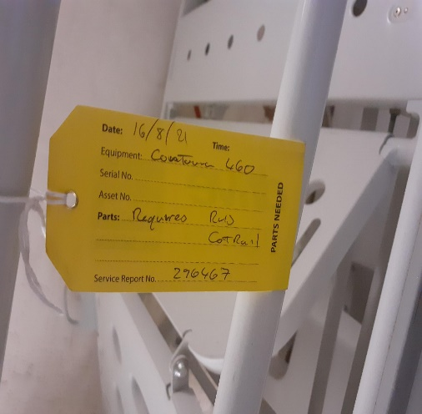
- Report through FM First stating bed asset number and brief description of the fault. Take note of the job reference number given.
- Attach yellow label to bedframe with the FM job reference number clearly stated. A yellow label is all that is required, no paper signage is needed.
- Prior to bed leaving department ensure the mattress and all bedlinen are removed, bedframe has to be cleaned before request is made to portering staff to transfer to the bed maintenance area.
- Please note that portering staff have been advised not to move a bed unless this process is followed.
- Please contact local Moving & Handling team if further information is required.

