Within this guidance document you will find advice on how to laterally transfer a supine patient using a rigid transfer board with sliding sheets. This guidance provides one method to undertake this activity; it is not the only method available. For further assistance or alternative methods contact the Moving and Handling Team.

Preparation
- In a ward environment there should be a minimum of three staff to carry out a lateral transfer using a rigid transfer board with two ‘flat’ sliding sheets. Risk assessment should be ongoing considering patient height, shape, medical condition and working environments, for example, theatres, diagnostic and recovery areas
- An efficient movement pattern should be applied to the best of the individual’s ability throughout. Guidance to support staff regarding this is available on the MH HR Connect pages (Link)
- Throughout the manoeuvre, one person should take the lead, communicating with the patient and other staff, explaining the process and ensuring all understand what is happening
- The bed area should be cleared to allow space for the transfer to happen without obstruction, for example, bed lockers, chairs etc
- Ensure the bed sheet is fully opened out and un-tucked from underneath the mattress to assist with transfer. Flat or fitted sheets may be used
- Check the transfer board and sliding sheets are in good condition before commencing task
- If on air mattress ensure ‘max inflate’ function is activated

To fit transfer board and sliding sheets
- Raise the bed and trolley to the same height, ensuring the height is appropriate for the smallest member of staff and the brakes are on.
- Leave a gap between the two surfaces and ensure the bed and trolley brakes are on. One staff member stands in the gap between the two surfaces and passes the bed sheet over the patient to the other two staff who will use it to tilt (roll) the patient towards them

- Staff should take an indirect hold (palms up) of the sheet, that is, the sheet should be held between the thumb and the palm of the hand

- A minimum of two members of staff are required to tilt / roll the patient. When tilting the patient, this should only be as far as to allow the transfer board and sliding sheets to be inserted under the patient and should be done smoothly
Remember, if the patient is able, they should be encouraged to do as much of this for themselves as possible.
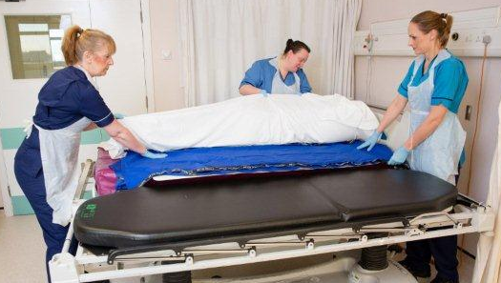
- Two members of staff should insert the transfer board and sliding sheets. Ensure the transfer board and sliding sheets are placed underneath the patient’s head. If the patient is particularly tall this may mean their feet are not on the board in which case additional staff may be required
- Once the transfer board and sliding sheets are in place, take the brakes off either the bed or trolley and bring both surfaces together and then reapply the brakes
In some environments it is not possible to have a gap between two surfaces, therefore, another member of staff will be required. In this case, two staff members should be positioned with one at the head and the other at the foot of the bed / trolley. They will together pass the sheet to the other two staff and when ready insert the transfer board and sliding sheets under the patient

To carry out lateral transfer manoeuvre
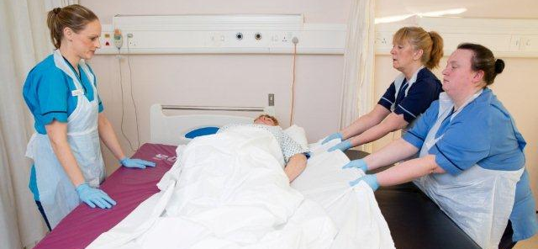
- Two staff should be at the side the patient is transferring towards with one person on the other side. This person places one hand under the sheet / patient’s shoulder and the other under the patient’s hip to provide a bridge between the mattress and the transfer board. This person should not move with patient as they are transferred across to the other surface
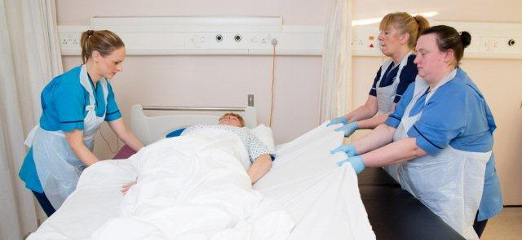
- The member of staff on the side the patient is moving to (and at the head of the bed), will lead manoeuvre and issue clear instructions for both staff and patient on how far the patient will move and on what commands
- When taking hold of the sheet and just prior to pulling the patient across, all staff should check they are not top heavy (leaning forwards)
- If using fitted sheets ensure that the slack / stretch is taken out prior to the move beginning
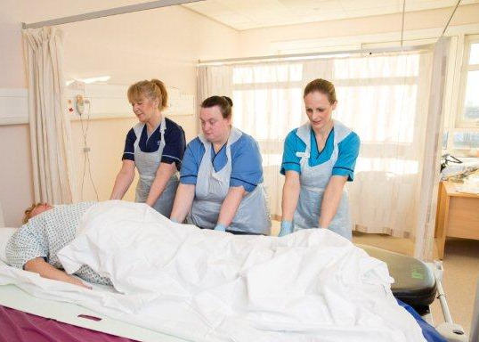
- The lateral transfer will require 2 or more moves which should be controlled, smooth and gentle (not jerky or fast). The number of moves required will be dependant on a number of factors including the size / girth of the patient. Once the initial move has been made, the person who was providing the ‘bridge’ between the mattress and the transfer board can move either to the patients feet or to assist in pulling the patient the rest of the way across.
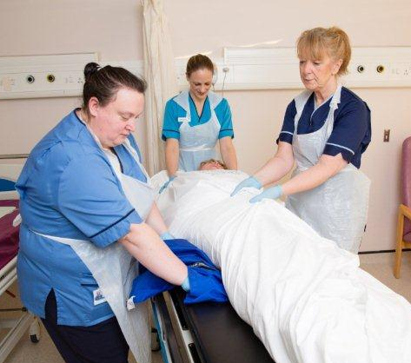
- Once the patient has transferred across, remove the transfer board and trolley / bed
- Use the sliding sheets (which will still largely be under the patient) to reposition the patient in the bed if required and then remove them
- Remember to readjust the mattress from ‘max inflate’ to an appropriate setting

