Within this guidance document you will find suggestions on low level working with particular emphasis on working with divan beds or double beds within a community setting. For further assistance with the following information contact the Partnerships Moving and Handling Team ([Link](https://www.nhsggc.scot/staff-recruitment/hrconnect/safety-health-and-wellbeing/moving-and-handling/)).

Before commencing a task ensure your environment is as clutter free as possible to enable you to manoeuvre within the workspace. This will assist in enabling an efficient posture ([Link](https://www.nhsggc.scot/downloads/competency-assessment/?wpdmdl=69406&refresh=6406008808fcb1678114952&ind=1678095664860&filename=mh-information-sheet-no-2-efficient-movement-_v1_.pdf)).

**Postures to avoid**

The following three photographs illustrate positions to be avoided because of the increased risk of potential musculoskeletal injuries.

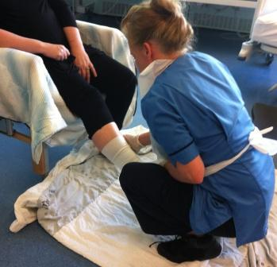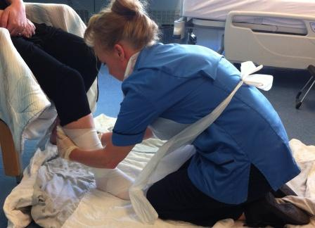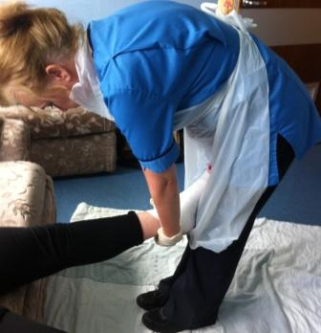

**X**

**X**

**X**

1) Squatting 2a) Top Heavy Kneeling 2b) Top Heavy Standing

**Postures to Adopt**

If sitting or upright standing is not an option, the following photographs illustrate how these same activities can be carried out reducing the risk of musculoskeletal injury while working at a bedside or chair. These positions reduce static posture and encourage staff movement with postural changes.

High Kneeling Open Kneeling

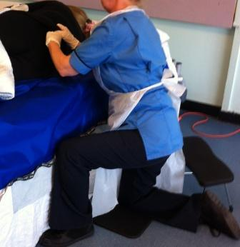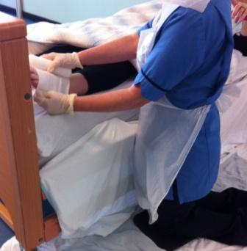

**✓**

**✓**

**Sliding Sheets**

Consider using sliding sheets to position the person closer to you to avoid overreaching.

On a single width bed, sliding sheets can be used to bring the person closer to the working side. Guidance on how to insert sliding sheets can be found at the StaffNet ‘M&H Documentation’ page ([Link](https://www.nhsggc.scot/staff-recruitment/hrconnect/safety-health-and-wellbeing/moving-and-handling/))

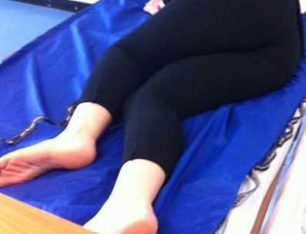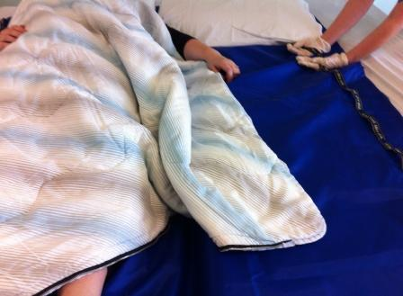

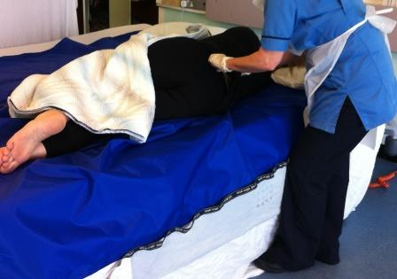

The same process can be used on double beds

using bariatric size sliding sheets. This will reduce

kneeling on the person’s bed to deliver required

care.

**Equipment**

There are various kneeling and perching stools and limb supports which can be used to reduce strain to staff and adjusted to suit the patient.

The following photographs illustrate how Carbonlite Medical Technology | Ergonomic Medical Equipment ([Link](http://www.carbonlite-medical.com/acatalog/About_Us.html)) can be applied to low level working:

a) Kneeling pad, perching stool and limb support

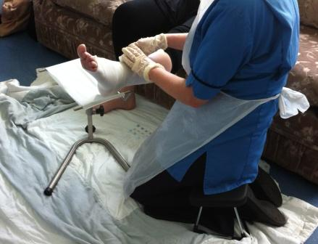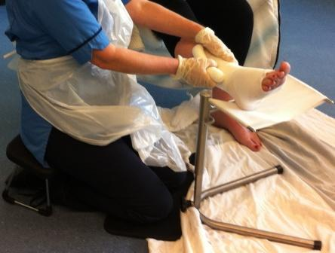

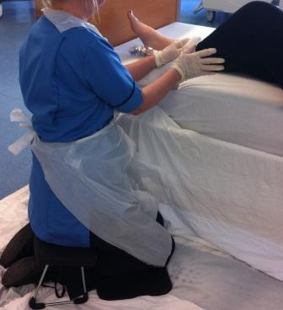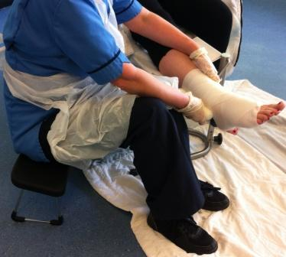b) Perching stool and limb support c) Perching stool and knee pad

The following photographs illustrate the various postures that can be adopted using the ergokneeler ([Link](http://www.ergokneeler.co.uk/))

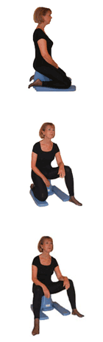



These photographs shows the Hadewe foot rest and an example of it in use ([Link](http://www.canonbury.com/index.php/hadewe-foot-rest.html))

