**Mobilising Guidance**

Tripping and falling while mobilising remains a high risk activity for patients when in our care. To reduce the risks from mobilising, staff should follow the guidance below:

1. Ensure the path being used is clear of obstructions
2. Identify whether a walking aid is required and if so, that it is used appropriately.
3. Ensure patients only have access to appropriate footwear and that this is worn during mobilisation.
4. Consider the distance to be mobilised and whether the person will manage it. Consider reducing the distance to be walked or positioning seating along the way in order to rest.
5. Offer only the support required, too much assistance can increase the persons dependence on you and inhibit successful mobilisation.
6. When walking with someone, walk close to them on a slight angle (to reduce twisting). Do not assist the person to walk from directly in front, unless the persons care plan identifies this as an appropriate approach.
7. If providing assistance, do so using a long low hold towards the persons lower back / hip. Do not use a ‘lock on’ hold, for example, holding the persons hand; holding under their auxilla; or, allowing the person to hold on to you

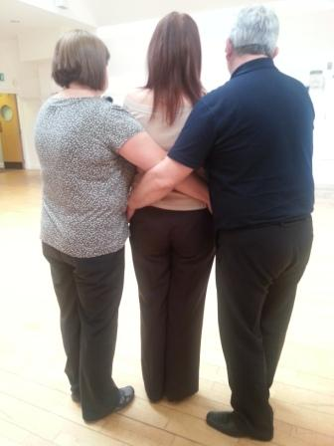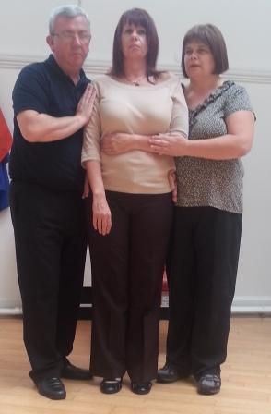





1. Match the speed the person is walking at, do not rush them. Provide verbal encouragement as required.
2. Encourage the person to look ahead when walking rather than down at their feet.
3. Monitor and review the activity, reporting and / or updating changes as required.

All staff involved in these tasks should be aware of the [falls guidance](http://www.staffnet.ggc.scot.nhs.uk/Acute/Rehab%20Assessment/Falls%20Services/Pages/defaultbbc4c21b05d14695845d724d458d4a58.aspx) and interventions if a fall does occur. Please refer to relevant local risk assessment documentation as necessary.

For further information, please visit our Moving & Handling HR Connect pages [here](https://www.nhsggc.scot/staff-recruitment/hrconnect/safety-health-and-wellbeing/moving-and-handling/).