The HoverMatt system is used to assist with lateral transfers and repositioning patients. The safe working load for the HoverMatt is 544kgs.

**Preparation**

* In a ward environment the HoverMatt is primarily used for the transfer of bariatric patients from bed to trolley / bed and vice versa. Further to individual patient risk assessment there should be a minimum of four to six staff to carry out the manoeuvre. Risk assessment should be ongoing, considering; the patient’s height; weight; shape; medical condition; and, working environments, for example, theatres, diagnostic and recovery areas.
* An efficient movement pattern should be applied to the best of the individual’s ability throughout. Guidance to support staff regarding this is available on the HRConnect moving and handling pages ([Link](https://www.nhsggc.scot/staff-recruitment/hrconnect/safety-health-and-wellbeing/moving-and-handling/)).
* Throughout the activity, one person should take the lead, communicating with the patient and other staff, explaining the process and ensuring all understand what is happening.
* The bed area should be cleared to allow space for the transfer to happen without obstruction, for example, beds, equipment, lockers, chairs etc.
* Check the HoverMatt system is working before commencing the activity.
* 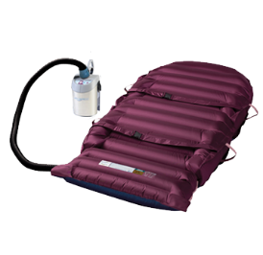There are two types of HoverMatt and air supply:
  + The reusable HoverMatt is blue and purple. The blue side has perforations and is the underside of HoverMatt. The patient should be lying supine and centered on the purple side.
  + 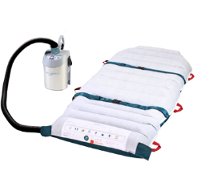The single patient use HoverMatt is white and green. The green perforated side is the underside of HoverMatt. The patient should be lying supine and centered on the white side.
  + 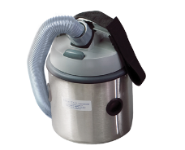The HoverMatt comes in different widths - 34, 39 and 50” (86, 99 and 127 cm).
  + 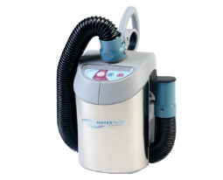Older versions of air supply only have one button; newer versions have 4 buttons and relate to size of HoverMatt used.
* If the patient is lying on an air mattress, ensure the air mattress ‘max inflate’ function is activated prior to using the HoverMatt.

**Position the HoverMatt under the patient**

* Raise bed / trolley to an appropriate working height for staff.
* 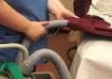Roll the patient onto their side and place the HoverMatt underneath the patient. Ensure the patient is centered on the correct surface (purple or white) of the HoverMatt before inflation and transfer. Attach the patient safety straps over the patient loosely, to allow for inflation of the HoverMatt.
* Plug in the air supply. Insert the air supply hose into the HoverMatt, preferably on the side away from the surface you are moving to, this will reduce the risk of tripping over the air hose or cable

**Moving the patient using the HoverMatt**

* Ensure the two surfaces are at the same height.
* Staff should be positioned:
  + One or two staff on the side the patient is moving to and one on the other side;
  + One at both the head and foot ends;
  + One operating and moving the air supply.
* Turn on the air supply and let the HoverMatt fully inflate before moving patient.
* For heavier patients, inserting a rigid lateral transfer board under the inflated HoverMatt may aid smoother transfer.

**Never leave the patient unattended on an inflated HoverMatt**

* 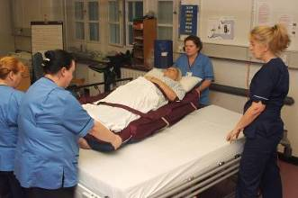The staff member at either the foot or head end of the surface moves the HoverMatt first, sliding the HoverMatt a short distance. This is repeated at the other end until the HoverMatt is sufficiently close to the staff waiting at the side of the surface the patient is being moved towards.
* 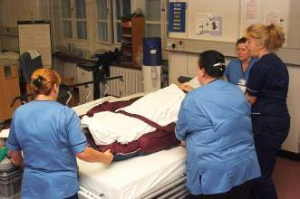The staff at the side now assist, ensuring the manoeuvre is carried out over a number short moves, ideally 4-6).
* Ensure patient is centered on the new surface before deflating the HoverMatt by turning the air supply off.
* If no further adjustment required, remove the HoverMatt, clean down with detergent wipes and dry before placing back on trolley.