Situation
This Briefing Note has been developed following an incident involving an Electric Profiling Bed. Whilst no patient was harmed in this incident, there is a significant risk of injury should the incident recur.

Background
- A bed was found tipped onto it’s side lying on its bed rails. On investigation, two bed models to date have been identified as being able to be tipped onto their side by the action of a person trying to climb out of the bed.
- In order for the bed to tip, the three items below need to occur together:
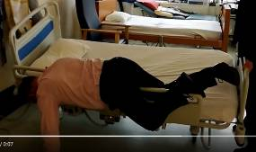
  - the wheels have to be pointing under the bed, away from the side the person is exiting from; and,
  - the bed rails have to be raised; and,
  - the person has to be able to climb over the raised bed rail

Action
- All staff working with people in beds should note the Guidelines for the Prevention and Management of Falls (Section 3.6) and the NHSGGC Bed Rail Risk Assessment documentation which state ‘Where there is a risk of the patient climbing over the bedrail, bed rails should not be used’. (Link).
- All staff are reminded to report any similar occurrences, should they occur, on Datix and to the moving and handling team.
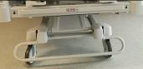
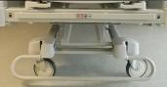
As seen from the foot end

Recommendation
- In addition to the above action, after moving a bed, ensure the wheels are pointing to the head or foot end of the bed. The easiest way to do this is to finish moving the bed by pushing it towards or pulling it away from the wall at the head end of the bed.
- Prior to working with a patient on the bed, check the wheels are pointing to the head or foot end of the bed.

Author and for further details – Cameron Raeburn, Health & Safety Service Manager

