Issue Number |  | Date | 24/02/2021
Subject: | Bed and trolley safety side rail check  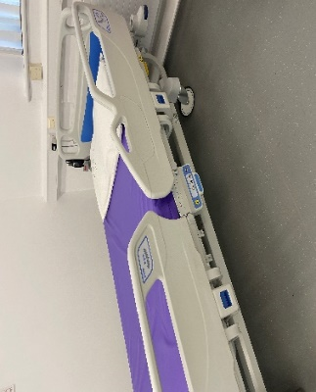  This affects both:  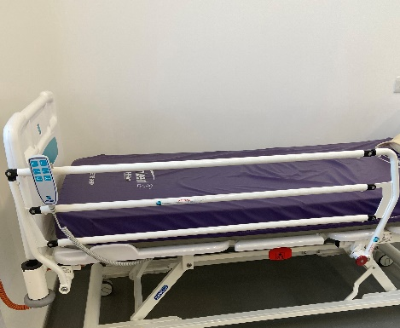  ¾ Length rails, and Split rails
Background
A significant patient safety incident within NHSGGC occurred when a patient fell out of a bed to the floor from height during a care giving activity. The safety side rail had been raised, however, it lowered unexpectedly during the activity enabling the patient to roll out of the bed. A Safety Action notice has previously been issued relating to this type of incident.

Action
To prevent the bed or trolley safety side rails from lowering unexpectedly, when you raise the rail, ensure that the locking mechanism is securely engaged. This can be done by following all three points below, every time you raise the side rail on a bed or trolley:
- Listen for and hear a ‘click’ when the rail is raised, and;
- Visually check the locking mechanism has engaged, and;
- Physically check the rail is locked in position by attempting to lower the rail without disengaging the locking mechanism
Any fault noted with the side rails should be reported to Estates through FM First and the bed or trolley taken out of use and safely stored until a full inspection and / or repair by an authorised person is carried out. Remember to take a note of the bed make, model and serial number and ensure ‘Do Not Use’ signs are displayed on the bed, with the reason and reporting date recorded.
Clinical staff should familiarise themselves with the MHRA Guidelines in Safe use of bedrails and the NHSGGC Bedrail risk assessment documentation.

Authors
Jillian McDonald, Moving and Handling Lead Practitioner, Jillian.McDonald@ggc.scot.nhs.uk
Laura Halcrow, Falls Prevention Lead, Laura.Halcrow@ggc.scot.nhs.uk

