Background
Three staff activated fire alarms have been triggered in the past 10 months, due to the smell of burning identified as coming from Arjo patient lifting hoist batteries which were on charge at the time.
The issue has been reported to Arjo and the NHS Incident Reporting and Investigation Centre (IRIC). Arjo have investigated the problem and sourced the issue being a compatibility conflict between one of their battery charger models and a type of battery manufactured during the last couple of years, further information is available in Arjo’s Corrective Advisory Notice (here ).
The battery charger affected is used to charge the batteries for the following Arjo hoists:
- MaxiMove - Encore - Tempo
- Opera - Chorus

Action required
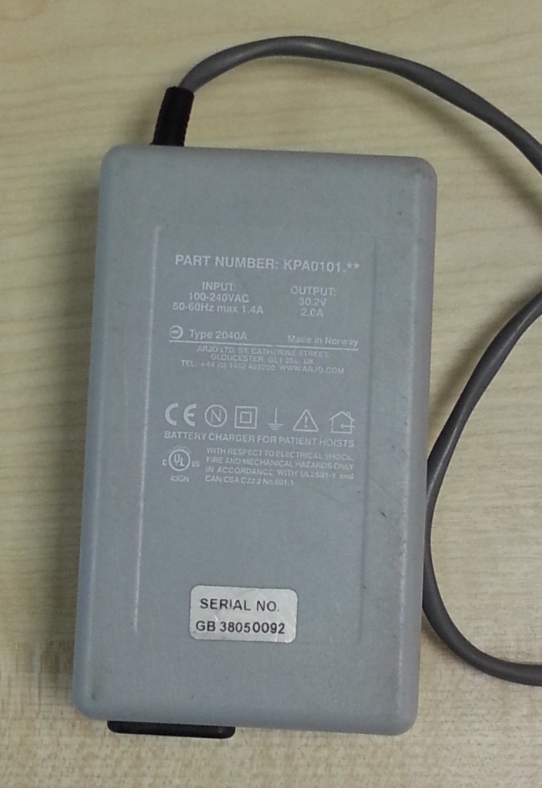
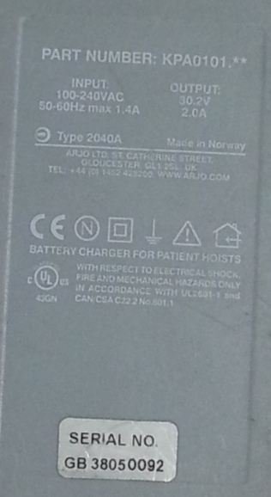
The battery charger involved is shown below. Chargers identified with part number KPA0101-xx should be removed from use and reported to cameron.raeburn@ggc.scot.nhs.uk

The following information should be reported:
- Location – site & ward / department
- No. of chargers removed
- Serial number of chargers removed

On receipt of the above information a new charger will be supplied by Arjo with part number KPA2000-xx. This new charger should be plugged in using the existing mains cable (previously used with the old charger)

In addition to the above all staff should be reminded that should they smell burning, the fire alarm should be activated and the incident reported via DATIX as per the NHSGGC Fire Safety Policy.

