Essential pre-use checks

Prior to every use the following checks must be undertaken:

- Inspect hoist for any obvious signs of damaged or missing parts

- Ensure spreader bar is attached to hoist correctly (fig. 1).

Fig.1
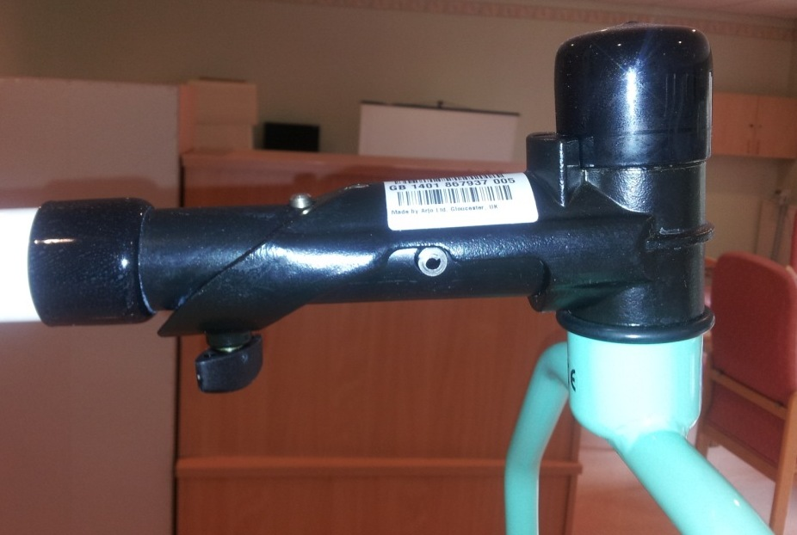
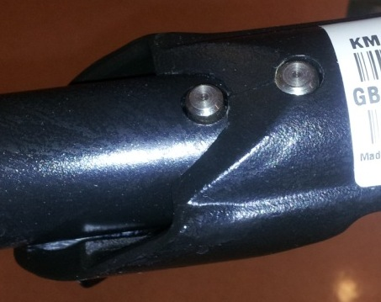
Ensure:
- The two pins are
securely located
- The screw is tight

- Ensure hoist castors move freely

- Raise and lower mast to ensure hoist operates freely

- Ensure hoist legs open and close freely

- Ensure battery has sufficient charge to complete transfer

- Check dates on Service and LOLER stickers on hoist. If out of date report to estates
- If in doubt DO NOT USE. Report it to estates and put a sign on the hoist noting the issue, date reported and person reporting it.

