This Briefing Note has been developed following an incident involving a passive hoist and a community style electric bed

Background
- When using passive hoists with a bed frame with side rails attached, the hoist lifting motor may get positioned over the side rail.
- This can occur if the bed is at a low position and the bed rail is obscured (by a sheet or bed rail bumper) or the hoist has been pushed up against the bed (this may occur if the patient is not in the centre of the bed).
- If this occurs and the bed is raised, the hoist is also raised with the bed. This may cause the hoist to tip / fall causing injury.

Action
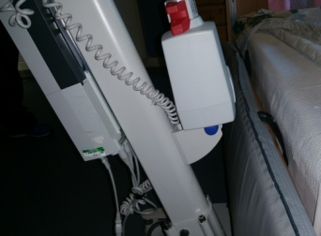
- Staff to ensure they have read and understood the hoist guidance document (Link) and complete basic checks before proceeding with hoisting activity.
- Check the side of the bed / side rail is visible and there is space between the hoist lifting motor and side rail / side of the bed
- Ensure the hoist is not pushed or held tight against the side of the bed.

If the hoist and bed do get stuck together
- Stabilise the hoist and lower the bed to release the contact.
- Do not pull at the hoist to release it as this will cause tipping.

