**Moving Mobile Shelving Units**

* Standing too far away, causing top heavy postures
* One handed pulling, causing twisting

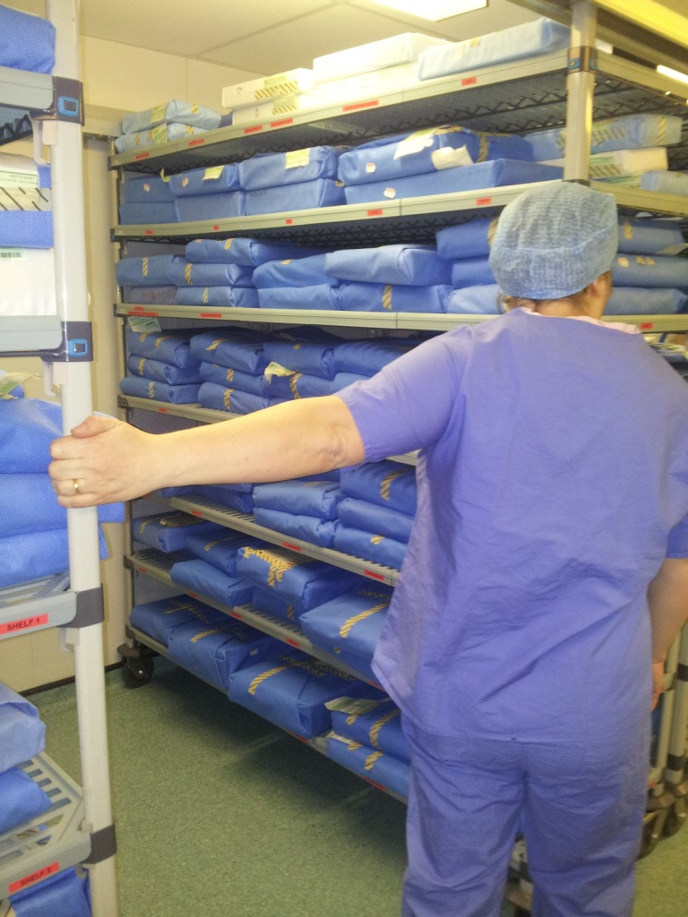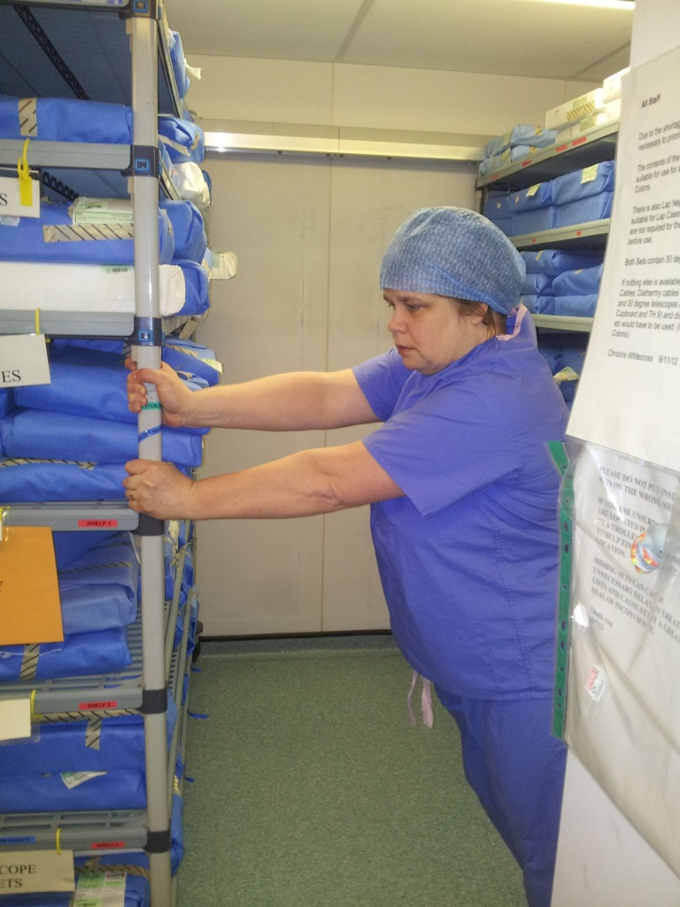

🗶

🗶

**Following a workplace visit, the practices below were identified:**

**To reduce musculoskeletal risk, the following should be implemented:**

* Ensure there are no obstructions
* Move one shelving unit at a time
* Stand close to the unit being moved
* Push rather than pull





