Diagnostics Directorate  Laboratory Medicine  Department of Pathology | 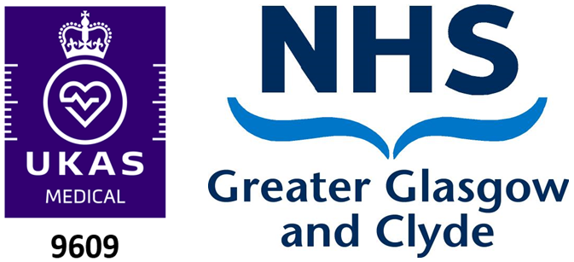

Terms of Service
Accreditation
Details of Scope of Accreditation and the testing performed by the laboratory is available via the UKAS website: 9609-Medical-Multiple.pdf (ukas.com)
User Information
The Pathology Department provide full details of the clinical tests available, specific sample types we can perform analysis on, minimum acceptance criteria, how to send a sample to the department, expected turnaround times, medical/technical EQA participation, opening times and contact information in our user manual. This is referred to throughout this document and the latest version is available online: NHSGGC Pathology User Manual - NHSGGC
The user manual along with request forms for different sample types and other key documentation can be found on our departmental website: Pathology & Mortuary Services - NHSGGC
Terms and Conditions
Each request accepted by the laboratory for examination(s) shall be considered an agreement. If the laboratory requires a formal service agreement, this will be discussed with the service user.
Submission of a sample and request form to the department implies that appropriate consent for testing has been obtained by the user. Legally some sample types (e.g. products of conception) require specific informed consent forms to be completed, see user manual for details. If the samples and requests for testing we receive meet the requirements described in our user manual we make the following commitments. These apply to all referred samples and associated testing provided by the department and include any pre-defined aspects of individual service agreements.
- The department will inform service users as soon as possible, if there is a concern that the results provided for any test/sample or their interpretation and reporting, are for any reason believed to be inaccurate/unreliable.
- Service users will be quickly informed by the department if there are any circumstances that negatively impact the quality of the services we provide or our expected turnaround times. Estimates of expected turnaround times are listed in our departmental user manual.
- The department participates in External Quality Assurance (EQA) schemes, or inter-laboratory comparison programmes, where available for the sample types and we perform. Full details of Medical and Technical EQA participation are available in our user manual.
- The department will inform you of any adverse EQA that result in persistent poor performance.
- Any changes to the minimum requirements of acceptance for a sample type will be communicated to service users. This could include: sample volume, preservative/fixative used and conditions specimen transport.
- The minimum acceptance criteria for each type of sample or test performed is detailed in the departmental user manual. For any urgent/perishable sample which deviates from this criteria, the department will contact the user to seek clarification. The department will also communicate to users upon the receipt of any sample or request for testing that does not meet our minimum acceptance criteria and seek resolution with a non-conforming sample letter requesting further information/action.
- The department will communicate to service users if there is a need to refer the sample to another department/clinician for further testing or a second opinion.
- Communication from the department will be received by service users if there is any change to our processes/procedures or error that could lead to the reporting and/or its interpretation being significantly different to what is expected for the specific sample or test requested.
- The department will alert users of any changes to our Quality Management System that could affect the quality of the results we provide.
- Service users will be notified of any circumstances affecting our ability or resources to provide the service requested.
- Changes to key contact numbers for the department will be communicated to service users. Contact details for the department are available in our website and within our user manual.
- In compliance with article 6, of the Data Protection Act 2018 we may release patient information on request to competent and authorised parties.

