Dictations

In order for the typists to type your clinic letters correctly the following simple instructions must be adhered to

- Log in with your own Winscribe Author login.

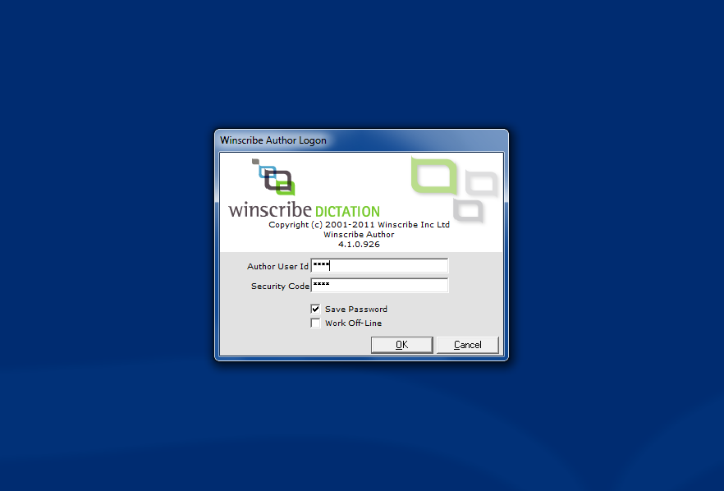

This is essential for the typist to know who is speaking. It also provides the correct spelling of your name for them so ensure these details are correct in the signature part of the letter.

If for any reason you are unable to login to your own Winscribe account, state who you are (your name/title) clearly before beginning your letter.

- Confirm TO field is ORTHO – GRI ( this allows the dictation to be seen and typed here at GRI)
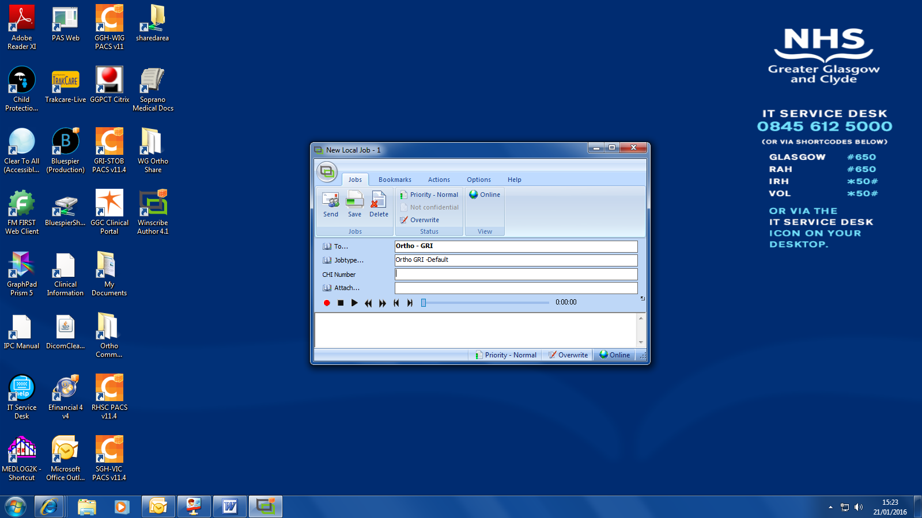

- Choose the job type
NOTE: (Ortho GRI-Default is NOT an acceptable job type)

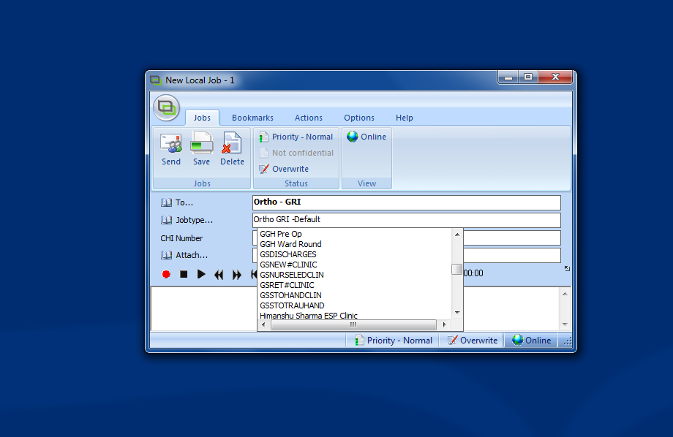

Here is a list of ALL the Ortho Job Types. Please do NOT choose a Job Code which is not listed below.

249 | GRI ANAES REVIEW
201 | GRI COMBINED CLINIC
128 | GRI DISCHARGES
209 | GRI FRACTURE
204 | GRI Frame Clinic
127 | GRI GENLETTER
159 | GRI ORTHOCLINIC
335 | GRI Tibial Nail Clinic
161 | GRI TRAUMAHAND
250 | GRI WARDROUND
378 | GRI WLI
193 | MSK Oncology
196 | Oncology Clinic

Correctly docked dictations will let the typist know which letter template to use; (Fracture clinic, Ward round, Ortho Clinic, Anaesthetic Review, General letter). It is important that you do NOT use any other Job Code other than is listed above.

If you are unsure, check with one of your colleagues before docking your dictations as changes later are more laborious, and omissions could lead to an important Fracture Clinic letter not being sent out the same day as intended but staying on the general dictation list to be typed anything up to two weeks later.

- Patient CHI number

The importance of this information cannot be stressed enough. The hand held devices can scan and log the CHI number for each dictation (check it has done this correctly) If you prefer CHI numbers can be added manually via the PC keyboard. However, the CHI number must always be repeated in the body of the dictation.

This helps avoid confusion with similarly named patients and is general good practice.

- Begin recording by pressing record on the hand held device. Wait a second or two before speaking to avoid having the first few words cut off.

Recording and playback can also be controlled via the PC control buttons

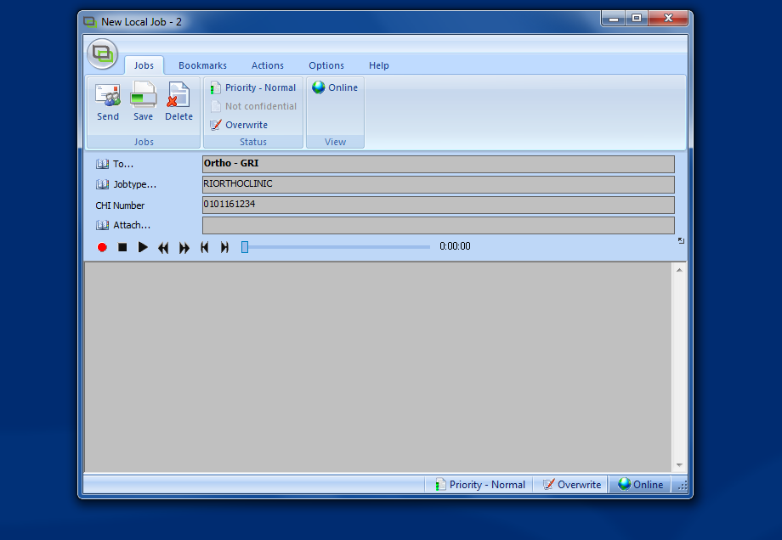

CHECKLIST FOR WINSCRIBE

- LOG IN

DICTATION CONTENT

Begin recording by stating

- YOUR NAME (if not logged in to your own personal account)

- THE PATIENT’S NAME followed by the FULL 10 DIGIT CHI NUMBER.
  - Saying the patient name first and clearly will allow the typist to find the patient by name quickly and confirm it is the correct person with the CHI number. Mistakes are time consuming to rectify as once they have been typed they automatically go onto the patient’s electronic record and have to be removed via a request to the IT department.

- “copies to” (specify addressee, title and location)
  - Eg. To Dr Roberts, Consultant Rheumatologist at Vale of Leven Hospital (“copy to Jack” will not have the desired result – and yes we have had examples like this)

Recording should take place in as quiet surroundings as possible. You can pause your recording if a phone rings close by or if an ambulance passes by, as this has a very detrimental effect on the sound quality. Dictations done in the plaster room are not recommended as the noise of the saw drowns out even the most professionally trained theatre voice ;)

- Listen back to your recording if time permits

Should you need to add any information you can do so with the insert button (top right). Play back the audio until you reach the point you wish to insert and then using INSERT and not RECORD, dictate the additional information.

- When satisfied press SEND to queue your dictation for typing on the GRI server.

Quick Check List
Log in

Specify job type
GRI Ortho Clinic
GRI Fracture Clinic
GRI Ward round

Recording
Your name (if not logged in to personal account)
Patient’s name

Chi number
All ten digits - scanned (typed) and spoken

Addressee(s)
Letter to GP
Letter to patient
Letter to referrer (name, title, and location)

Begin dictation

Stop

Check

Send

