Early Level – Primary 1 Lesson 2 – Substance Misuse

Unsafe Situations and Emergencies
Aim
- To increase learners’ understanding of when a situation is unsafe;
- To increase learners’ understanding of when a situation is an emergency;
- To highlight what action the learner should take in emergency situations.

Link to Curriculum for Excellence
Experiences & Outcomes | Benchmarks
I can show ways of getting help in unsafe situations and emergencies.  HWB 0-42a  I know and can demonstrate how to keep myself and others safe and how to respond in a range of emergency situations.  HWB 0-17a  I use drama to explore real and imaginary situations, helping me to understand my world.  EXA 0-14a | - Suggests ways to get help in unsafe and emergency situations, for example, seeking out an adult;  - Names the emergency services.  • Takes on a role within a play or dramatised situation, for example, a real or  imagined situation;  • Communicates their ideas through improvised drama i.e. making it up as they  go along.
Across Learning
Within real and imaginary situations, I share experiences and feelings, ideas and information in a way that communicates my message.  LIT 0-09a  I listen or watch for useful or interesting information and I use this to make choices or learn new things.  LIT 0-04a | • Talks clearly to others in different contexts, sharing feelings, ideas and  thoughts;  • Recounts experiences, stories and events in a logical sequence for different  Purposes;  • Uses new vocabulary and phrases in different contexts, for example, when  expressing ideas and feelings or discussing a text.  • Identifies new or interesting information from spoken texts.

Early Level – Primary 1 Lesson 2 – Substance Misuse

Learning Outcomes

I can…
- Identify examples of unsafe situations and emergencies;
- Describe the actions I should take in an emergency situation.

Resources

- Scenario Cards, Unsafe Situations and Emergencies – prepare in advance
- Teacher Resource Sheet, Unsafe Situations and Emergencies.
- Dressing up clothes.

Unsafe Situations and Emergencies

Activity

- With the learners, discuss what an unsafe situation is and ask for examples, either from personal experience or imaginative
e.g. broken glass in park or crossing a busy road with no crossing;

- Now discuss what an emergency situation is and give examples such as a car crash, house fire etc.
Ask learners who the emergency services are and what their job is.
You may want to download some images to use as aids;

- Place the labels “emergency” and “not safe” on a table and discuss with the children what they mean;

- Ask the children to sort the cards into two piles according to whether or not they think each scenario is an emergency (call 999) or unsafe (might cause harm if not used properly).
Include in the discussion that an unsafe situation may become an emergency if left unattended and no action taken;

- Using Teachers Resource Sheet, Unsafe Situations and Emergencies, discuss with the learners what to do in an emergency situation. Follow this by getting them to act out an emergency situation and then calling 999.

Teacher Resource Sheet

Unsafe Situations and Emergencies

How to contact the Emergency Services

- Stay calm.
- Using the telephone, dial 999.
- When the operator answers, listen carefully. The operator will say: “Emergency. Which Service?”
- Tell the operator which service you want:
  - Fire
  - Police
  - Ambulance
  - Coastguard
- The operator may need to know the number you are calling from. Give it carefully and clearly (if you know it).
- Stay on the line. The operator will connect you to the emergency service. Tell the person that you are speaking to:
  - What the emergency is
  - Where it is
  - Where you are phoning from
- The emergency service will be on its way
- NEVER make a hoax call. It is against the law and can risk the lives of people who really need the help.
Scenario Cards

Unsafe Situations and Emergencies

- Cut the scenario cards out in advance of the session

- Place the labels “emergency” and “not safe” on a table and discuss with the children what they mean.

- Ask the children to sort the cards into two piles according to whether or not they think each scenario is an emergency (call 999) or unsafe (might cause harm if not used properly)

Include in the discussion that an unsafe situation may become an emergency if left unattended and no action taken.

House fire
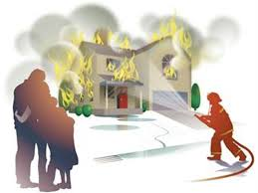

Hot Iron

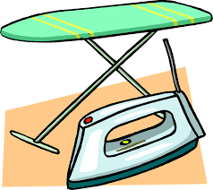
Pan boiling on cooker

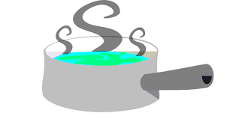
Open fireplace with fire

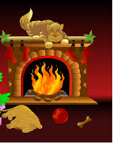

Broken bottle outside

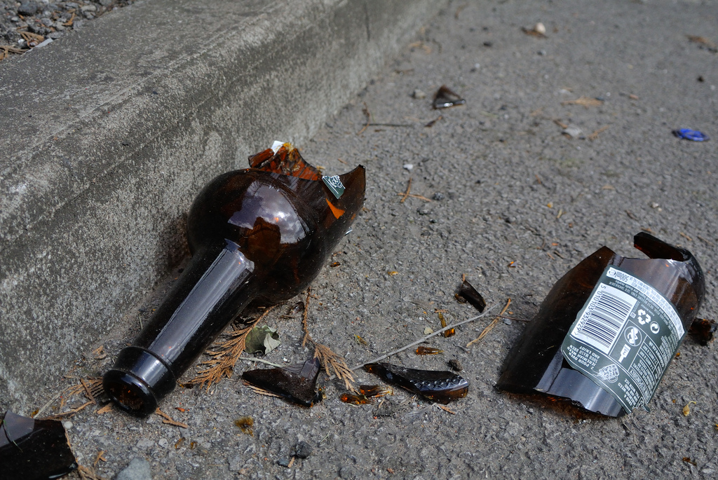
Crossing a busy road

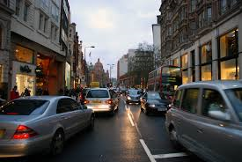
Walking on a frozen water

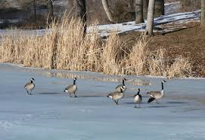

Swimming / Playing in water without adults

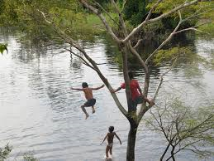
Finding someone unconscious

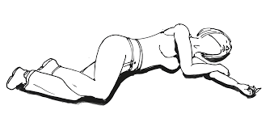
Car crash
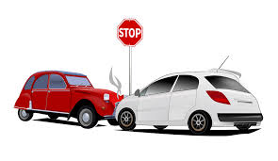
Falling down the stairs

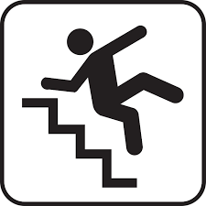
Stroking a dog you don’t know

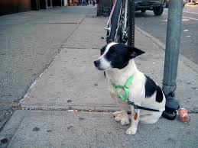

Emergency

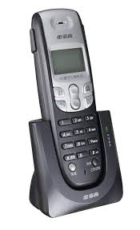 | 999

Not Safe
