First Level – Primary 3 Lesson 2 - Substance Misuse

Risks
Aim
  - To increase learners understanding of what a dangerous situation might look like and the risks associated with the situation;
  - To enable learners to make sensible decisions to keep safe and avoid negative consequences.

Link to Curriculum for Excellence
Experiences & Outcomes | Benchmarks
I know how to react in unsafe situations and emergencies.  HWB1-42a  I know that there are medicines and some other substances that can be used in a safe way to improve health and I am becoming aware of how choices I make can affect my health and wellbeing.  HWB1-38a | - Identifies why misusing medication can be harmful;  - Links personal actions to health and wellbeing, using role play for example;  - Describes when and how to contact emergency services;  - Shares key information about an emergency situation.  - Identifies conditions which require medication and how it benefits health.
Across Learning
When I engage with others, I know when and how to listen, when to talk, how much to say, when to ask questions and how to respond with respect.  LIT 1-02a  I can show my understanding of what I listen to or watch by responding to and asking different kinds of questions.  LIT 1-07a | - Takes turns and contributes at the appropriate time when engaging with others in a variety of contexts;  - Listens and responds appropriately to others in a respectful way, for example, by nodding or agreeing, asking and answering questions.  - Asks and responds to different types of questions to show understanding  of the main ideas of spoken texts.

Learning Outcomes

I can…
- understand that some decisions I make or situations I find myself in can be unsafe and may put me and others at risk;
- recognise the positive decisions and actions I should take to remain safe.

First Level – Primary 3 Lesson 3 - Substance Misuse

Risks

Resources

- Activity sheet, Risks.

Teacher’s note

- Please note that the questions in Activity 2 could unveil some child protection issues. Should this situation arise please follow your organisation’s policies and procedures and discuss with Senior Management.

Activity

- Ask the class to sit in a circle on the floor. Ask the class if anyone knows what the word risk means. Give them an explanation of what the word risk means:
A risk is a chance of getting hurt or losing something.

- Now ask the learners the following questions:
- Can you think of a time when someone you knew felt or was at risk?
- Can you think of a time when you were at risk but did not realise it until after the event?

- Give out the Activity Sheet, Risks.

Ask the learners to work in pairs to go through the activity sheet and discuss the questions.

Activity Sheet
When could I be at risk?

In pairs, look at each picture and talk about the following questions:
- What risks can you see in the picture?
- How do you know it is a risk?
- What could happen?
- What positive decisions and actions could you take to keep safe?
- Who could help you to keep safe?

RISK 1:
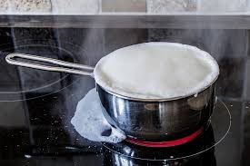

RISK 2:
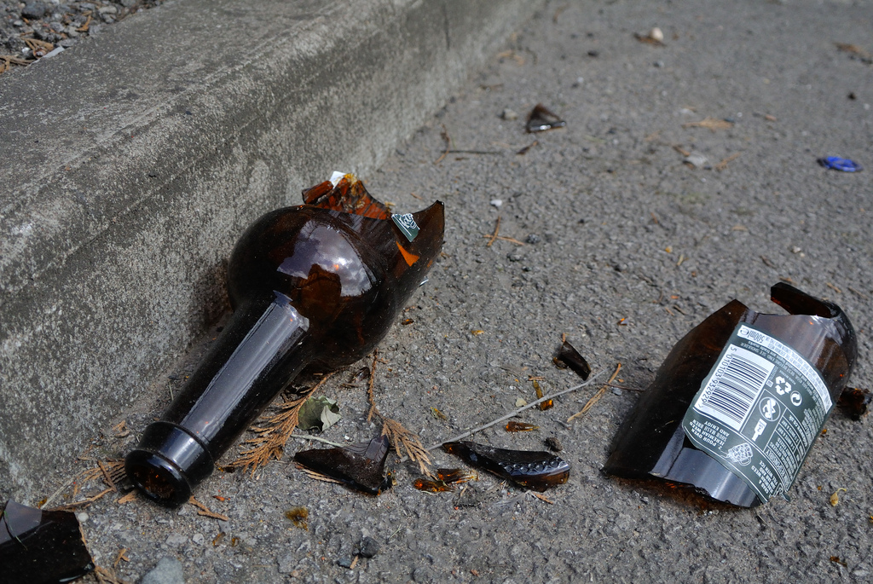
RISK 3:
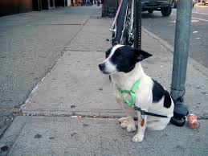
RISK 4:
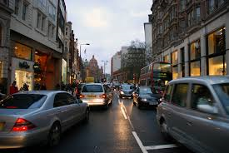
RISK 5:
