Dear    Parent / Guardian,

Your child has now been allocated an appointment for assessment in the feeding clinic.

So that we can start to understand your child’s feeding pattern in more detail, it would be very helpful if you could complete 2 things before your first appointment.

The first of these is a questionnaire about your child’s feeding pattern.  This is completed online using the following QR code.

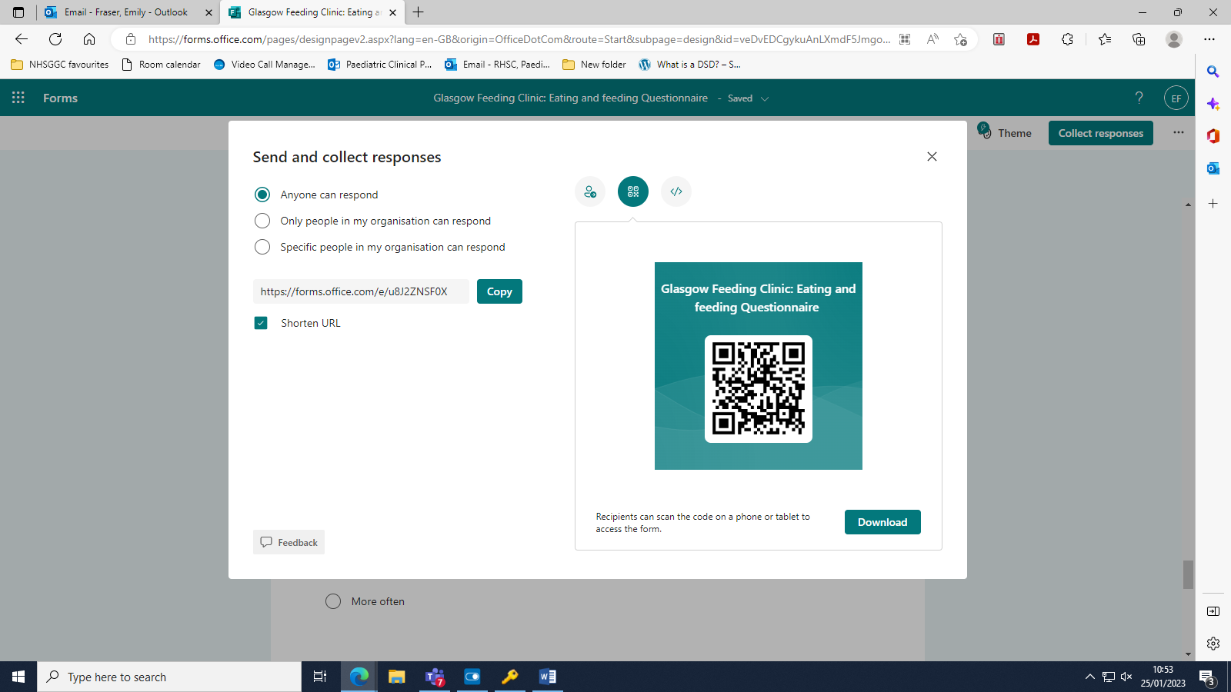

The second is a food diary- a blank copy is enclosed.  It would be very helpful if you could use this to keep track of everything that your child eats and drinks over 5 days- instructions are included on the front of the diary on how to complete this.

Thank you very much, and we look forward to meeting you in the feeding clinic.

Feeding Clinic

Office Block

Royal Hospital for Children

1345 Govan Road

Glasgow

G51 4TF

E-mail:- [ggc.feedingclinic@nhs.scot](mailto:ggc.feedingclinic@nhs.scot)

Website: [www.nhsggc.scot/hospitals-services/our-hospitals/royal-hospital-for-children/feeding-clinic/](http://www.nhsggc.scot/hospitals-services/our-hospitals/royal-hospital-for-children/feeding-clinic/)