**Paramedic Student Placements**



With the drive towards a connected, whole-system approach to improving care for all, we want to prepare paramedic students for professional practice by engaging with diverse learning experiences in practice settings.

Experience in a variety of healthcare settings can support students with decision-making involving patient and service-user groups who attend these settings. This will also help students develop more targeted skills and understanding of patient assessment, consultation, treatment, management and referral.

By learning more about the patient journey, they will be better equipped to identify appropriate pathways of care.

[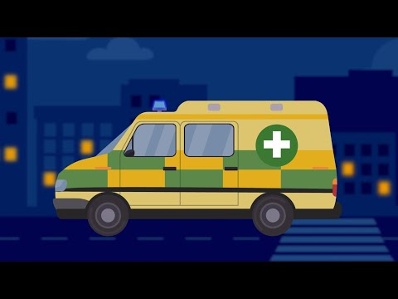](https://www.youtube.com/embed/D3Lm7etIux8?feature=oembed)

[Click here](https://youtu.be/D3Lm7etIux8?feature=shared) or on the image above to see a short video on why these placements are important and a bit about what to expect!

**Please read on** for an introduction to some of the areas that students at Glasgow Caledonian University will attend throughout the BSc Paramedic Science programme.

If you wish to know more, please contact NHS GGC PEL at [Sarah.Richardson6@nhs.scot](mailto:Sarah.Richardson6@nhs.scot)

If you have a question about a paramedic student, please contact [paramedicplacements@gcu.ac.uk](mailto:paramedicplacements@gcu.ac.uk)

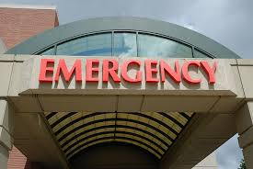

Acute Wards

Paramedic students will attend 1-week placements in each of these three key Acute Ward areas:

* + Adult A&E
  + Paediatrics
  + Maternity (Labour Suite)

Paramedic students placed in these settings can achieve learning outcomes associated with early development of the holistic healthcare practitioner, such as:

* Enhance understanding of patient assessment, treatment and management in in-hospital emergency care settings
* Exposure to a variety of patient groups and clinical presentations
* Recognise the role of the healthcare professional in maintaining patient autonomy, dignity and quality of life
* Explore adaptations to communication and care provision to aid delivery of person-centred care to patients with a variety of needs
* Opportunity to develop knowledge and understanding of NHS services and the complexity of patient journeys
* Identify the need for, and reflect on, interprofessional collaboration and multidisciplinary team working to enable quality person-centred care
* Explore and analyse wider health and social care provision challenges

**Please read the relevant Paramedic Placement Info document before placements start.** This contains useful information, including suggestions for what you can direct students to do while on placement in your department.

More detailed information can also be found in the Practice Education Handbook.

NHS Specialties

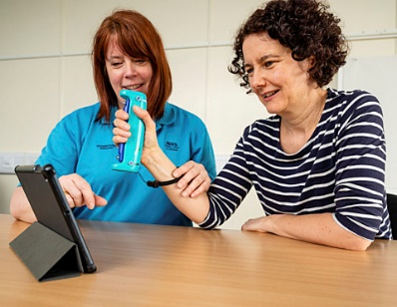

Paramedic students will attend two 2-week placements in specialised healthcare teams and settings relevant to paramedic practice.

These placement settings include:

* Falls prevention services
* Unscheduled care
* HM prison services
* Mental health services
* Addiction services
* Learning disability services
* Adult AHP services

Students are ideally allocated to areas according to their individual interests. Each year, all placement settings offering places will be allocated at least 1 student.

Paramedic students placed in these settings can achieve learning outcomes associated with early development of the holistic healthcare practitioner, such as:

* Exposure to a variety of patient groups and clinical presentations
* Enhance understanding of patient assessment, treatment and management in primary, secondary, tertiary and community care settings
* Opportunity to develop knowledge and understanding of NHS services and the complexity of patient journeys
* Ability to build on and apply communication/interpersonal skills with patients, families, carers and service providers
* Identify the need for, and reflect on, interprofessional collaboration to enable quality person-centred care
* Explore adaptations to communication to aid delivery of person-centred care to patients with a variety of needs
* Recognise the role of the healthcare professional in maintaining patient autonomy, dignity and quality of life

**Please read the relevant Paramedic Placement Info document before placements start.** This contains useful information, including suggestions for what you can direct students to do while on placement in your department.

More detailed information can also be found in the Practice Education Handbook.