NHS GREATER GLASGOW & CLYDE 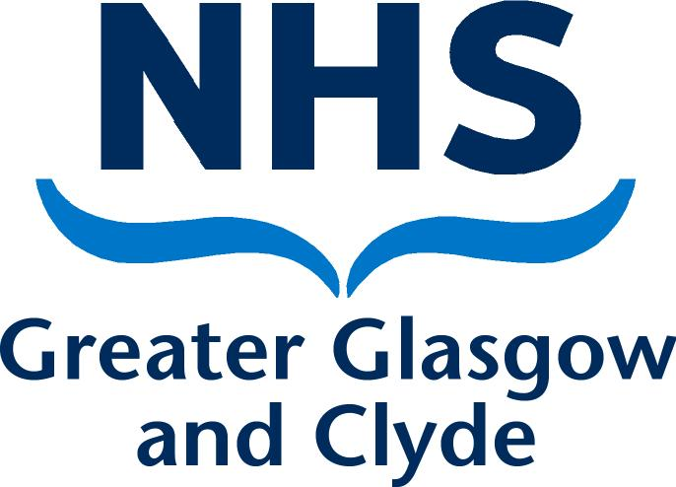

Meeting: | Pharmacy Practice Committee
Date: | Thursday 31st October 2013
Paper No: | 2013/ | ITEM No.  3
Subject: | Application for Inclusion in the Board’s Pharmaceutical List – Kyle Square Ltd, Unit 5, 151 Western Road, Whitlawburn, Cambuslang, Glasgow, G72 8PE | ITEM No.  3
Presented by: | Janine Glen – Contracts Manager – Community Pharmacy Development | ITEM No.  3
Contact for further information: | Trish Cawley  0141 201 5207

Publication: | The content of this Paper may be published following the meeting.

National Health Service (Pharmaceutical Services)
(Scotland) Regulations 2009 as amended

Recommendations: | The Committee is asked to:-
Consider the following PPC & NAP decisions of Eggle Ltd’s first application:

.

Date | Address | Decision
11/12/2012 | Eggle Ltd  199 Gallowgate  GLASGOW  G1 5DY | Not Granted  Neighbourhood  The Committee considered that the neighbourhood should be defined as follows:  North: Railway line – Glasgow Queen Street – Edinburgh line;  East: Abercromby Street;  South: River Clyde; and  West: Saltmarket/High Street  Decision of the Committee  The PPC considered the neighbourhood put forward by the Applicant. It did not agree that the area could be defined a discreet neighbourhood as it was too small and did not contain enough of the facilities and amenities associated with the ordinary definition of neighbourhood.  The PPC agreed with the Applicant’s North boundary, however did not agree with the other boundaries. They considered the Applicant’s South boundary – Glasgow Green and felt that it was not appropriate as there was easy access through and across the park to the River Clyde. The river represented both a physical boundary and a psychological boundary separating the City Centre, Calton and Bridgeton from what was commonly known as “the South side”. The PPC considered that the Applicant’s West boundary Barrack Street/Bain Street was not appropriate as beyond that to the east lay derelict ground. The Committee did not consider that this land formed part of the Bridgeton area. As such, Abercromby Street was felt to be a more appropriate boundary as it clearly marked the beginning of the area commonly known as Bridgeton.  The PPC considered the view of the CP Sub-committee that the neighbourhood should be extended north to include the area commonly known as Drygate at Duke Street. The Committee disagreed that this should be included as the area was significantly different to that to the south of the railway line. The new Collegelands development brought business interests to the area; however a significant majority of the land was given over to car parking or remained derelict and not developed.  The Committee agreed that the neighbourhood which it had defined contained schools food shops, take aways, leisure facilities, residences, a fire station, hardware stores, public houses, a pet shop, a dental practice, a Health Centre, homeless accommodation and various other business interests. There was a sense of community within the area and it enjoyed good transport links with its close proximity and easy access to the City Centre.  The Committee noted that within the neighbourhood as defined by the PPC there were currently three pharmacies.  The Committee noted that the pharmacies offered all core contract services along with a comprehensive range of additional services.  In addition there were several further pharmacies situated within the general city centre location. All pharmacies met the needs of the different elements of the neighbourhood including the transient population and the resident population.  The Committee considered this existing network provided comprehensive service provision to the neighbourhood with extended opening hours and all services required by the pharmacy contract, along with additional services. The Committee considered that access to services was readily achievable in a variety of ways either by foot, public transport or by care. A collection and delivery service was available for any resident finding access to services problematic.  The PPC considered the specific basis of the Applicant’s case i.e. that the Barras was a destination which attracted a large visiting population and which could be compared to major retail facilities such as Silverburn, Braehead and Buchanan Galleries.  The Committee rejected this comparison. The retail developments mentioned above were, in the PPC’s opinion major shopping facilities which all had what was termed as “destination” stores, which drew large numbers of shoppers. The facilities were all open seven days per week and attracted numbers in the thousands. All offered a significant choice of different outlets. By comparison, the main draw of the Barras, the market opened on two days. The other retail developments were generally single use facilities i.e. bridal shop which did not attract a similar level of custom to the major facilities mentioned by the Applicant. The PPC were aware that the area was of some historical value, however it was clear to see that custom to the area was only of any significance on the days the market was open.  The Committee also considered the Applicant’s assertion that patients with long term conditions would be better served by a pharmacy within the defined neighbourhood; however the Applicant had not, in the PPC’s opinion provided evidence that showed that this element of the population did not already enjoy access to services from the existing network.  Having regard to the overall services provided by the existing contractors within the vicinity of the proposed pharmacy, the number of prescriptions dispensed by those contractors in the preceding 12 months, and the level of service provided by those contractors to the neighbourhood, the committee agreed that the neighbourhood was currently adequately served.  The PPC was satisfied that the provision of pharmaceutical services at the premises of the Applicant were not necessary or desirable in order to secure adequate provision of pharmaceutical services in the neighbourhood in which the premises were located by persons whose names were included in the Pharmaceutical List and in the circumstances it was the unanimous decision of the PPC that the application be refused.  For National Appeals Panel decisions please see appendices 1 & 2

