NHSGGC LGBTQ+ Staff Forum – Pronouns and Gender Identity

1 | Introduction
1.1 | NHS Greater Glasgow and Clyde is passionate about staff being able to be their authentic self. By expressing our preferred pronouns and having these used correctly, we can be treated with dignity and respect.
1.2 | This page has been developed in partnership with our LGBTQ+ Forum and aims to provide some background to gender identity, pronoun use, what we can all do and links to further reading.
1.3 | The use of pronouns is a key element of being an LGBT+ ally. It’s simple to do, but makes a big difference.
1.4 | As part of our values of dignity and respect, all staff are asked to respect and use the preferred pronouns of colleagues and patients. Sharing your own personal pronouns or adding your preferred pronouns to Outlook signatures and Microsoft Teams is a personal choice.
2 | Gender Identity
2.1 | When a lot of people think of “gender”, they often base this on how a person looks, dresses or behaves, which can lead to an assumption that a person is male or female and using the pronouns he/him and she/her. However, it’s important to remember that we can’t tell another person’s gender just by looking at them.
2.2 | We all have our own gender identity which is individual to us. For some people our preferred pronouns, are clear and obvious from an early age and for others, the answer takes much longer. There is nothing wrong with questioning our gender, being unsure about it or taking the time we need to work out what is right for us.
3 | What are pronouns?
3.1 | Pronouns are words we use in everyday language to refer to ourselves or others. They can be an important way to express our gender identity. ‘I’, ‘me’, ‘she/her’, ‘he/him’ and ‘they/them’ are some examples of pronouns.
4 | Pronoun Types
4.1 | They / Them  ‘They’ has been used as a singular pronoun for hundreds of years. We use a singular ‘they’, ‘them’ or ‘their’ often. For example, if you find a bag that was left behind in the office, you may ask: “Did someone leave their bag in here?”  Some trans and gender non-conforming people may choose to use ‘they’, ‘them’ and ‘theirs’ as personal pronouns. ‘They’ is considered a gender-neutral pronoun, compared to pronouns like ‘he/him’ or ‘she/her’ which are generally perceived as gendered terms. For example: “Abigail works in our communications department. They delivered an informative presentation today about their recent work with Inverclyde Royal Hospital”.
4.2 | Multiple Pronouns  Some people may wish to use more than one set of pronouns to refer to themselves. For example, a gender non-conforming person may feel equally comfortable with ‘they/them’, ‘he/him’ or ‘she/her’ pronouns. Other trans and gender non-conforming people may prefer to use certain pronouns at different times to enable them to feel comfortable depending on the situation i.e. at work or at home.  If someone uses more than one set of pronouns, you can ask them what they would prefer you to use.
4.3 | Not Using Pronouns  For some people, the correct way to refer to them is by using their name only. If you’re unsure of someone’s pronouns, you can also refer to them by name instead. For example, “Nick is preparing for Nick’s next one-to-one meeting”.
5 | Why it is important to use people’s preferred pronouns at work
 | Whilst it’s important to use correct pronouns in all aspects of our lives, the correct use of pronouns is key to helping all staff feel included at work. It can reassure trans and gender non-conforming colleagues that they are welcome and included in our organisation.
6 | What can I do?
6.1 | These simple steps can make a huge difference:  - Don’t assume somebody’s preferred pronouns based on how they look, dress or act. If you’re not sure, use gender neutral pronouns or just ask. You can also use gender neutral pronouns to refer to someone you’ve not had contact with yet, or simply refer to them by their name.  - Use a colleague’s correct pronouns or preferred way of address once you’re aware of them. It may feel simpler to refer to everyone with gender neutral pronouns (e.g. ‘they/them’), but you could accidentally misgender someone by doing this.  - If you make a mistake when referring to a colleague, apologise, correct yourself and carry on. Don’t apologise too much or repeatedly, as this can draw further attention to your mistake and make your colleague uncomfortable.  - Consider adding your preferred pronouns to your signatures on emails and Microsoft Teams. Guidance on adding your preferred pronouns on Microsoft Teams can also be viewed in Appendices 1 and 2. Guidance on adding your preferred pronouns to your email signature can also be viewed in Appendix 3. This has the benefit of making clear how you would like to be referred to, while also indicating to others that you will respect their gender identity and choice of pronouns.  - Consider stating your preferred pronouns when introducing yourself at meetings – as above, this makes clear your own preferences, but indicates a willingness to respect the preferences of others and encourage them to share theirs in turn.
7 | Useful Reading
7.1 | Personal pronouns and why you should start sharing yours today – Rosie Tyler-Greig | Healthcare Improvement Scotland Blog  Inclusive Language Guide – Healthcare Improvement Scotland  Use of Pronouns – Scottishtrans.org  NHS England » Wearing our pronouns with pride: small words, big impact  Why pronouns matter | NHS Confederation  Pronouns – Glasgow Caledonian University  Pronoun Guidance – The University of St. Andrews  A Short Guide to Sharing Pronouns – Edinburgh University  A beginner’s guide to pronouns and using pronouns in the workplace | Stonewall  What Are Pronouns? Why Do They Matter? — Pronouns.org Resources on Personal Pronouns  A Guide to Neopronouns – Mermaidsuk.org  If you have any questions or would like to find out more, please contact: Lgbtstaff.Forum@ggc.scot.nhs.uk or ggc.staffexperience@ggc.scot.nhs.uk

Appendix 1 – Adding Preferred Pronouns to MS Teams

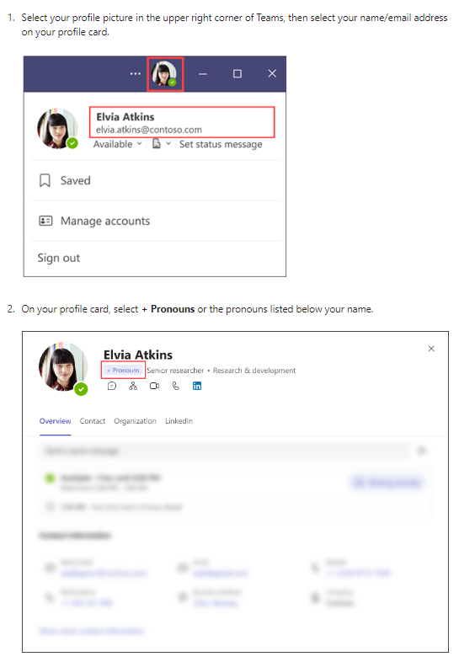

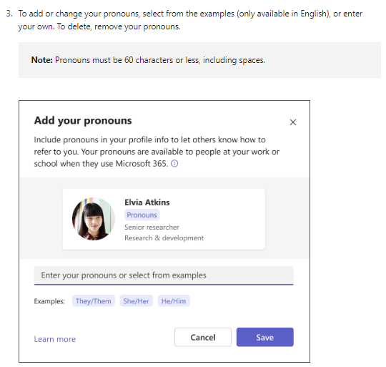

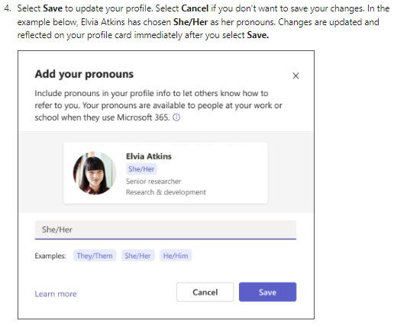
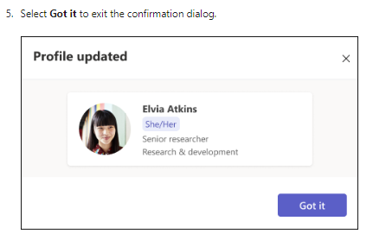

Appendix 2 – Adding Preferred Pronouns to Outlook

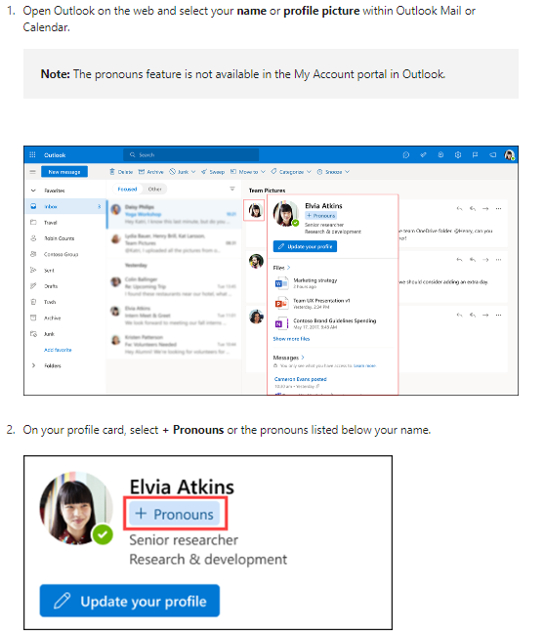

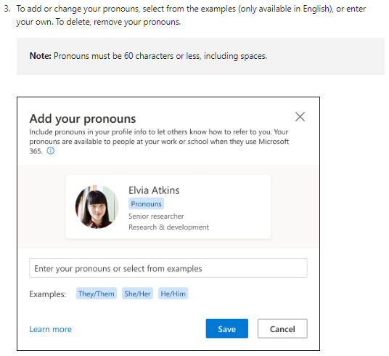

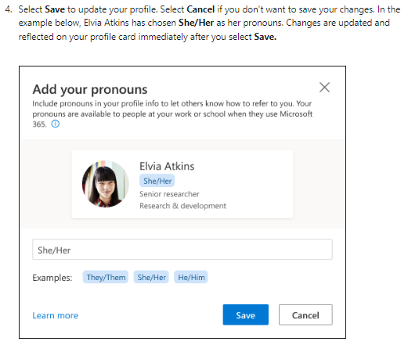

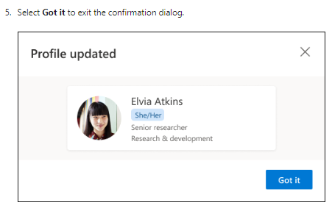

Appendix 3 – Adding Pronouns to your Outlook Signature

- In Outlook Desktop, click File, Outlook Options, Mail and Signatures

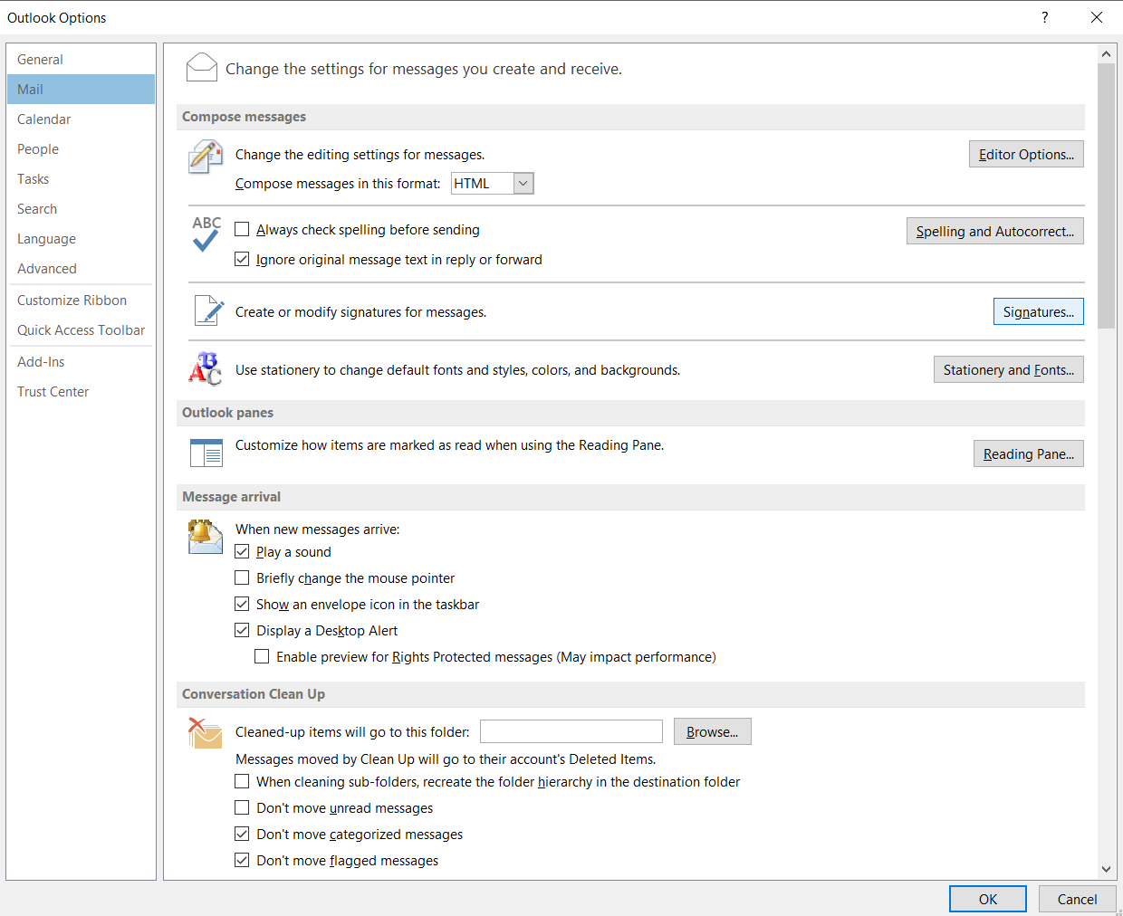

- Edit your signature to add your preferred pronouns after your name.

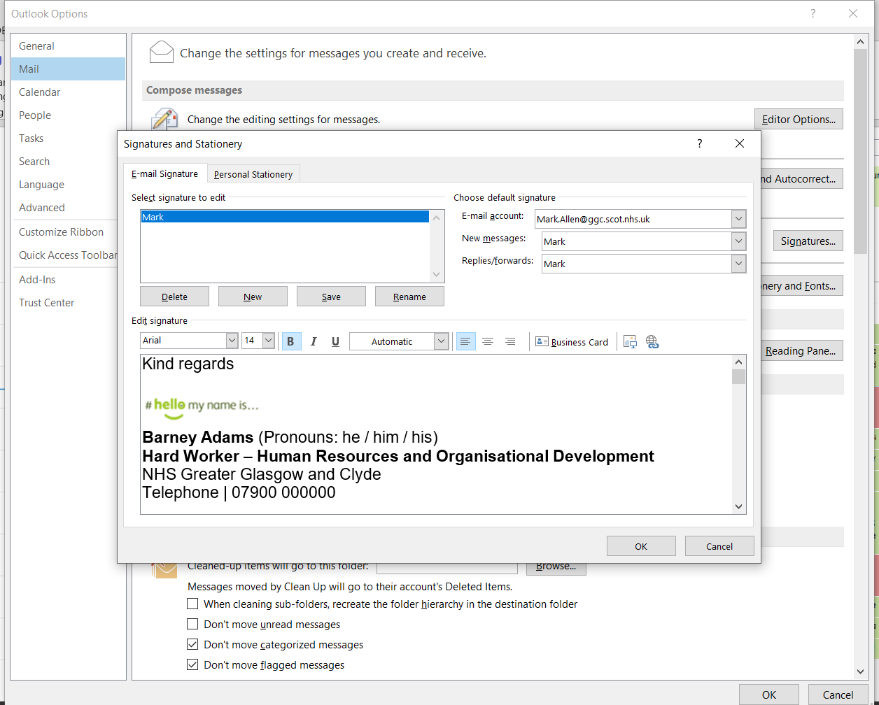

- If using Web Outlook (Office 365), follow the steps below:

- Click the gear icon at the top right corner of the screen, ensure email is selected and choose compose and reply

- Type or edit your signature in the text box and choose whether to automatically include it in new messages and replies.

- Click Save or OK to apply the changes.

