Making a referral to Speech and Language Therapy (SLT) referral via EMIS

As of 1st December 2022 all Speech and Language Therapy referrals will be received via EMIS. This is in order to:
      - Streamline the referral process for both referrer and SLT.
      - Ensure that referrals can be received and actioned in a timely manner
      - Ensure that patient information is kept in line with other record keeping processes.
Please do not send referral forms via e-mail or use the “task” function on EMIS. Instead, follow the process below



- Go to EMIS and open the patient’s record.You can do this either by searching for them using the patient search function, or selecting them from your ward list.
OR

- Click the ‘patient consultation’ tab


- Click add, then click ‘consultation’ from drop down menu
Consultation

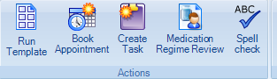
- Click ‘Run Template’

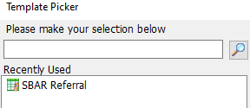

- Search for ‘SBAR Referral.’ If you have used before, this will appear in ‘Recently used’ section.

- Click on SBAR Referral.

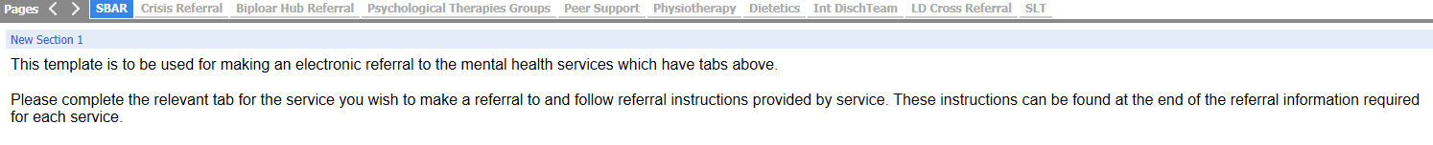
- Scroll along. Click on ‘SLT’
→
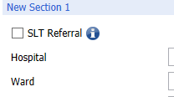

- Make sure you tick the SLT referral box.

Complete the referral form using drop down and free text boxes.

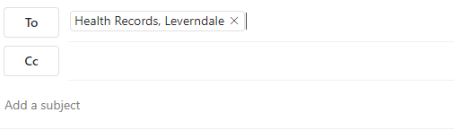
- Click ‘Save template’. This saves the referral form to the patient record.

- Send an e-mail to
Patient name:
CHI:
EMIS Referral made to (insert local area/Directorate) SLT

Leverndale.healthrecords.ggc.scot.nhs.uk

Include patient’s name, CHI and that referral made via EMIS to SLT

PLEASE BE AWARE THAT AN E-MAIL NEEDS TO BE SENT TO MEDICAL RECORDS, IN ORDER FOR THE SLT TO BE MADE AWARE OF THE REFERRAL.

You can still contact your local SLT via e-mail or phone to discuss existing cases or ask for pre-referral advice. See EMIS Learnpro module and guides or contact SLT department for additional help with the referral process if required.

