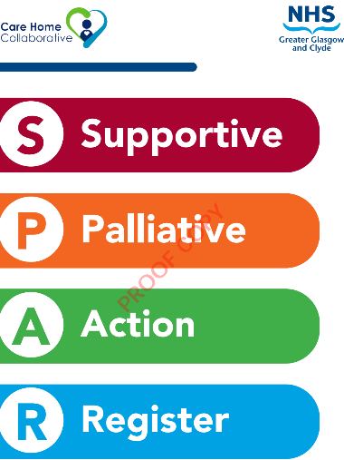
Participation Agreement
The Supportive and Palliative Action Register (SPAR) is a palliative indicator tool used to improve recognition of the deteriorating palliative care home resident. SPAR provides simple documentation to record assessment detail and associated actions as well as suggesting actions that should be considered when decline/deterioration is recognised.
Uses PPSv2 (Palliative Performance Scale version 2)

What homes will be doing:  - Ensure all mandatory training for staff on obtaining/understanding vital signs is up to date  - Engage in education and training and assign a SPAR “Champion”  - Ensure residents baseline NEWS2 and soft signs recorded  - Use the SPAR tool if a resident shows signs of  deterioration; to support decision making and communication  - Cascade training to other members of the team  - Feed back to the Care Home Collaborative on the use of the SPAR tool  - Ensure staff maintain competence in using RESTORE2 | What the Care Home Collaborative will be doing:  - Provide initial training and education on SPAR  - Provide initial paper copies of the SPAR tool for care home staff to use  - Act as an expert resource to the home  - Provide regular support to staff either face to face and/or by telephone or email  - Support the evaluation of SPAR to see where it has helped residents and staff  - Support with SPAR measurement and feedback  - Provide a certificate of attendance
Home Name: | Organisation:
Home SPAR Lead / Champion: | Your Support Contact Name:
Please contact ggc.chccontact@ggc.scot.nhs.uk if you require assistance

