
Cycle of exercises to relax the jaw muscles
Information for patients

Do not do this exercise until your therapist has explained it

How can I relax my jaw muscles and help reduce my facial pain?
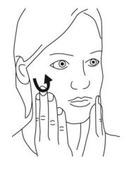 | Do the masseter massage for 20 seconds  - See the masseter massage leaflet for more detail
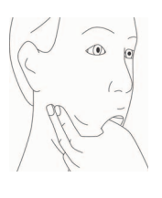 | Do this squeeze and stretch technique:  - Use your opposite hand to gently squeeze the tender muscle with your thumb inside your mouth and fingers outside your mouth) for 20 seconds  - Then gently push your thumb into the muscle (inside mouth) in an outwards and slightly backwards direction for 10 seconds  - Your therapist will explain how to do this technique in more detail
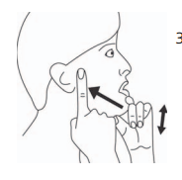 | Do the exercise to improve jaw control.  Repeat 5 times  - See the exercise to improve jaw control leaflet for more detail

How many repetitions and how frequently should I do the exercises?
- Do this cycle of all 3 exercises
- Repeat the cycle 3 times in one session
- Do the 3 sessions daily, for example after each meal
- Begin very gently, then gradually increase force as you feel able

