
Jaw Relaxation Technique
Information for patients
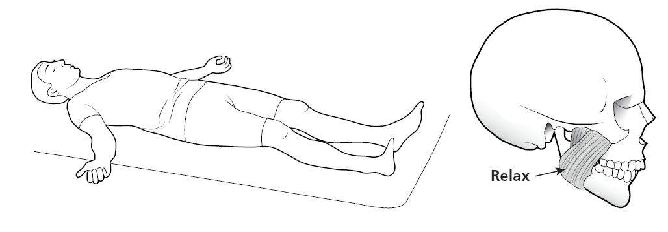
- Relax and stop what you are doing (if possible lie down) and allow the tension in your body to release – particularly any tension in the muscles around your jaw.
- Close your eyes
- With your teeth apart say ‘Emma’ – so your jaw and mouth drop open slightly
- Gently rest your tongue just behind your upper front teeth in the ‘clucking’ position – make a ‘cluck’ noise with your tongue to find this position
- Place one hand on your chest and the other on your tummy. Breathe slowly and deeply in and out, breathing from your tummy – imagine a balloon inflating in your tummy, not in your chest
  - When you breathe in think about the tension in your cheek muscles
  - When you breathe out think about your cheek muscles relaxing/ the tension ‘melting away’
- Continue for another 4 minutes to get complete relaxation of your jaw muscles
- To help regain a more relaxed jaw, perform this technique at least once daily (possibly just before you go to sleep at night)

Sleep Hygiene
Things to avoid…
- Drinks containing caffeine (stimulant): If absolutely necessary have one cup in the morning only, but try not to have any later in the day
- Smoking (stimulant): Try to stop
- Alcohol (stimulant): Try to abstain while trying to correct your sleep problem
- Exercise before bedtime: (increases alertness)
- Daytime naps: (reduces the sleep debt)
- Discussing potentially stressful topics before bedtime: (increases alterness)
- Exciting books or TV programmes before bedtime: (increases alertness)
- Work activities before bedtime: (increases alertness)
- Office work in bed: (Increases alertness)
- Blue screens in the bedroom (interferes with melatonin): Avoid laptops, TV’s phontes etc

Things to try…
- Strict routine: Go to bed at the same time and get up at the same time including weekends
- Relaxing routine before bedtime (helps to prepare your body for sleep): Calming activities such as a warm bath, soft music, relaxation CD
- Blackout blinds/curtains (prevents a disturbed sleep pattern): A light outside the bedroom window or a bright morning can make you wake up early
- Turn off all lights (prevents a disturbed sleep pattern): Such as lights in the bedroom including plug switch lights or just outside the bedroom door
- Create a comfortable room temperature: Extremes of temperature can disrupt sleep or prevent you falling asleep
- Relaxation technique: Rather than getting up if you cannot sleep, as this causes alertness, it is better to use a relaxation technique to let go of the muscle tension and surrender to sleep again. Also consider taking meditation classes
- Regular mild exercise during the day: Such as walking, tai chi or yoga
- Keep a pen and paper by the bed: If you worrry about what you have to do the next day it is best to make a list – that way you are more likely to relax instead of worrying that you will forget
- If you live in a noisy house it may be useful to use earplugs or have a fan to act as white noise
- Review your diet: A balanced diet during the day can give you energy when you most need it (to improve alertness) and reduce your energy levels (when you need to relax). Try having a main meal earlier in the day which includes proteins and complex carbohydrates to give you energy and something lighter in the evening. Some herbal teas can be beneficial in calming the mind. Avoid drinks containing citrus, spice or caffeine (these are stimulants).
- Be patient: For most people, it will take 4-6 weeks to implement these skills.

