
Temporalis Massage
Information for patients
How can I promote muscle relaxation and help reduce my facial pain?

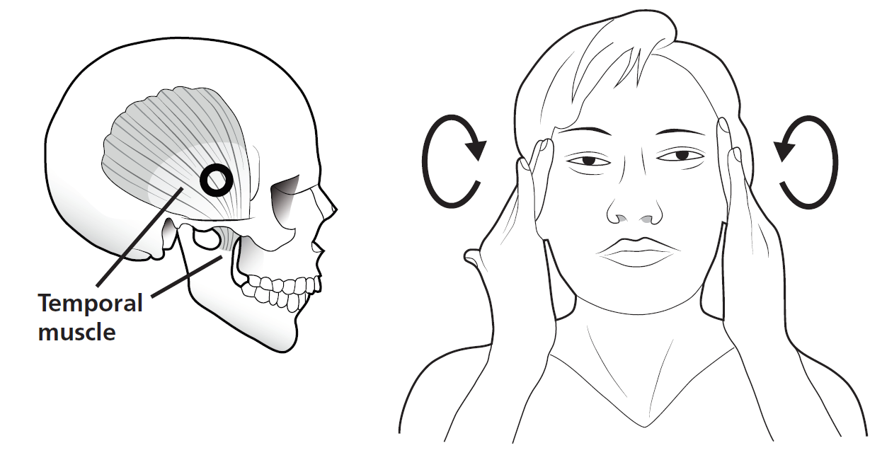
Gentle kneading massage
- Gently massage your jaw muscles in a slow circular motion for 5 minutes using your fingers.
- As you become more confident, gradually increase the depth of massage.

Perform this massage technique 3 times daily (possibly after each meal).

