
Temporomandibular Disorders
Information for patients
What are temporomandibular disorders?

- Temporomandibular disorders (TMD’s) are a group of conditions that cause pain and dysfunction in the temporomandibular joint (jaw joint) and the muscles that control jaw movement (see image below).
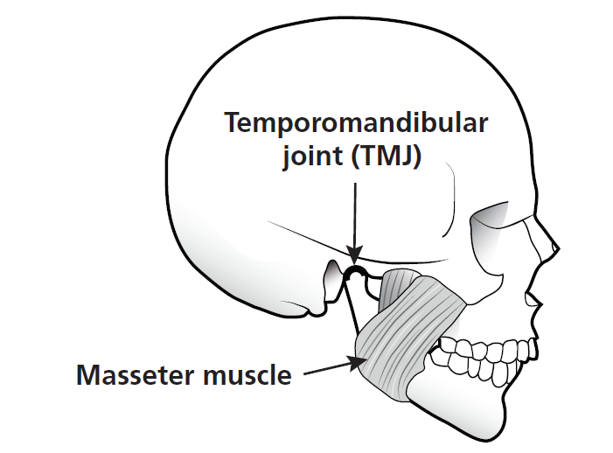
- About 1 in 3 people are affected and these conditions appear to be more common in women than men.
- For the vast majority of people, pain in the area of the jaw joint or muscles does not signal a serious problem.
- Generally, discomfort from these conditions is occasional and temporary, often occurring in cycles. The pain eventually goes away with little or no treatment. About 1 in 20 people, however, develop significant long-term symptoms.

Where can I find further information about TMD’s?
There is helpful information about TMD’s on the following website:
https://www.nidcr.nih.gov/health-info/tmj
Scroll down to ‘Health Information’ and click on ‘TMJ Disorders’.

How can I reduce stress/strain on my jaw joint and jaw muscles?
Avoid oral habits
- Emotions can be translated into increased muscle activity, tension and pain.
- Oral habits are well-established patterns of inappropriate muscle activity. They increase strain on the temporomandibular joints and muscles and may contribute to your symptoms and may act as a barrier to your recovery.
- Examples of such oral habits include:
  - Tooth contact, clenching or grinding
  - Nail biting
  - Chewing chewing gum
  - Pen chewing
  - Lip sucking
  - Habitual protrusion (movement of your lower jaw forwards)
- Monitor your oral habits and any related pain, and especially be aware of the circumstances in which these habits occur
- Greater awareness of such habits and the circumstances in which they occur will help you to avoid this inappropriate muscular activity. This will help to reduce the strain on the temporomandibular joints and muscles and improve your symptoms

Regularly check your ‘relaxed’ jaw rest position
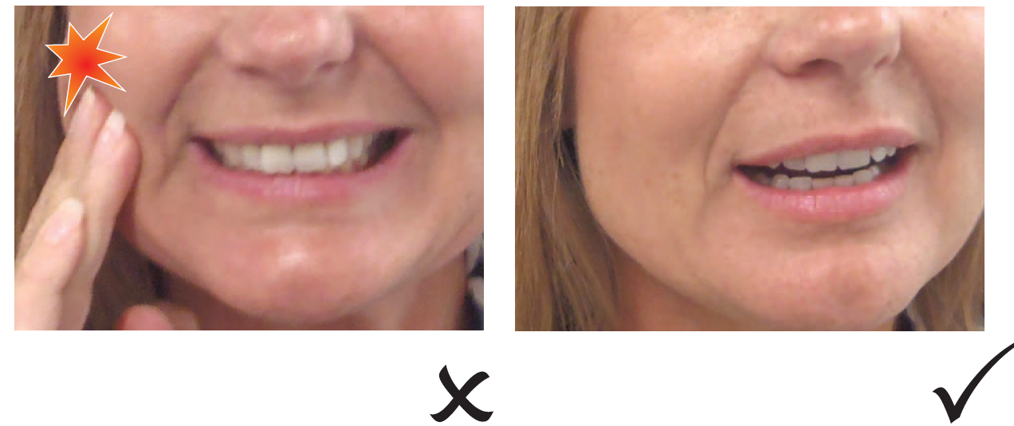
- Teeth apart: Say ‘Emma’ - so your jaw and mouth drop open slightly
- Tongue on the roof of your mouth: Just behind your upper front teeth in the ‘clucking’ position – make a ‘cluck’ noise with your tongue to find this position
- Regularly check your jaw ‘rest position’ throughout the day, especially after eating, while working on your computer, driving etc
Remember – Keep your tongue up and teeth apart!
Avoid a ‘forward’ head posture
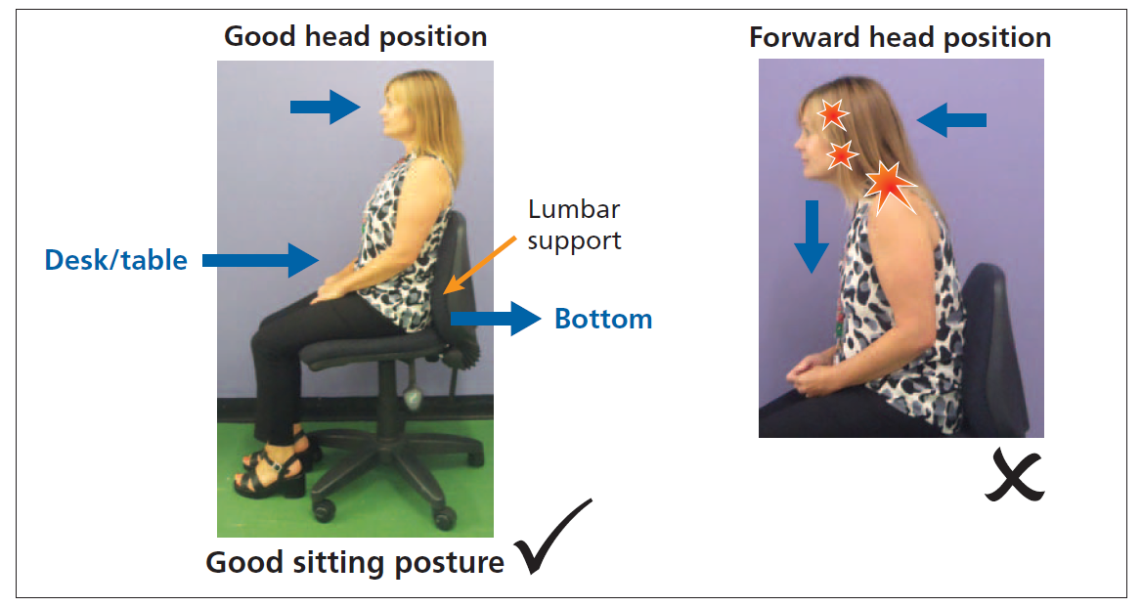

- Regularly check and correct your sitting position (see image above) to prevent a forward head posture. A prolonged forward head posture will increase stress on your joints and muscles
- Sit correctly when working a computer, driving, watching TV, reading, eating, knitting etc
- Use chairs with lumbar support (or use a lumbar roll)
- Always push your bottom to the very back of the chair
- When sitting at a desk or table pull your chair in, so your tummy makes contact with the desk or table
- Position your keyboard and mouse within easy reach
- Position your monitor at eye level
- Use a document stand when inputting information to the computer
- Don’t sit for long periods without a break – stand and stretch every 15 minutes

Other ways you can reduce stress/strain on your jaw
- Eat a soft diet, avoid hard crunchy foods, and cut food into small pieces
- Chew slowly. Chew on both sides or alternate sides
- Avoid caffeine. Caffeine can cause increased muscle activity
- Avoid repeated or prolonged wide mouth opening
- Keep the tip of your tongue on the roof of your mouth when yawning to prevent excessive mouth opening
- Do not rest your chin in your hands
- Avoid sleeping on your front
- If your dentist has provided you with a bite appliance, use it as directed
- Use simple analgesics or non-steroidal anti-inflammatory medication as directed by your GP or Pharmacist
- Regular daily exercise such as walking is beneficial for your general health

