QR Code | Link/Thumbnail | Description
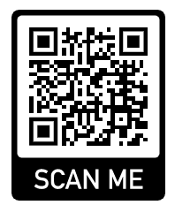 | 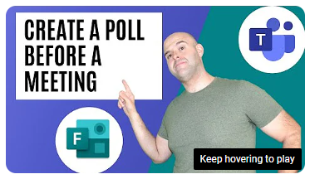 | How to create a poll before your meeting starts. 5 mins 47 secs
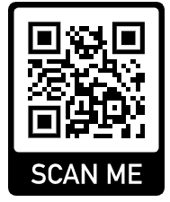 | 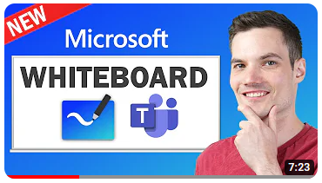 | Creation and use of Whiteboards in Teams. 7 mins 23 secs
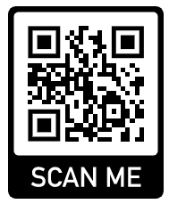 | 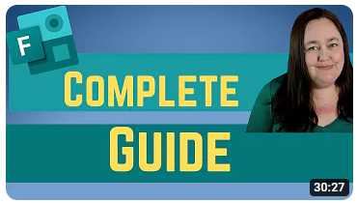 | How to create MS Forms. Fully indexed video demonstrating the full functions of MS Forms. 30 mins 26 sec
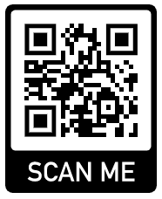 | 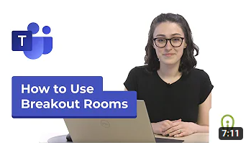 | How to set up and manage breakout rooms. Fully indexed video showing the functions of Breakout Rooms in Teams. 7 mins 11 secs
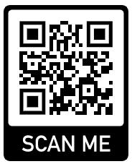 | 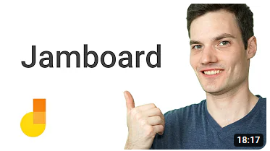 | Tutorial on how to set up and use Google Jamboards. 18 mins 17 secs
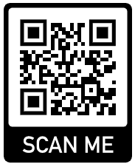 | 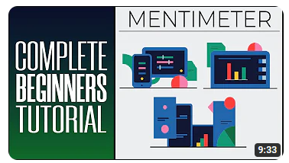 | Tutorial on how to use Mentimeter for beginners. 9 mins 33 secs

