Paediatric Wheelchair
Reporting Form


Telephone: 0844 811 3001  Fax: 0141 201 2649  Email: Westmarc@ggc.scot.nhs.uk  Website: www.nhsggc.org.uk/WestMARC  Criteria: www.retis.scot.nhs.uk/ |  | WestMARC  Queen Elizabeth Hospital  1345 Govan Road  Glasgow G51 4TF
When to use this form

This form should be used when a WestMARC patient requires:
- review due to a change in their condition or needs, or
- modification to their existing seating equipment, or
- replacement parts for existing seating.

Measurements should only be completed by staff who have received training in taking seat measurements. If you have not received this training, please leave Section 5 blank.

Requests for repairs of existing equipment should be telephoned to: 0844 811 3001 or 0141 201 2624

Section 1 About the Patient
Family Name |  |  | CHI No
First Name |  |  | Address
Date of Birth
Telephone No. |  |  | Post Code

If the patient attends a special school or nursery, please give details.
School Name |  |  | Address
Telephone No. |  |  | Post Code

Has the patient and their parent / guardian / carer agreed to this review?

Yes No (If ‘No’, please obtain consent before proceeding any further)

Section 2 About the patient’s condition
Diagnosis:

Patient’s weight  in kilograms |  | Kgs.

Section 3 What equipment does the patient have problems with? Tick all that apply

Buggy |  |  | Other – please give details
Self propelling manual chair
Attendant propelling manual chair
Energy efficient wheelchair
Powered wheelchair
Special seating

Section 4 Reason for report / review? Please complete all sections that apply

Review for growth? | Yes

Review for change in | Please give details of change:
clinical condition?

Replacement parts? | Part |  |  | Details
 | Belt / lap strap
Please tick part/s | Harness
and give details | Cushion
 | Covers / Upholstery
 | Other:

Increase in postural | Please give details:
support required?

Issues with | Please give details:
discomfort?

Change in type of | Type required |  |  | Why needed?
equipment patient | Buggy
requires? | Self-propelling manual chair
 | Attendant propelling manual chair
Please tick type of | Energy efficient wheelchair
equipment requested | Powered wheelchair
& say why it is needed. | Special seating
 | Other – give details:

Other reason for | Please detail:
review?

Section 5 Seat measurements

How to take seat measurements | Measurements in centimetres (cm)
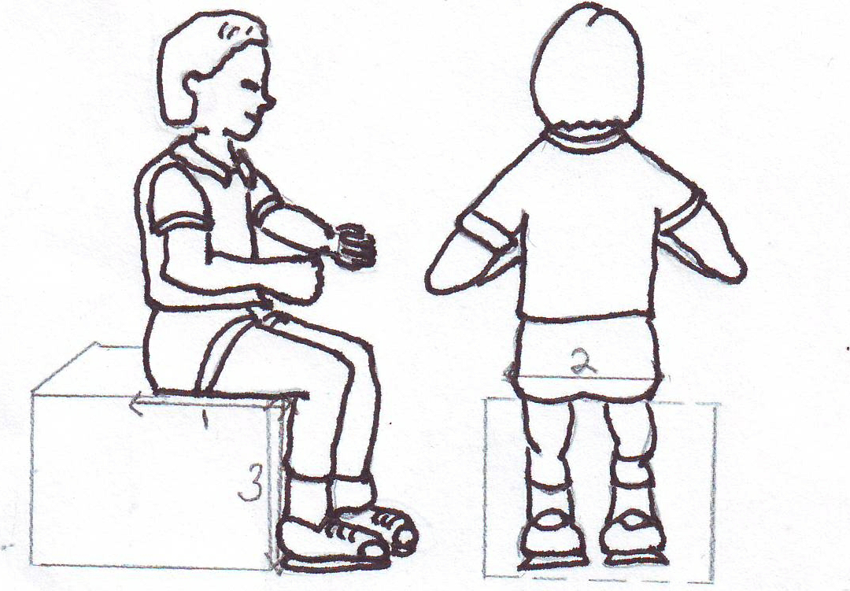  2  1  3
  1 | Seat Depth  Measure from sacrum to popliteal fossa and subtract 2cm. Ensure patient is upright, with anteriorly tilted pelvis.
  2 | Seat Width  Measure across hips, from front or back, at widest point, keeping tape measure straight.
  3 | Calf Length  Measure from popliteal fossa to floor.

Patient’s  Measurements: | 1 | Seat Depth | = |  | cm.
Patient’s  Measurements: | 2 | Seat Width | = |  | cm.
Patient’s  Measurements: | 3 | Calf Length | = |  | cm.

Section 6 Attending WestMARC

If a formal assessment at | Public transport |  |  | Ambulance Car*
at WestMARC is required, | Own transport |  |  | Ambulance – 1 man*
how would the patient travel? | Unable to travel |  |  | Ambulance – 2 man*
 | *If ambulance required, this is a direct access service - please contact Scottish Ambulance Service on 0300 123 1236

Section 7 Details of person completing this form.

Name: |  |  | Address
Telephone No. |  |  | Post Code

I am the patient’s | GP / family doctor |  |  | Physiotherapist
 | Hospital doctor |  |  | Occupational Therapist
 | Other, please state:

Signature: Date

FOR WestMARC USE ONLY

Section A Complete if replacement parts only are required:
Part | Size | Details / colour/ etc | Date ordered
Belt / lap strap
Harness
Cushion
Covers / Upholstery
Other- Details:

Authorised by |  | Date |  |  | / |  |  | /

Section B Complete for all other report / review reasons.

Mandatory |  | Transit buggy
 |  | Transit manual chair
 |  | Thigh length
 |  | Hip width
 |  | Weight
Optional |  | Self- propelling manual chair
 | d |  | d |  | m |  | m |  |  | y | y
Date of report screening |  |  |  | / |  |  |  | /
Direct Provision prescription– tick box if suitable
Prescription details |  | Type
 |  | Size
 |  | Accessories

 |  |  | d | d |  | m | m |  | y | y
Prescription authorised by |  | Date |  |  | / |  |  | /

Date form received

