PLEASE COMPLETE DSE ASSESSMENT PRIOR TO COMPLETION OF THIS FORM.
Line Manager :
Is your manager aware of this referral?
Any equipment recommended is purchased by manager / department.
DSE user: Y/N DSE Completed: Y/N
Post:
Work Duties -
Hours: FT/PT …….. hrs How many hours sitting?
Breaks:
Medical history:

Medications:

Do you exercise with increased heart rate 5 x 30 minutes each week? Y/N
Details:
Do you have any issues with your vision?
Designated Work Station: Y/N
Desk Shape: Straight Edged / Corner L:R / fixed bench style / Other
Desk Height: ……….. Depth: ………….. Width: ………….. (cms)
Flooring: Hard floor or carpet?
Is current chair adjustable and in working condition?
Does your chair need to be vinyl (clinical area) or fabric (non-clinical)?
Do you have a footrest / audio typing pedal?
Number of monitors?
Telephone: Right or Left side of desk?
Are you right or left handed?
Do you have a phone headset?
Desktop or Laptop computer?
What is your height?
What is your weight (the chairs have different weight limits)?
Measurements (complete if a chair is required)  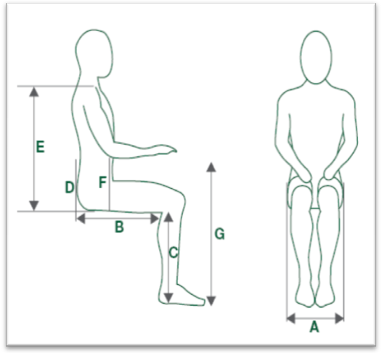 | A – Widest part of hips / thighs | cms
 | B – Buttocks (or straight backrest) to back of knees when sitting upright | cms
 | C – Behind knee to under heel of normal work shoe | cms
 | D – Top of seat to middle of lumbar curve | cms
 | E – Top of seat to top of shoulder | cms
 | F – Top of seat to under slightly bent elbow | cms
 | G – Desk height | cms
For guidance see - https://youtu.be/revpm9Iw8ow
Any current Issues with your desk set up?
1
2
3
4
5
Any other relevant information.
Previous input from Occupational Health Service Y/N
THIS FORM CANNOT BE PROCESSED AND WILL BE RETURNED IF IT IS NOT COMPLETED IN FULL ALONG WITH A COMPLETED DSE ASSESSMENT.
Revised: November 2020

